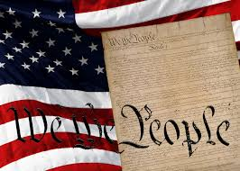

Description: An English language workshop to prepare students for the Citizenship process. The workshop will be on Thursday evenings, beginning June 6 at 6:30pm and last through July 25. It will cover some of the questions and topics that may be discussed during the Naturalization interview.

When: Every Thursday beginning June 6, 6:30p.m. – 8:00p.m.

Where: Southern Oaks Public Library, 6900 S. Walker Ave. Oklahoma City, OK 73139, (405) 631-4468.

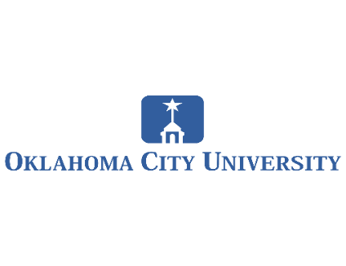
Presented by: Students of the OCU Citizenship English Program.

Cost: Free. No Registration Required.
