Pablo Picasso facts for kids

Pablo Ruiz Picasso (25 October 1881 in Málaga, Spain – 8 April 1973) was a Spanish painter and sculptor. He created over 20,000 images.
He is considered one of the greatest artists of the 20th century and is best known as the co-founder of cubism. A work of art is cubist when the artist opts to break up objects and re-assemble them in abstract and geometric form. Picasso could draw and paint when he was very young. His first word was lápiz, the Spanish word for "pencil".
Picasso was deeply affected by the death of a close friend in 1901. He began painting images of death, poverty and despair. He used mostly blue tones, so this part of his career is called his Blue Period. After he moved to Paris in 1904, he started painting in shades of rose, or pinkish red, and his subject matter was less sad. This Rose Period lasted until about 1907.
Perhaps his most famous painting is Guernica, which shows the horrors of war after the bombing of the town of Guernica.
He was 90 years old when a number of his works were shown in an exhibition at the Louvre in Paris. He was the first living artist to have an exhibition at the Louvre.
Picasso had four children with three women. He died of heart failure in Mougins, France, on 8 April 1973.
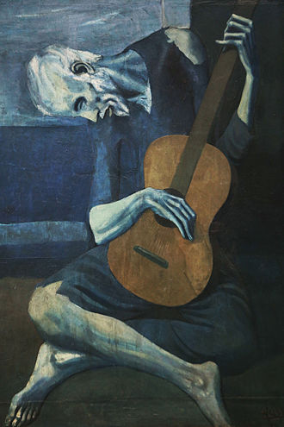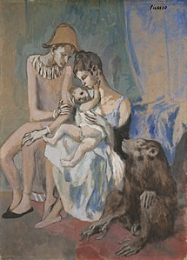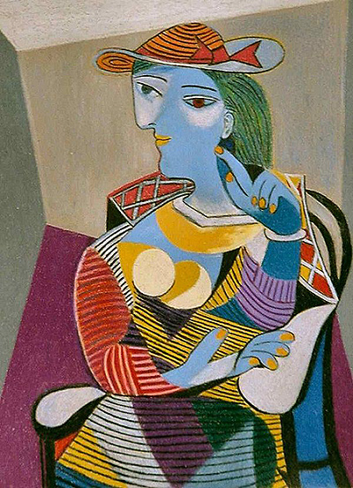
Pablo Picasso Facts for Kids. Kiddle Encyclopedia. 3 June 2020. https://kids.kiddle.co/Pablo_Picasso.
PHOTOS from https://www.pablopicasso.org

