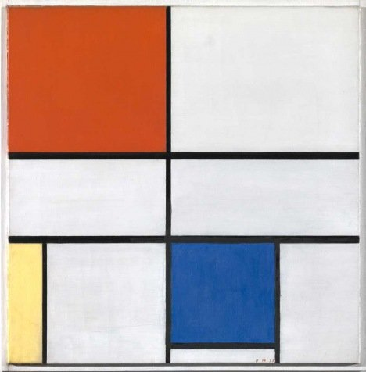
Piet Mondrian Composition C (No.III) with Red, Yellow and Blue © 2007 Mondrian/Holtzman Trust c/o HCR International, Warrenton, VA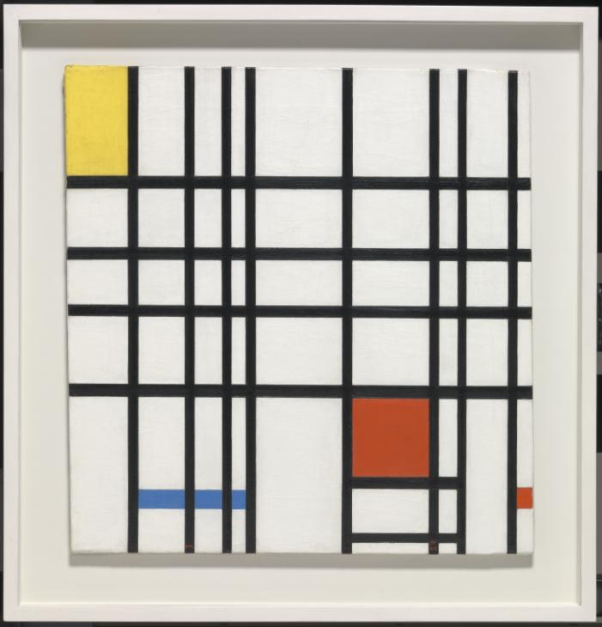Piet Mondrian
Composition with Yellow, Blue and Red 1937–42
Tate
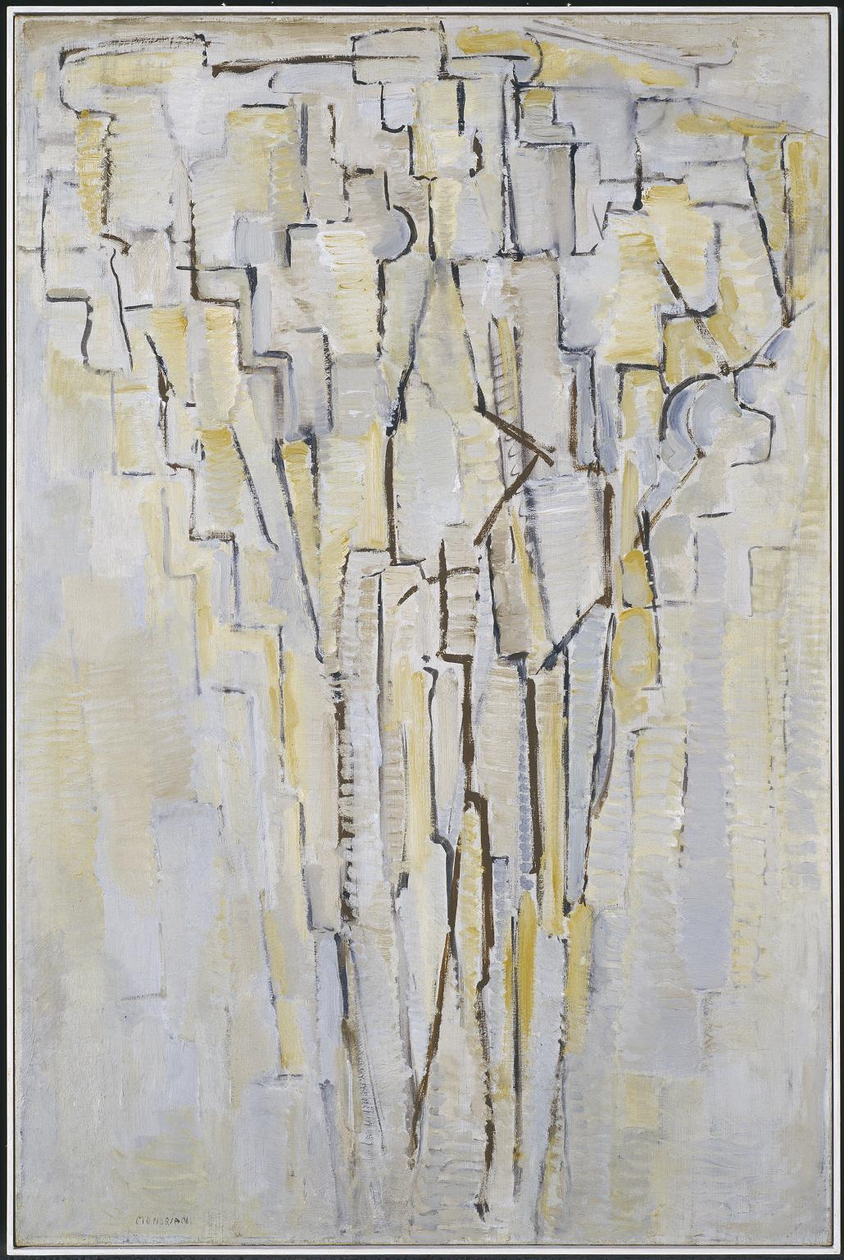
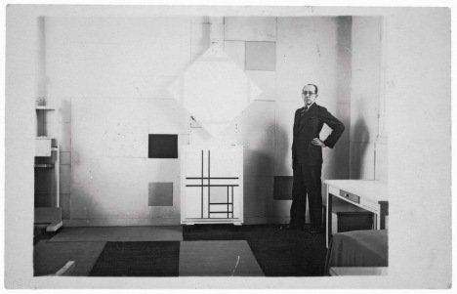
Mondrian in his Paris studio in 1933 with Lozenge Composition with Four Yellow Lines, 1933 and Composition with Double Lines and Yellow, 1933 © 2014 Mondrian/Holtzman Trust c/o HCR International USA
On Previous page:
Piet Mondrian
The Tree A c.1913
Tate
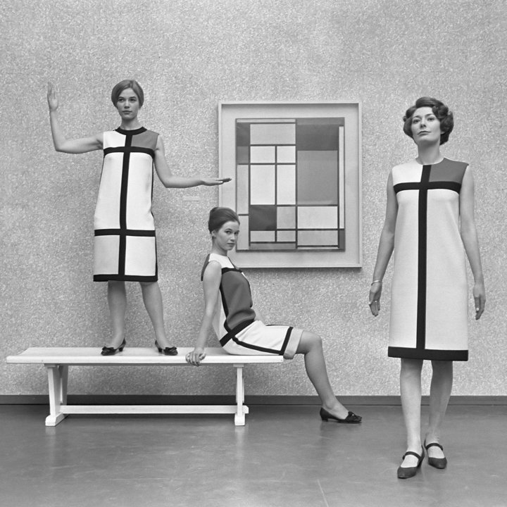Mondrian dresses by Yves St Laurent (1966)
Eric Koch / Anefo - Nationaal Archief, CC BY-SA 3.0

