Dealing with stress & anxiety?
Here are some new titles that might be helpful.

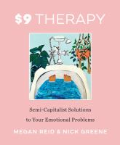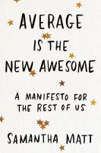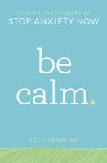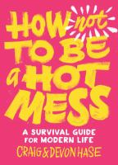
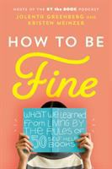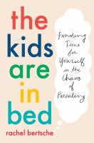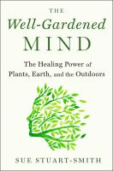

$9 Therapy: semi-capitalist solutions to your emotional problems
by Megan Reid
A tongue-in-cheek collection of the tips, tricks, and recipes that will fix your life without busting your budget. $9 Therapy proves that it's possible to take self-care seriously without taking yourself too seriously
Average is the new awesome: a manifesto for the rest of us
by Samantha Matt
A celebration of ordinary awesomeness, for all of us who were told "You can do anything " and then found out we actually can't
Be calm: proven techniques to stop anxiety now
by Jill P. Weber,
Manage anxiety--anytime, anywhere--with simple strategies that work.
If you suffer from anxiety you're not alone--like 40 million Americans, you know symptoms can strike anytime, anywhere. Relief is here. Be Calm targets symptoms wherever they strike with cutting-edge techniques that help you reduce anxiety on the spot.
How not to be a hot mess: a survival guide for modern life
by Craig Hase
The dumpster fire of life rages on, but you got this. Practice six rules to keep you grounded, weather the storm, and actually be a decent person.
How to be fine: what we learned from living by the rules of 50 self-help books
by Jolenta Greenberg
Part memoir, part prescriptive handbook, this honest, funny, and heartfelt guide is like a warm soul-baring conversation with your closest and smartest friends. In How to Be Fine, Jolenta and Kristen synthesize the lessons and insights they've learned and share their experiences with everyone. How to Be Fine is a thoughtful look at the books and practices that have worked, real talk on those that didn't, and a list of philosophies they want to see explored in-depth.
The kids are in bed: finding time for yourself in the chaos of parenting
by Rachel Bertsche
In an original survey conducted for this book, 71 percent of parents said their free time didn't feel free at all, because they were still thinking about all the things they should be doing for their kids, their jobs, and their households. Rachel Bertsche found herself in exactly that bind. After dozens of interviews with scientists and parenting experts, input from moms and dads across the country, and her own experiments with her personal time, Rachel figured out how to transform her patterns and reconnect to her pre-kids life. In The Kids Are in Bed, other parents can learn to do the same, and learn to truly enjoy the time after lights-out.
The well-gardened mind: the restorative power of nature
by Sue Stuart-Smith
A distinguished psychiatrist and avid gardener offers an inspiring and consoling work about the healing effects of gardening and its ability to decrease stress and foster mental well-being in our everyday lives.

