Instructions for Mandala Coasters
- Paint the wood coaster black and let dry. (2 coats of black paint may work best)
- Be creative with your dots. There is no right or wrong!
- When paint has dried, apply Mod Podge or other clear sealer of your choice.
- Place adhesive felt pads to the bottom of coaster to protect your tabletop.

Inspiration for Mandala Coasters
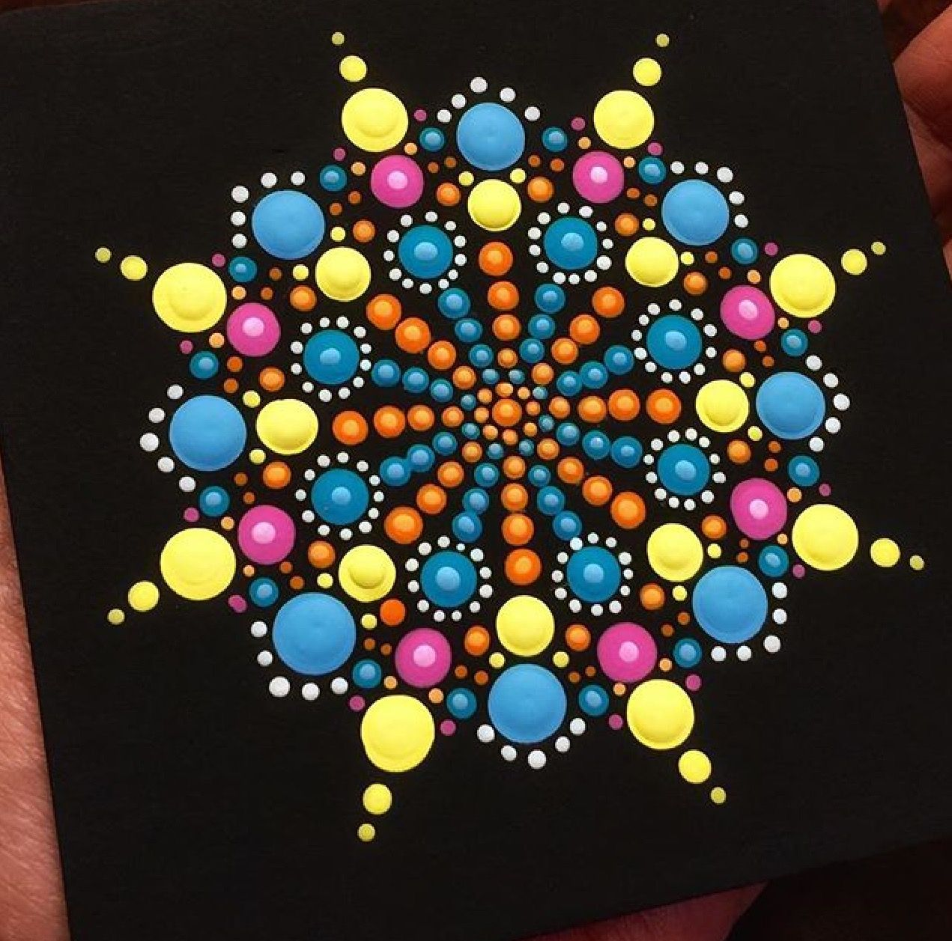

For more inspiration, search YouTube for “mandala dot painting for beginners.”

