Let’s Talk About Weather!
Heading into the fall and the end of summer this is the perfect time to talk to your little one about weather! Using the weather wheel allows your child to reinforce what they have learned each day. You can also use the weather wheel to focus on the seasons and the types of weather that are associated with them. While the weather wheel kit comes with constructions, they are not very concise. For this reason, I have included some pictures of what each section of the Weather Wheel is supposed to look like. The kit does feature all adhesive pieces that you can stick parts on to. However, I would suggest reinforcing it with glue where possible. Pieces do tend to fall off and need to be re-stuck if you only use the adhesive backing on the included stickers.

- Sunny
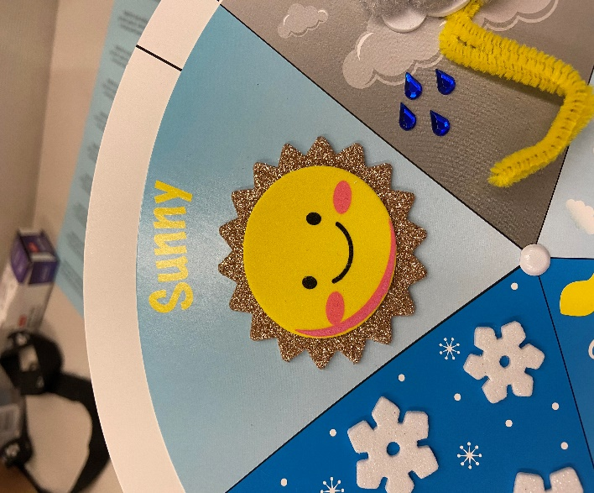

- Rainy/Stormy
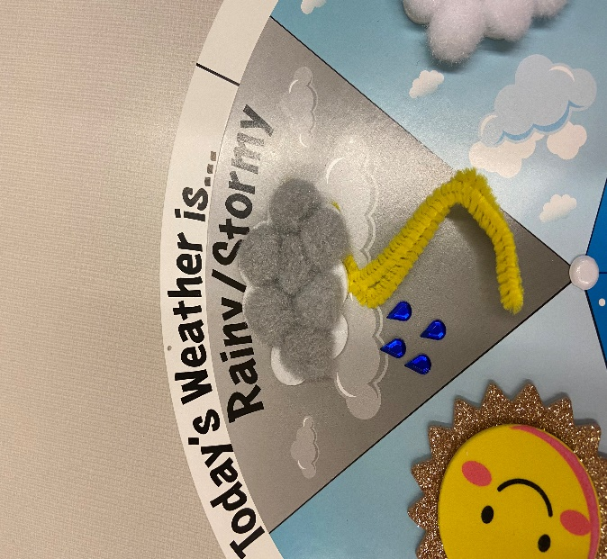
- Cloudy
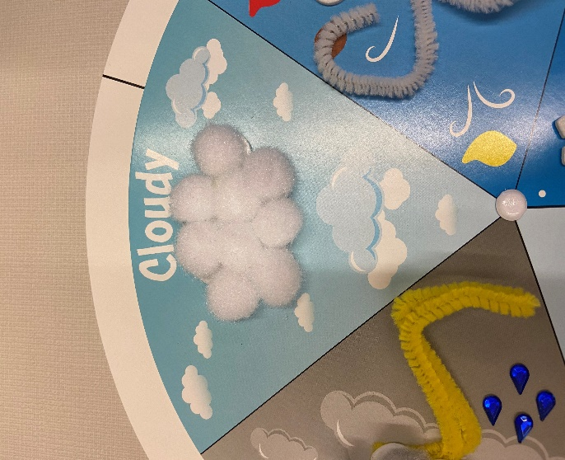

- Windy
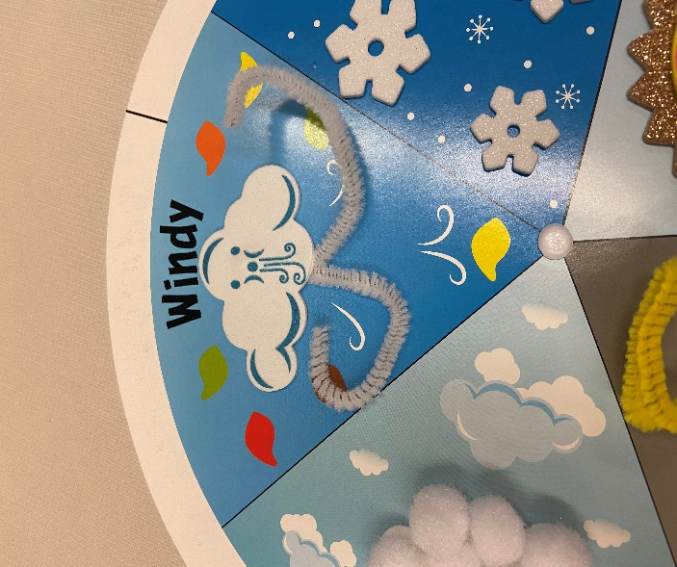
- Snowy
