CartARGh!RAPHY

for practical pirates

If you are a pirate who is going to bury treasure…
You will need to know how to make a map! Cartography is the study and practice of making maps. In this activity, you will make a three-dimensional map out of salt dough and paint. You’ll need to get your hands a little dirty, but as a pirate, you probably won’t mind that, will you? You will also need to decide ahead of time where you’ll be burying your treasure. Since September is Hispanic Heritage Month, it would be a great opportunity for you to explore uncharted seas and choose one of the more than 20 countries where people speak Spanish (and might still own gold doubloons!). 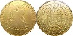
3D SALT DOUGH MAPS
January 29, 2012 by kidworldcitizen .org
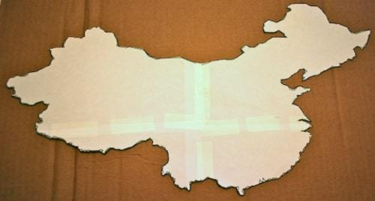

STEP 1: PRINT, CUT OUT THE OUTLINE, TRACE THE COUNTRY
If you don’t have a printer at home, the kit has outlines for 3 Spanish-speaking countries: Spain, Costa Rica (in Central America), and Peru (in South America). You can also visit our Culturegrams database to view/print a map outline of another country or to learn interesting facts about yours. Just go to Metrolibrary.org > Research & Learn > Databases > View Databases by Audience > Children’s Databases > Culturegrams (View Resource Website) > Kids’ Edition > Select a Region or Country (top left dropdown) > scroll to the bottom of that country’s page to view outline and detail maps.
You don’t have to be extremely careful cutting out the intricate bays and jagged coastline. Just do your best and it will turn out fine. Once it is cut out, trace the outline onto your cardboard, and remove the paper map. (Save it if you need the detail map on the back!)
Spanish-speaking countries: Argentina, Bolivia, Chile, Columbia, Costa Rica, Cuba, Dominican Republic, Ecuador, El Salvador, Equatorial Guinea, Guatemala, Honduras, Mexico, Nicaragua, Panama, Paraguay, Peru, Spain, Uruguay, Venezuela
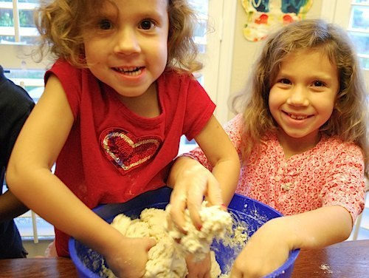

STEP 2: MAKE THE DOUGH FOR THE SALT DOUGH MAPS
Using your hands, measure out and mix together in a large bowl 1 cup of flour, ½ cup of salt, and ½ tablespoon (2 tsp) of cream of tartar. Stir in ½ c of water, adding a little more water at a time (if necessary) until dough is smooth and pliable like play dough.
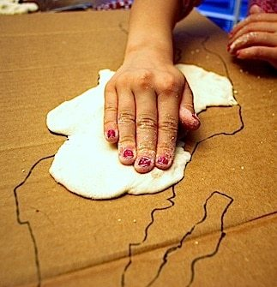
STEP 3: PRESS THE DOUGH ONTO THE MAP Take balls of the dough and flatten them into the outline you have traced. Look at the picture of the “detail map” to see the landforms. First make the map flat, and then slowly build up the elevation in the area(s) where there are hills or mountains.

STEP 4: PAINT THE SALT DOUGH MAPS ACCORDING TO THE ELEVATION When the dough is dry (it can take a couple of days if it is very humid), it is time to paint. On a physical map, the different colors represent changes in elevation, NOT vegetation. For example, green signifies lowlands, not tropical forests. Normally blue is water, green is the lowest land, yellow is climbing in elevation and brown is mountainous. The highest peaks of the mountains are sometimes red, purple, or white. Be sure to include important rivers and other bodies of water and to make a “key” to tell those who read your map what each color means.
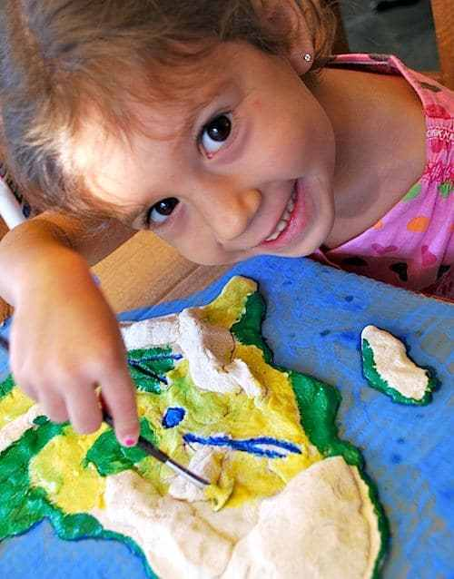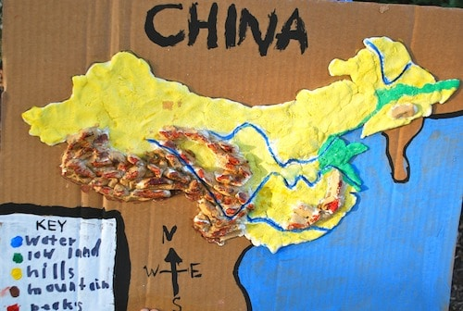
There are different ways to finish your map. To label landforms or major cities, you can place little pins in the dough before it has hardened. You can also label the countries that border yours by writing the names on the cardboard outside the boundaries of your salt dough country. How ever you decide to wrap up the voyage, talk like a pirate while you do it! To further your exploration of the people and culture, place a hold in the library catalog for a book(s) about your country or go to CultureGrams as directed above! To learn a little Spanish (or pirate!), visit our Mango database for languages @www.metrolibrary.org/mango.
