Taino Petroglyphs Necklace Kit

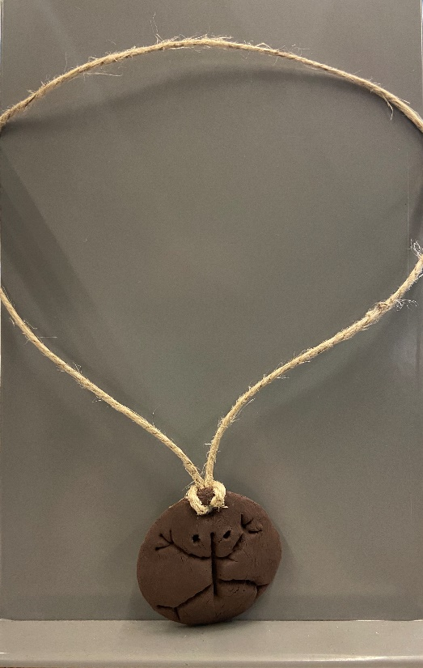

Items Needed:

1 package of air-dry clay (provided in kit)

1 straw (provided in kit)

Hemp string (provided in kit)

Plastic or Metal butter knife (use your own from home)

1. Roll your clay into a ball. Make sure the clay has a smooth appearance and does not have residual air bubbles.

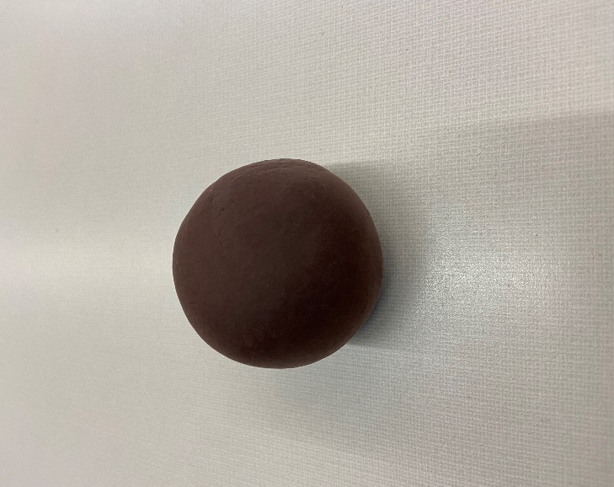

1. Divide the clay in half. Each package will make two pendants. If you are not going to make both pendants at the same time roll the unused clay into a ball and place it back into the ziploc baggie. Make sure to get all the air out of the baggie. You can then use the clay later.

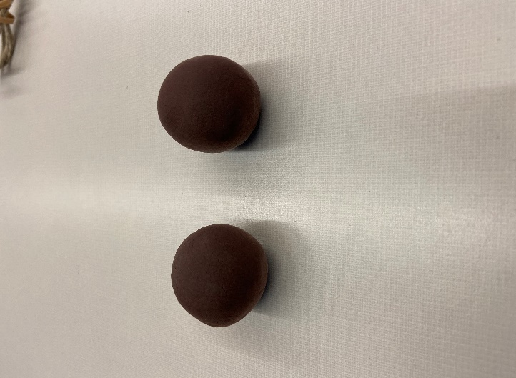

1. Roll the half of clay into a ball again and then flatten the clay with your palm. The clay comes up pretty easily from most surfaces, but if you would like to using a piece of parchment or wax paper will make getting it up even easier and prevent the clay from picking up textures from the surface it is being flattened on.

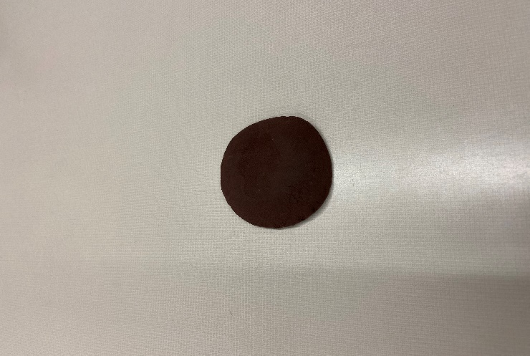

1. Use the straw to make a hole in your pendant. Depending on how you want to tie the string for your necklace you may want to try to make the hole a tad bigger. Once the clay is dry you will not be able to adjust, so make sure to make this the way you want.

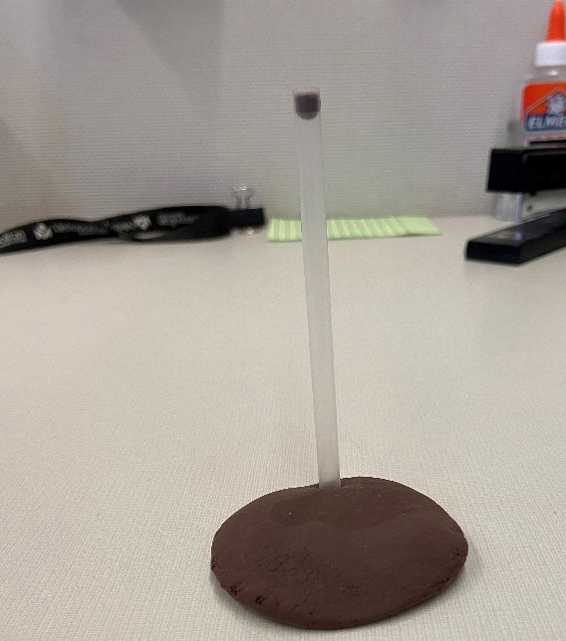

1. At this point you are ready to start putting designs in your clay. Using the included handout find a petroglyph design that you like. Use the butter knife to carve the design into the clay. You want the design to be pretty deep in the clay, if you do not make deep indentations it will not be as visible once the clay dries.

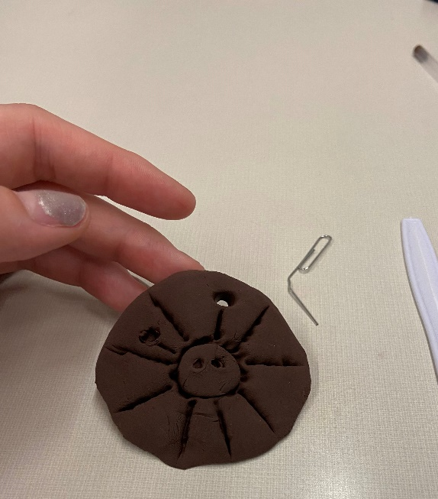

1. Leave your pendant to dry overnight.
2. Once your pendant is dry you may use the string to complete the necklace. There are several ways to do this all depending on what you want. Included are pictures showing how to make an adjustable cord. First you will thread both ends of the string through the hole in the pendant. Then pull the two loose ends of string through the closed loop. To make the cord adjustable length tie a loose knot on each side of the necklace. This allows the cord to be made larger to slip over the head, but smaller once it is on.

