Ugo Rondinone-Inspired Sculptures

SUPPLIES PROVIDED:
- Floral foam (provided)
- Magnets (provided)
- Newsprint or newspaper (provided)
- Tempera paints (provided)
- Paint brush (provided)

YOU WILL NEED:
- Butter knife for carving
- Permanent marker
- Masking tape, 1-inch (you could also use scotch tape, or experiment with glue)
- Scissors
- Paper mâche mix, or flour and water
- Whisk
- Plastic egg carton (optional but fantastic way to allow air drying)

HOW TO MAKE UGO RONDINONE-INSPIRED SCULPTURES:
1. Watch the short video, The Making Of Seven Magic Mountains (https://youtu.be/zLjxfzeif_o). Explore #ugorondinone and #sevenmagicmountains on Instagram to get a strong visual sense of his style.
2. Prepare large foam piece into smaller, more manageable pieces by cutting up into four small square blocks.

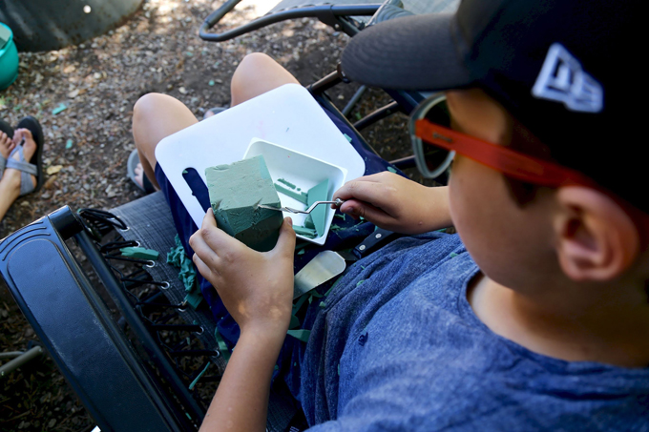

SCULPT
3. Slowly subtract surface area from the foam to create "boulders” similar in size to a baking potato. It is important to keep foam pieces somewhat consistent in size, as these pieces will be placed vertically on top of one another. Pieces should have both a flat top and bottom, so they can simply stack with balance. Working with floral foam is messy, so have a bowl for shavings.
4. Experiment with simple carving tools, which may include pallet knives, simple household butter knives, or flat edge kitchen utensils.
5. When creating a variety of forms, closely at Rondinone’s natural “bouldering forms,” consisting of small jagged angles on the edges, so they really look like rocks or boulders in nature.
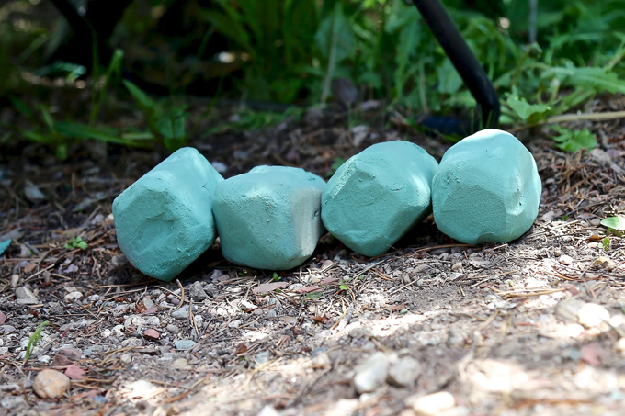
With this subtractive method, cut a little at a time, as you can’t “put back” what has been taken away. Remember that with process art, it’s truly about the experience.
Important Note: There must be a natural or defined balance to make this project a success, with an end goal of three to four small pieces, so the stacked sculpture doesn’t get too weighted on top or tippy, as the materials are extremely lightweight. Smaller/wide/flat pieces provide sturdier boulders rather than tall/narrow pieces. This is all part of the “experimental process” of learning balance and dabbling in sculpture.
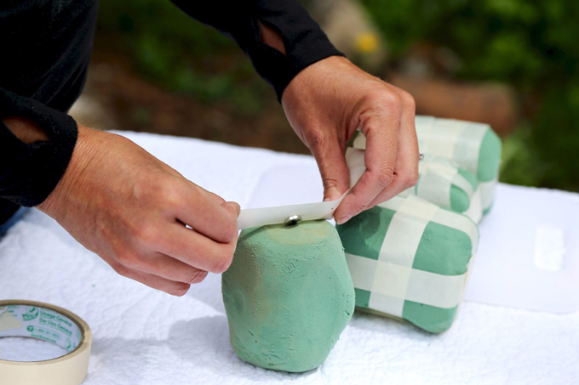
6. Use a black permanent marker to mark the positive and negative attraction of each magnet so you know which side of each magnet “faces up” and which side “faces down”.
Once foam pieces have been sculpted into boulders, use 1-inch masking tape to secure a neodymium magnet (small yet extra strong) on the top center and on the bottom center of the foam piece. Be sure to not implant the magnet too deep; keep all magnets flush with the surface.
Tape doesn’t stick to the foam very well, so you’ll need to take the tape completely around the foam piece to tightly reconnect to itself. For strength, create another tape loop around the middle of the foam piece.
It’s important to only have two layers of lightweight masking tape on top of each magnet so the magnet doesn’t lose any strength, as future paper-mâcheing will also add a few layers. It’s also important for the magnet to stay embedded on the surface in the center of each piece.
This is the most technical part of the project, so staying patient and having extra hands is very helpful.
Also, remember it’s so easy to restart with a fresh piece of tape.
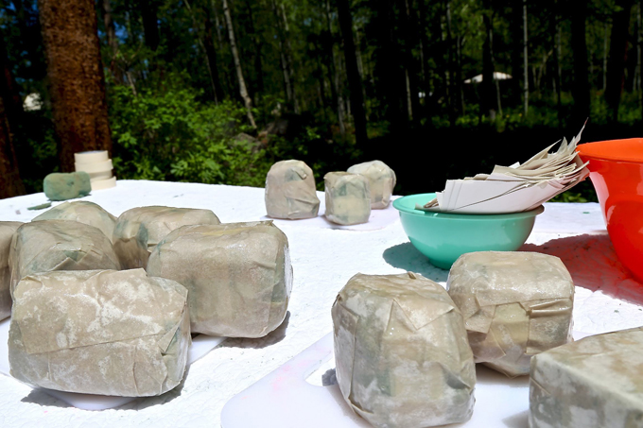

PAPER MÂCHÉ
7. Cut a small handful of approximately 3×3” pieces of newsprint, which can be cut into smaller pieces as needed with scissors.
8. Mix up a batch of paper–mâché, which is basically a dry powder plus cold water combination. If you don’t have a commercial paper–mâché mix, you can also use flour and water (equal parts) and mix with a whisk until you have a glue-like consistency.
9. Prepare a work surface by laying down plastic (or simply use a table that you don’t mind getting messy and that you can clean with a sponge and water). Apply a small amount of paper–mâche onto your hands and rub both sides of the paper so both sides become saturated and sticky. Be careful to apply no more than two layers to cover each foam boulder. Gently rub and smooth along the way.
10. Dry pieces by propping them up on plastic egg cartons with open airflow or bask pieces in the sun for 24 hours.

PAINT
11. Add Ugo Rondinone’s signature color pallet to dry boulders by painting each piece a solid color. Use tempera paint in neon colors, plus black, white, purple, and silver.
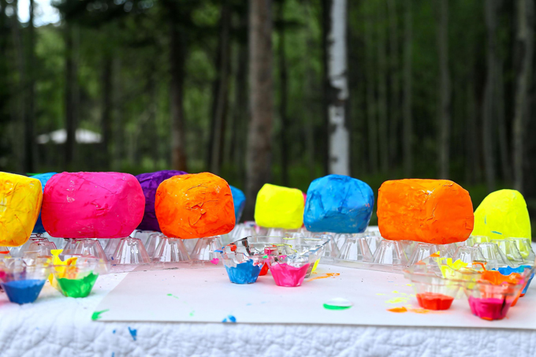
12. Allow pieces to completely dry propped up on plastic. (Plastic egg cartons shown here.)

13. Once pieces are completely dry, experiment with stacking, arranging, and balancing. If one piece is not a precise fit, simply rearrange.

Important Note: Placing sculptures on a magnetic (steel) surface is ideal to allow them to stand solo. Otherwise, they can blow over or tip, as they’re incredibly light weight. Magnetic bases can be purchased, or you may find something around your house, like a metal table, filing cabinet, or even a cookie sheet.

