Stitches and Techniques for Hand Sewing
Written by
Debbie Colgrove
Knowing basic hand sewing techniques allows you to quickly make repairs and do small projects. Even if you have a sewing machine, there are times that hand sewing is better to give you the results you want. Learn about hand-sewed stitches, how to sew them, and which technique works best for different purposes.

Thread a Hand Sewing Needle
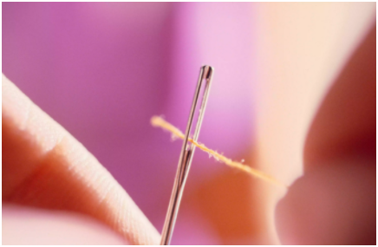
Threading a sewing needle can be an exasperating task. There are tips and tricks that can help make it less frustrating. For example, place a white background behind the needle to make it easier to see the eye and thread. Cut the thread with sharp scissors (to prevent frayed ends) at a 45-degree angle. Be sure to stiffen the thread using water, saliva, or wax. If you still have difficulty, use a needle threader tool or tweezers.

Use a Needle Threader
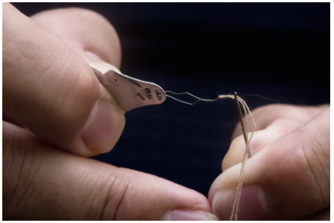
Needle threaders come with some sewing needles and can be purchased in almost all sewing sections. These are the basics:
  - Place the handle of the threader in your dominant hand, holding it between your thumb and forefinger.
  - Insert the diamond-shaped wire through the eye of the needle, all the way to the handle of the needle
  - Pass the thread through the diamond-shaped wire (which is a much bigger target than the eye of the needle). Keep hold of the thread in one hand.
  - Draw the needle away from the threader handle and back up the wire. With that action, the thread passes through the eye of the needle and threads the needle.

Hand Sewing Needles

Hand sewing needles are available in all kinds of shapes and forms. In most cases, the larger the size number, the smaller the needle. Finer needles are used with thin or delicate fabrics while heavier needles are used with thicker fabrics.

Knot the End of Hand Sewing Thread
Learn how to knot the end of your hand sewing thread. With a little bit of practice, you will be creating a perfect knot. The basic procedure:
- Place the end of the thread on your pointer finger, holding it in place with your thumb.
- Wrap the thread around your pointer finger a couple of times.
- Using your thumb, slide the thread loops towards the end of your pointer finger. The loops will wrap around each other as they travel toward the end of your pointer finger.
- Slide the loose knot to the end of the tread, then tug on the thread to tighten the knot.

Hand Sew a Backstitch
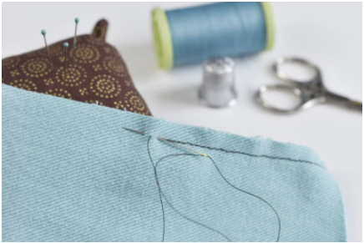
A hand-sewn backstitch is a strong, reliable stitch. It can be used to mend seams and replace zippers. Here is how you do this basic stitch:
  - Insert the needle into the fabric where you want to start the seam.
  - Bring the needle back through both layers of fabric a short distance in front of the previous stitch.
  - Insert the needle back into the fabric in the middle of the first stitch.
  - Bring the needle up through the fabric the same distance you came forward in creating the first stitch.
  - Continue making a continuous line of back stitches.

Sew a Slip Stitch
A slip stitch is a common hemstitch that is used when you do not want visible stitches. Here is how to do it:

- Thread your needle and knot the end of the thread.
- Anchor the knot on the inside of the garment or a hidden location.
- Pick up a few threads of the fabric directly under where the knot is anchored.
- Pull the needle through the fabric toward the hem edge.
- Move the needle over and insert the needle into the hem edge, so the stitch itself is under the hem edge.
- Repeat the stitch and continue until finished.

Chain Stitch
A chain stitch is a series of loops that lay on the fabric forming a loose style line. It can be decorative or functional. Here is how to do it:
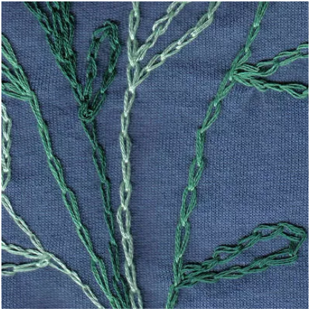
- Stich up from the backside of the fabric to the front side.
- Insert the needle into the top side of the fabric in the same spot, keeping a loop of thread on the top side.
- Bring the needle back up through the right side of the fabric a short distance from where the needle went into the fabric.
- Insert the needle through the loop of thread on the front side of the fabric.
- Pull the needle through the fabric, anchoring the loop. Be sure you do not pull the thread too tight, so you maintain the loop shape.
- Repeat to make a chain of stitches.

Hand Sew a Blanket Stitch
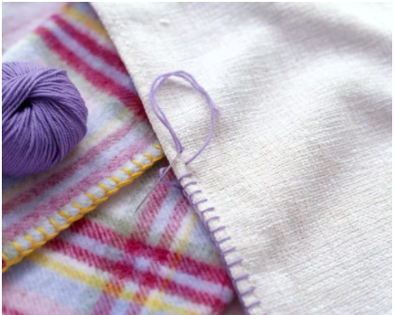
A blanket stitch can do more than trim a blanket. You can use it to decorate the edges of many sewing projects. Often, you will use a contrasting thread color or a thicker thread or yarn. You can play with the spacing and length of the stitches for different looks.

Sewing on Buttons
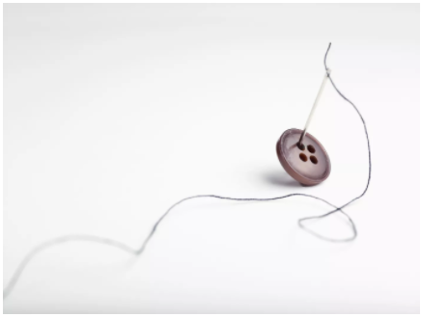
For a flat button, start by sewing an "X" on the fabric where you want to place the button. Insert a pin or toothpick through the "X." Sew up and down through the holes in the button several times. On the final pass, bring your needle and thread only up under the button. Wrap the thread tightly around the base of the button a few times. Pass the needle through this bundle a time or two. Then bring the needle back to the backside of the fabric. Stitch through the stitches to form a loop and make a knot.

