Button Bracelets – Version #1
Instructions found here: https://www.angeledenblog.com/2009/11/button-bracelet-tutorial.html
You will need enough buttons to stretch comfortably round your wrist, probably about 14, each measuring about 1 cms across. For this style of bracelet they need to be buttons with four holes.
You will also need a length of waxed cotton or good quality string. Cut the waxed cotton to a length of about 80 cms and fold in half. Tie a single knot in the folded end to form a loop. Before pulling this tight make sure that your loop is the right size for one of the buttons to pass through, be careful however to make sure the loop is not too large as this may cause the bracelet to come undone.
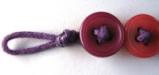
To make it easier to thread the buttons you could now fix the looped end to your table with some masking tape. Have the two loose ends of cord facing you and thread through two of the holes in the button from behind, with the cord coming out at the front. Cross the cord and thread diagonally through the other two holes in the button from the front to the back and pull tight.
Repeat the previous step with as many buttons as you need to go round your wrist.
Once you have the correct length tie a reef knot behind the last button. A reef knot is achieved by passing the right hand cord over the left and passing it under to knot and then passing the left cord over the right and under to give a second knot.
Pull the knot tightly. If you have any suitable glue it is a good idea to place a little glue on the knot. Once this is dry cut the ends and your bracelet is finished.
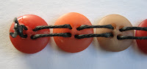
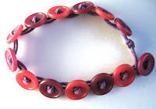
The loop that you made at the beginning will now be used to go over the last button to fasten the bracelet. Your done!

Button Bracelets – Version #2
Instructions found here: https://www.honest.com/blog/lifestyle/home/reuse-your-old-buttons-in-3-crafty-ways/9936.html
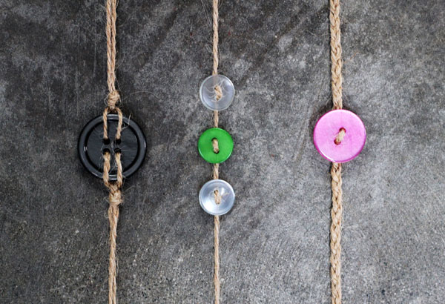
Measure out some twine and braid the strands or knot them together like a friendship bracelet. Secure buttons for unexpected and colorful flair.

Button Bracelets – Version #3
Instructions found here: https://www.wikihow.com/Make-Button-Bracelets
1) Select the buttons. For this piece, choose a very eclectic mixture of your finest, most fun and funkiest buttons. This is a showpiece, to show off buttons in the same manner as a charm bracelet.
2) Choose a lineup for the buttons. On a flat surface, work out the order in which you'd like the buttons to be placed. It is important to do this now, so that you can switch buttons around and out until you're happy with how the bracelet looks.
3) Thread the needle. Sew a clasp finding onto the thread first. Tie a knot either side to keep it in place.
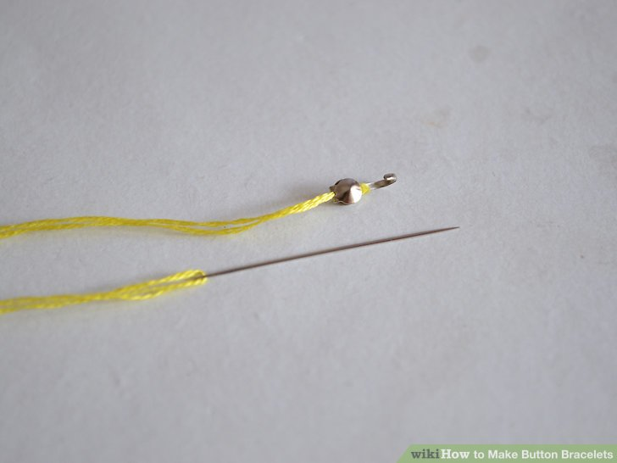
4) Pull the needle through the first button, up through one hole, then down the next. It should sit firmly in place next to the clasp finding.
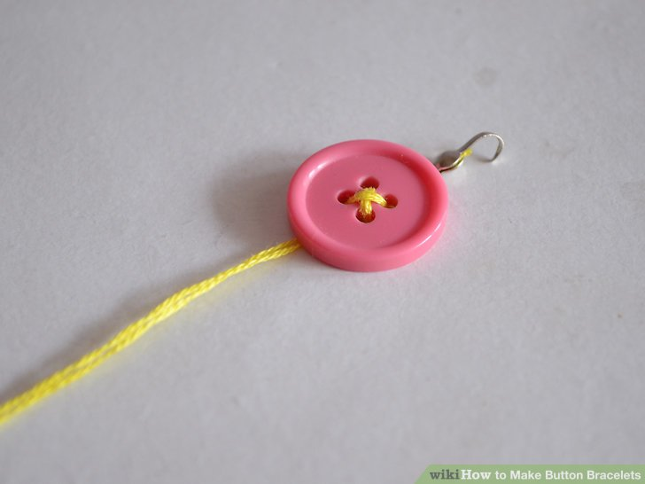

5) Thread the next button in place in the same way. Continue following the pattern you've arranged from the buttons.
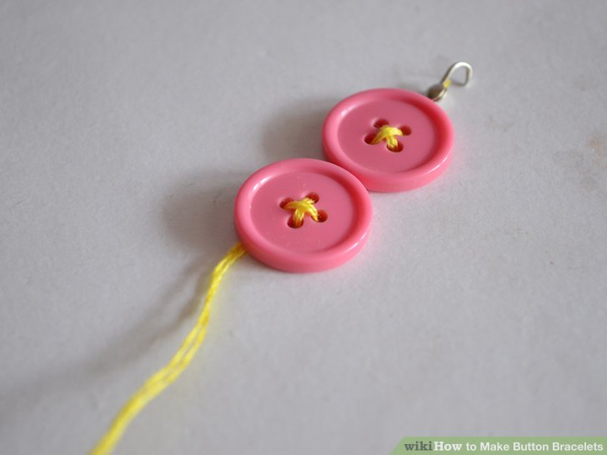
6) Check the fit now and then. When you reach the end, be sure to leave enough thread in place for finishing with the other part of the clasp finding. Stitch it on and the bracelet is complete.
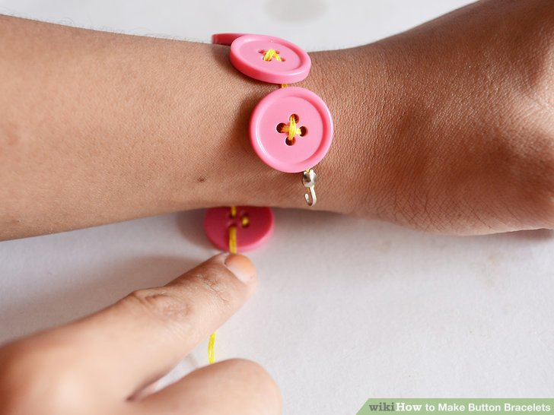

7) Try the bracelet on. Check that it is secure and push the buttons into place, as desired.
