Button Flowers
Instructions found here: https://atcharlotteshouse.com/how-to-make-colorful-button-flowers/
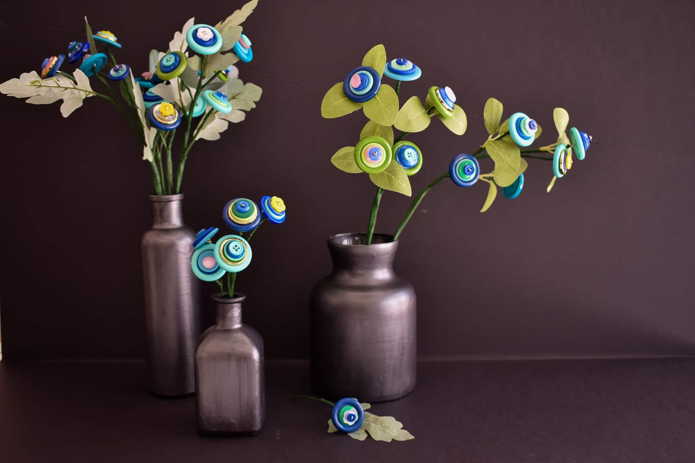
STEP 1. BUTTONS
You need buttons for this project. Lots and lots of buttons. One thing to keep in mind is that you also need buttons in a wide array of SIZES. I could have used more large buttons, but the ones I had worked fine. Also… most of the buttons should have at least 2 button holes in the middle.
STEP 2. MAKE THE TOP OF BUTTON FLOWER
Find 3 or 4 buttons and arrange them from largest to smallest. Cut floral wire to about 8 inches long. Bend the end of the wire over by about 1.5 inches.
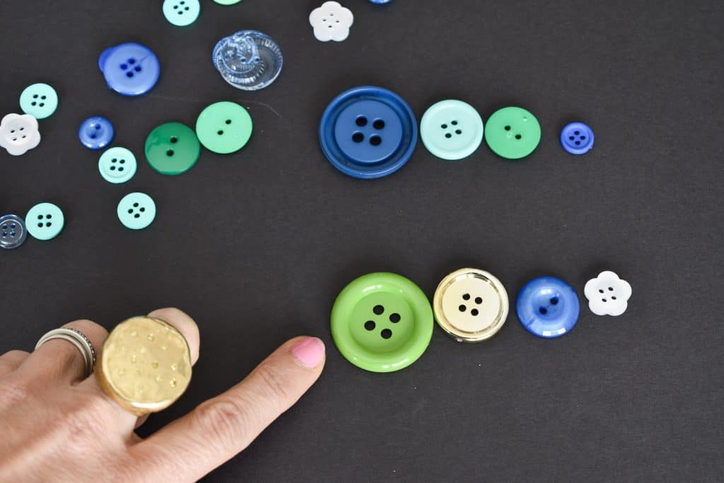
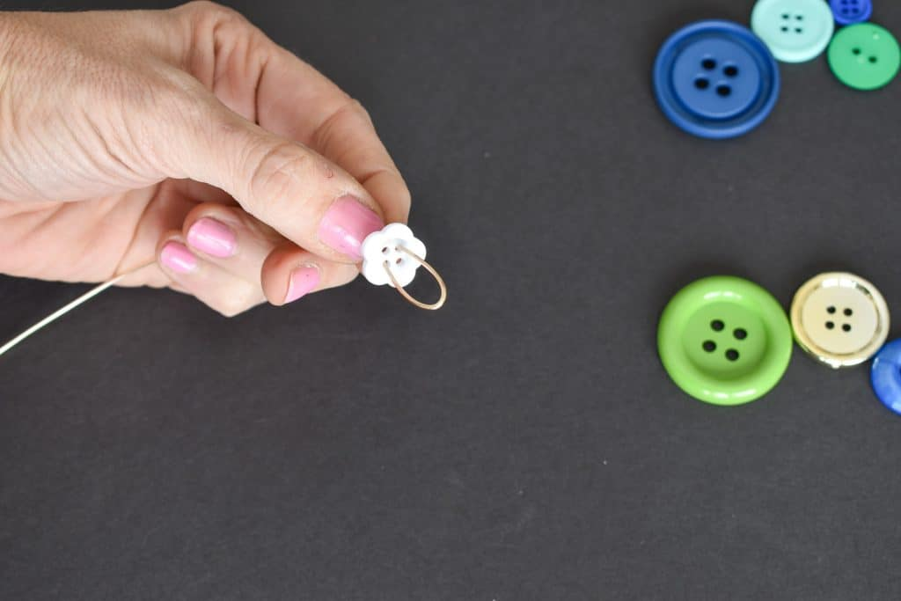
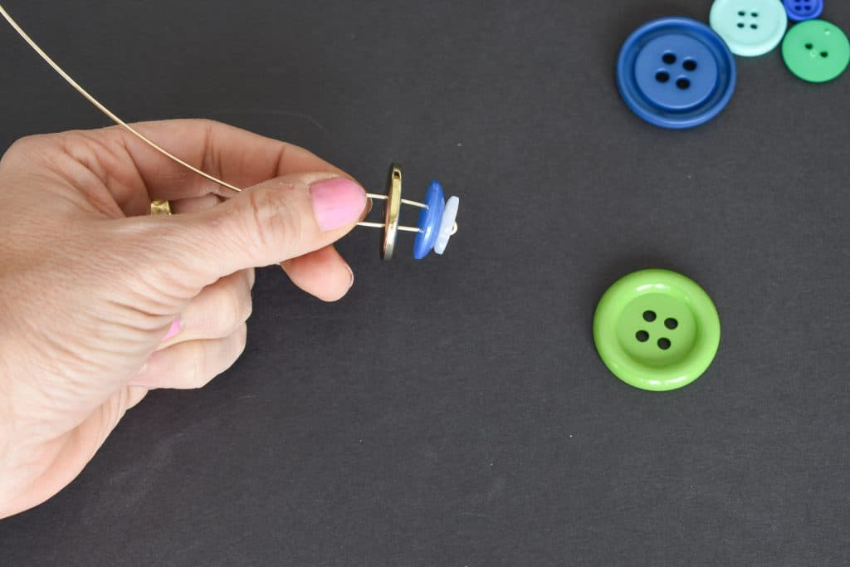
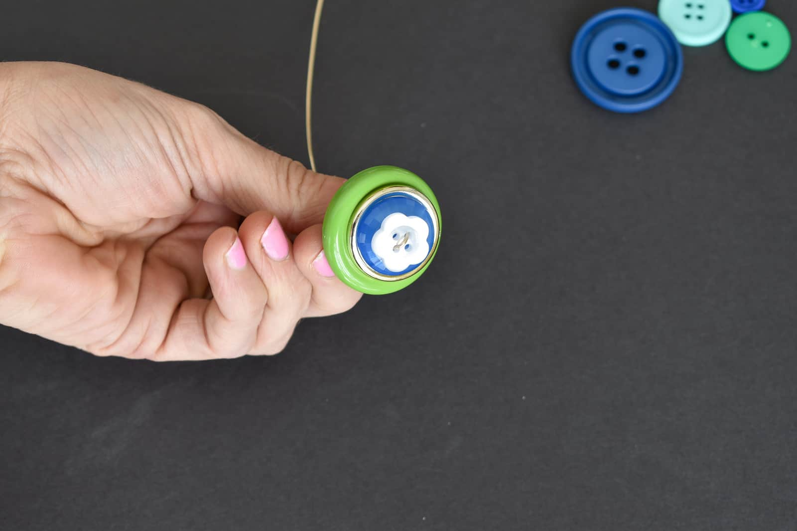
Twist the two ends of the wire together to secure beneath the flower. Repeat to make more flowers.
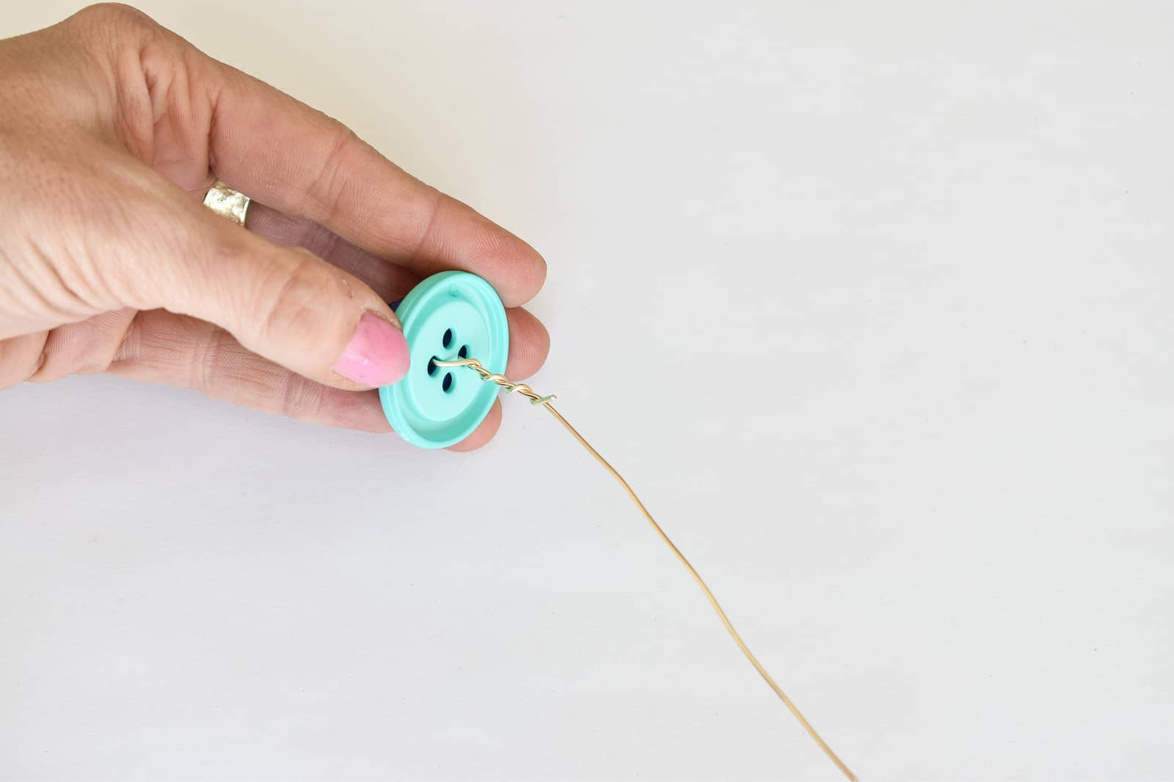
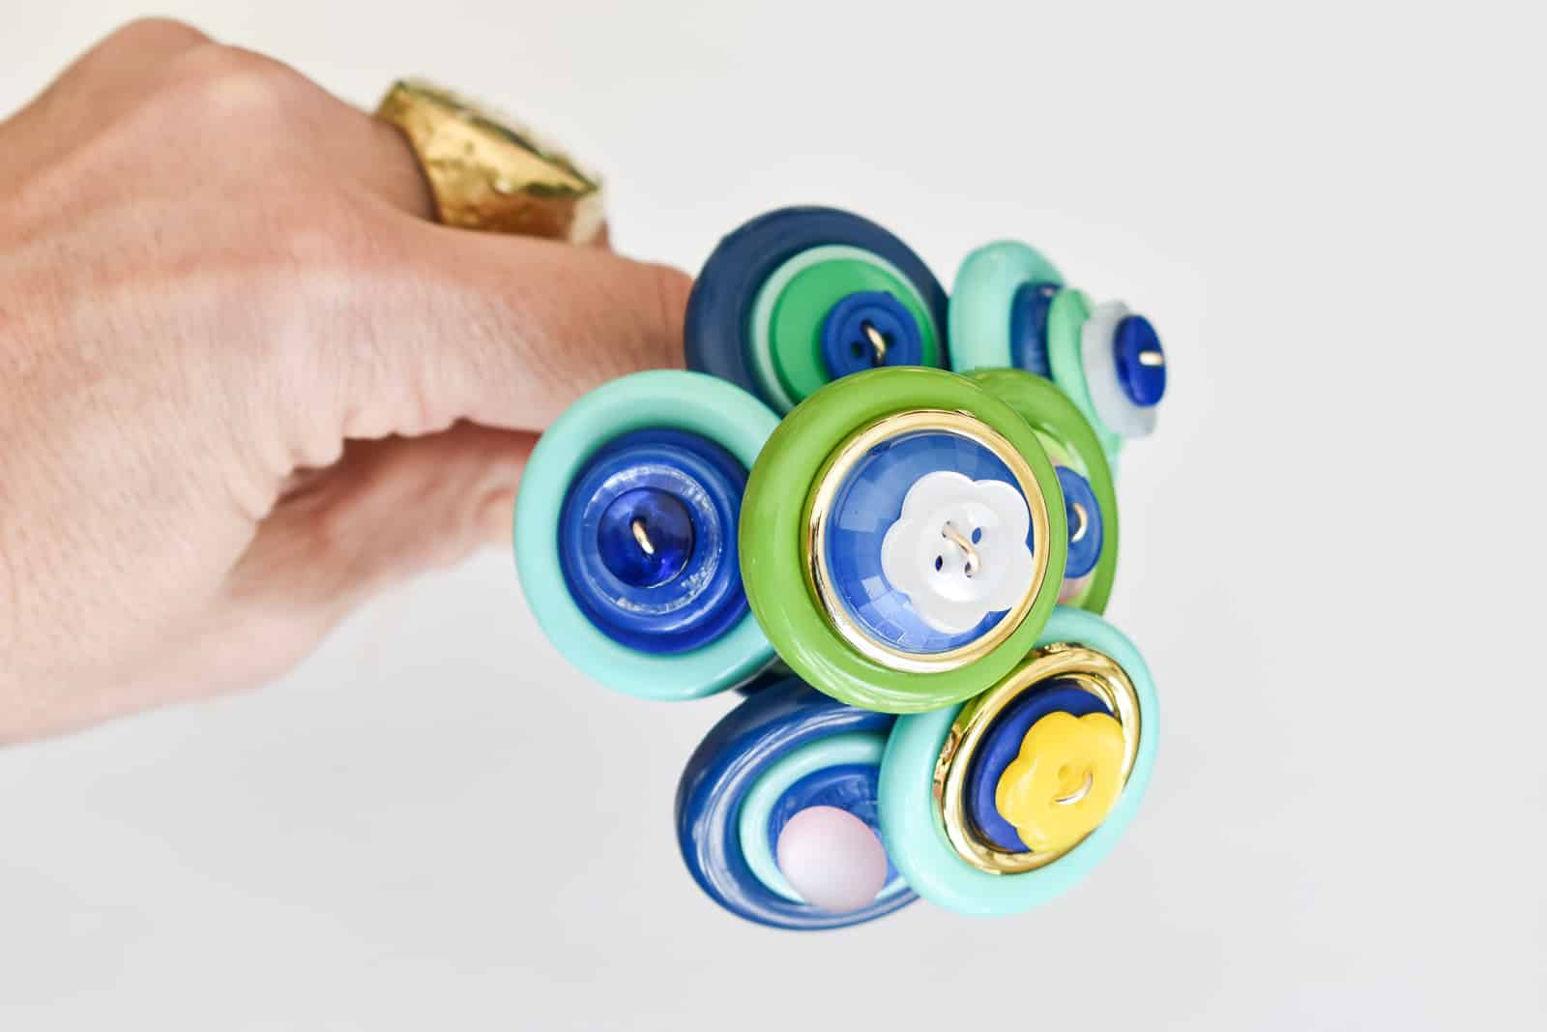
STEP 3. ASSEMBLE THE INDIVIDUAL FLOWER STEM
