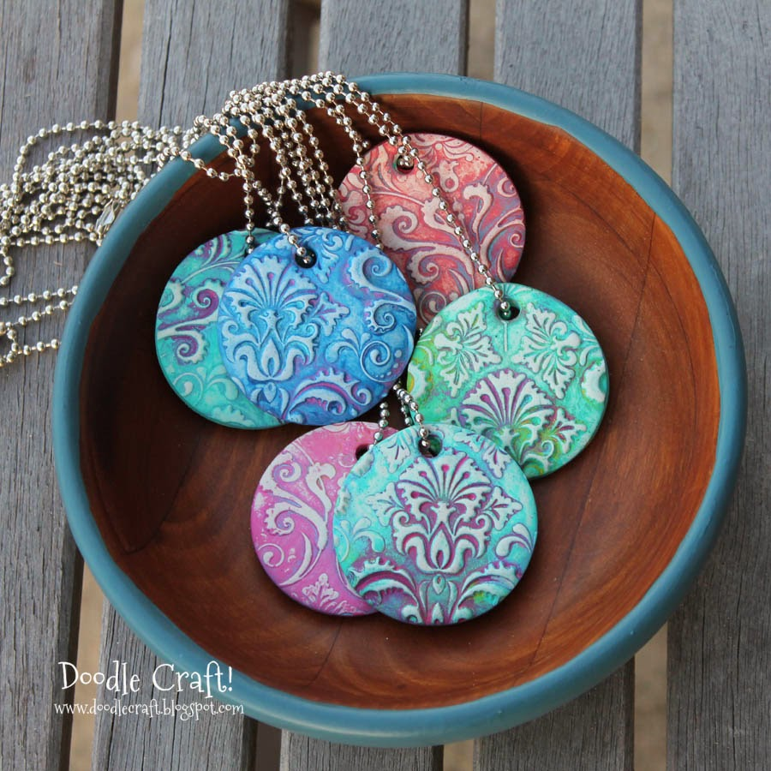
Damask Polymer Clay Pendants
Supplies Needed:
- Oven Bake Clay
- Rubber Stamps
- Circle Cookie Cutter
- Acrylic Paint
Instructions:
Soften and roll out some clay about 1/4" thick.
Stamp an impression on the clay
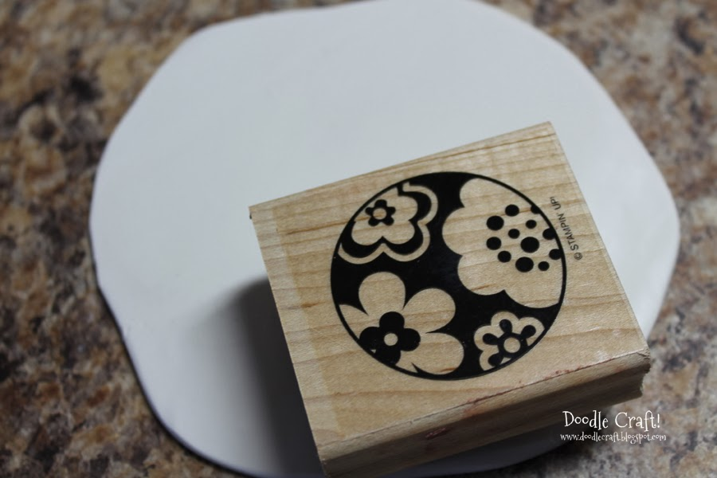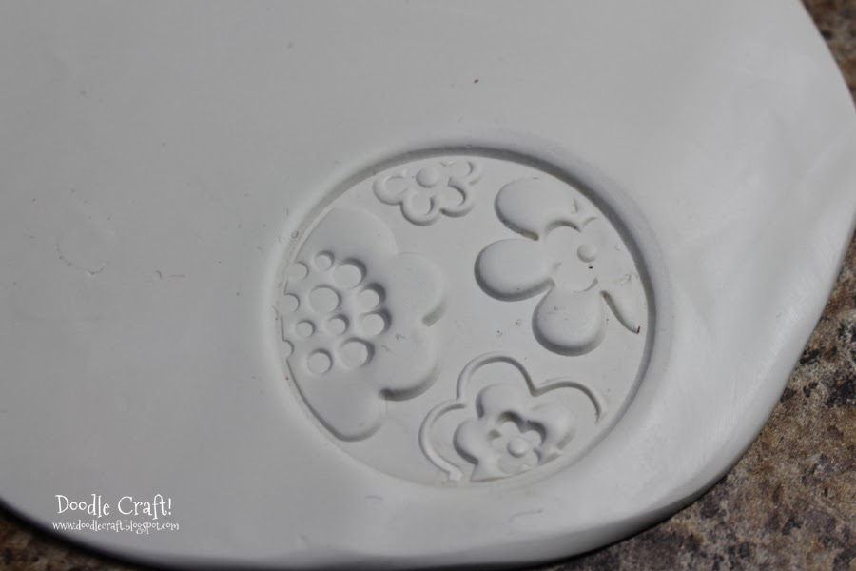
Use a cookie cutter to cut the clay
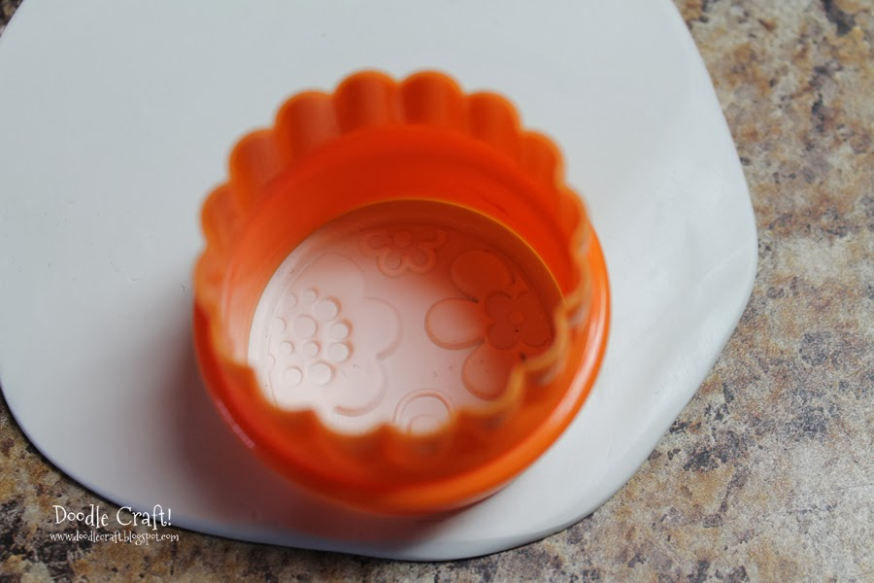

Add a necklace hole with a straw
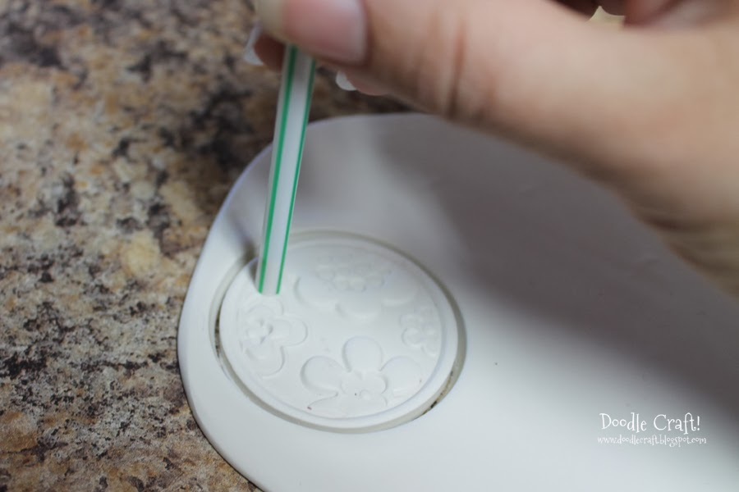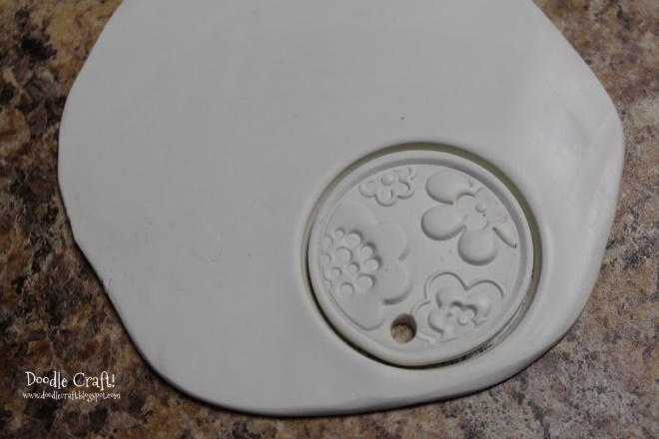
Place on a tray and bake according to package directions.
Now it is time to paint!
Start by giving each pendant a base coat...and let it dry.
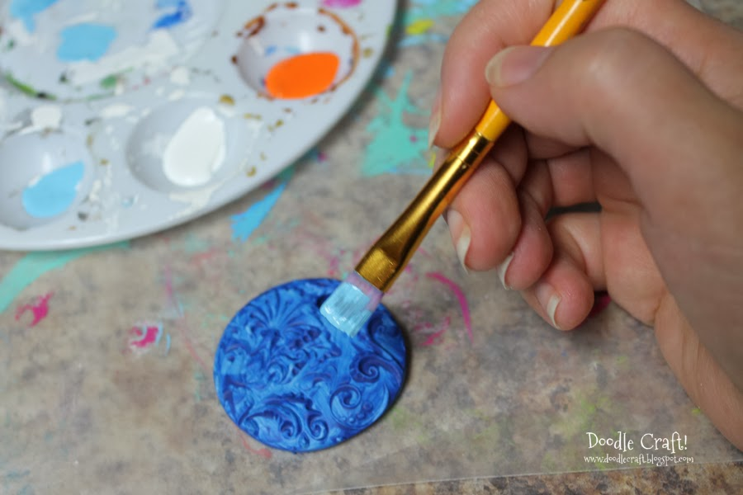

Dab another color on it and get down in all the cracks.
Just over part of the pendant.
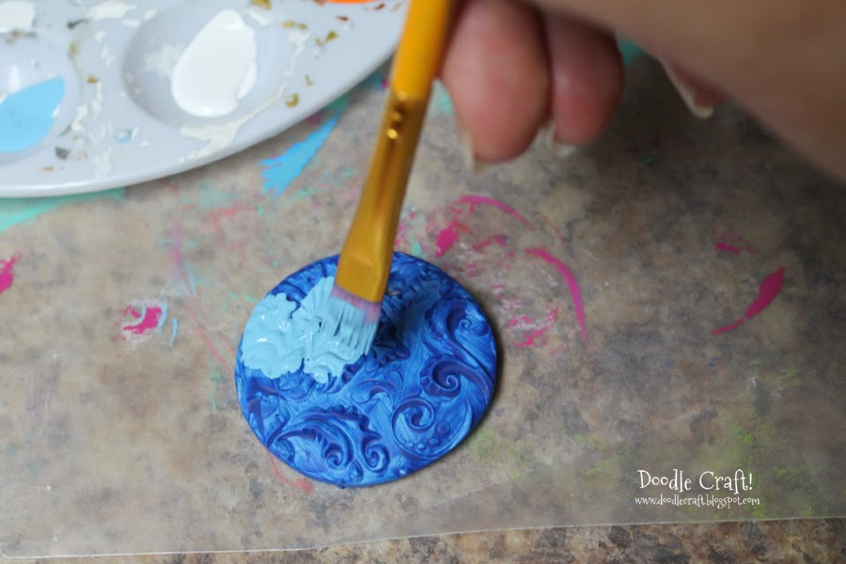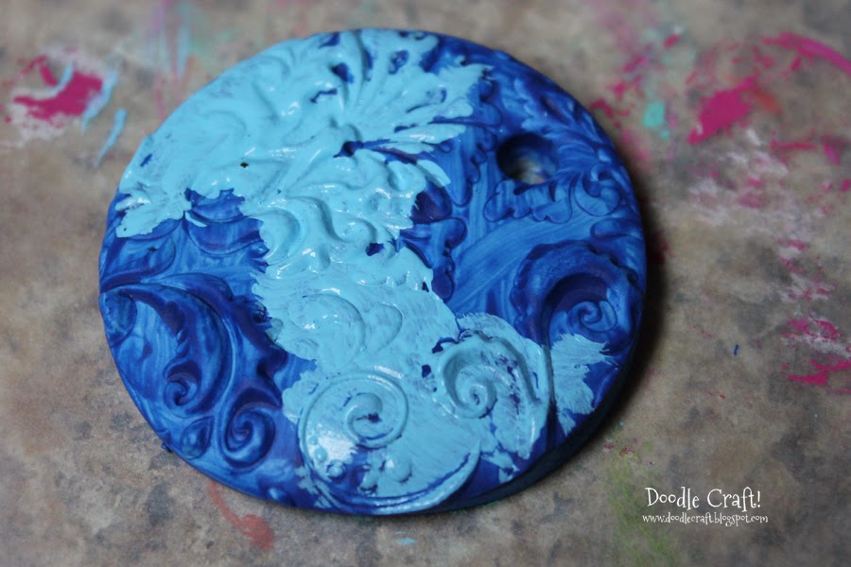
Then use a damp cloth and wipe off the top surface of the paint.
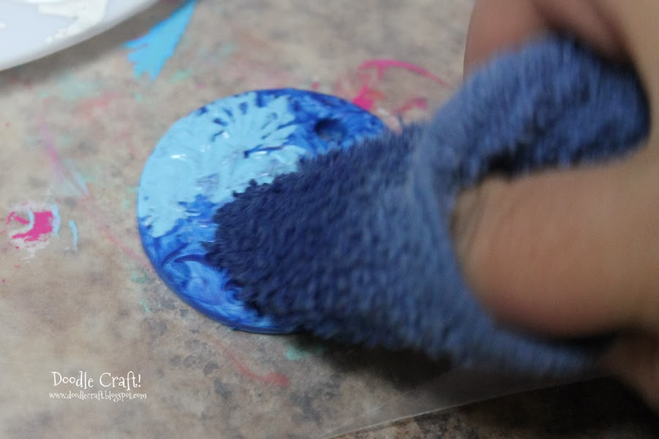

Add on some more paint, in another color!
Wipe again.
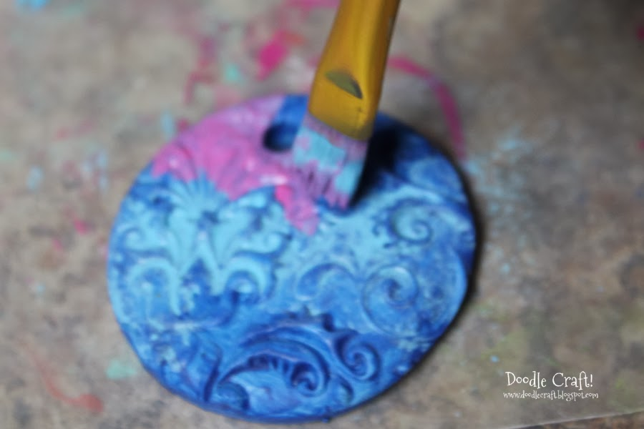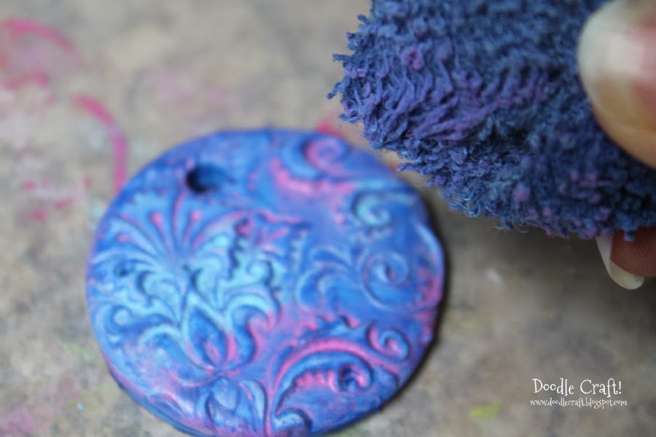
Keep it like this...
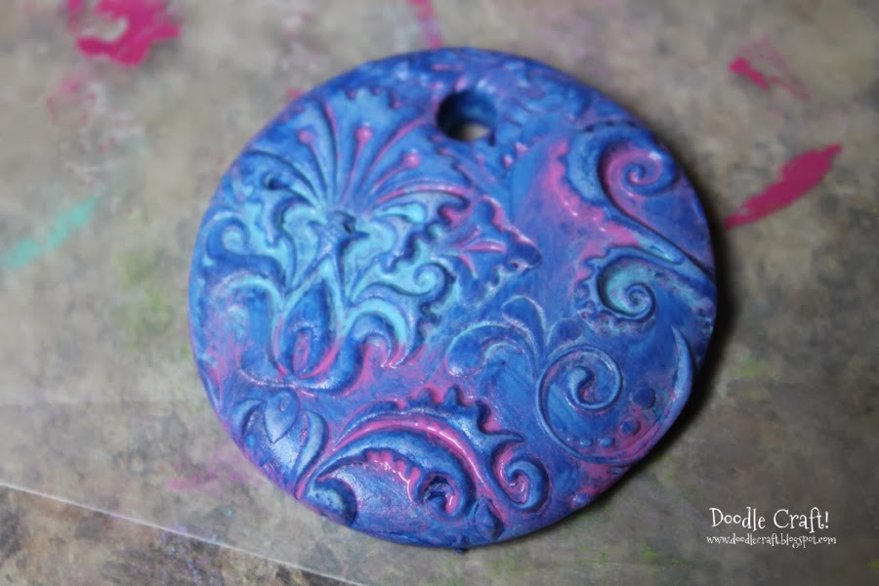
Or keep wiping and the paint on the highest surface will wipe off and show the white clay again!
