Design Your Own Jingle Dress Instructions
Supplies Needed:
Paper Template
2 12 inch pieces of ribbon
Silver Sequins (included in a baggie with googly eyes)
Liquid Glue

- Choose your paper template to use as a base. Included are two templates, one on a white sheet and one on a piece of colored paper. If you want to just use crayons/pencils/markers I would recommend using the white sheet. If you would like to add designs with ribbons and other colored paper I would recommend starting with the colored sheet.
- Add your designs. Included are examples of various jingle dress designs. Keep in mind there is normally a use of lines in the skirt of the dress. This is why I have included the ribbon that can be affixed to the dress. Tailor the activity to your child’s skill level by deciding how difficult or easy you want to make the activity
- Last, but certainly not least, add the sequins. The sequins are being used to represent the jingles on the dress, so they’re the most important part! You can add as many or as little sequins as you want, as jingle dresses have a various number of jingles.

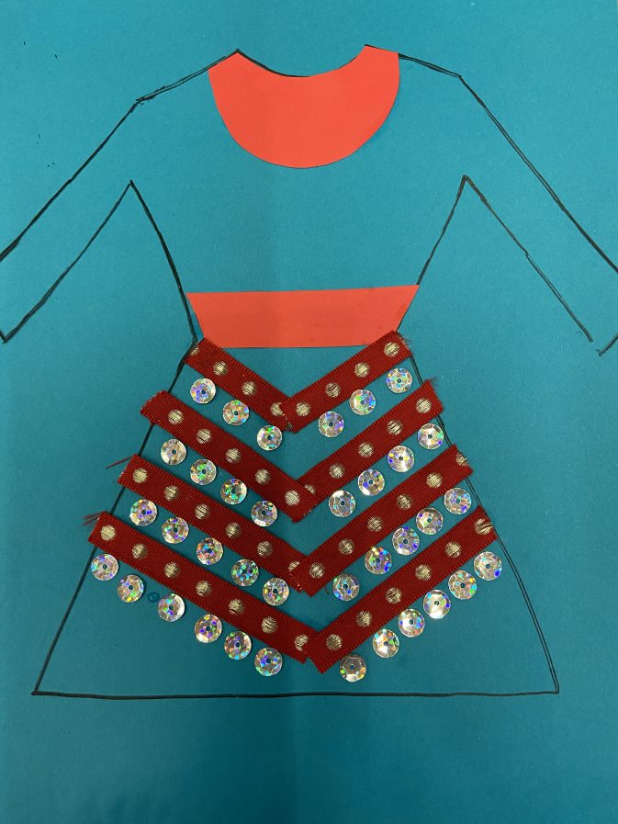
On the following pages you will see examples of various Jingle Dresses (you can also see them in the powerpoint Learn to Dance Like an Ojibwe Jingle Dancer). When you look at them you will see that they vary greatly in color, number of jingles, and even basic pattern. Each dress is unique to the dancer who wears it.

On the Left: This a completed design using the template printed on colored paper. It is very simple just using ribbon, sequins, and cut out paper of a different color.
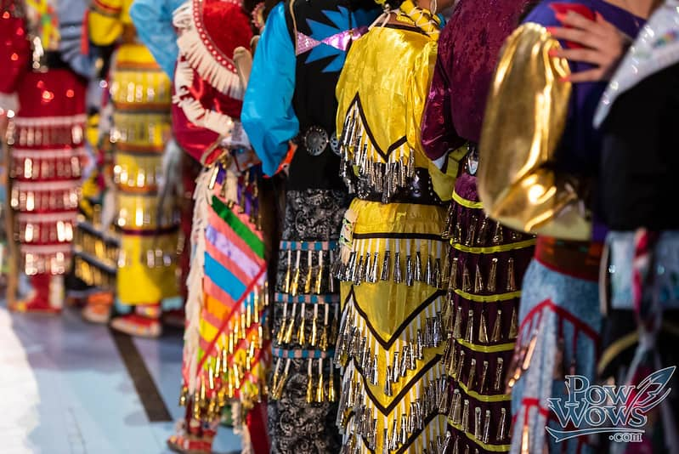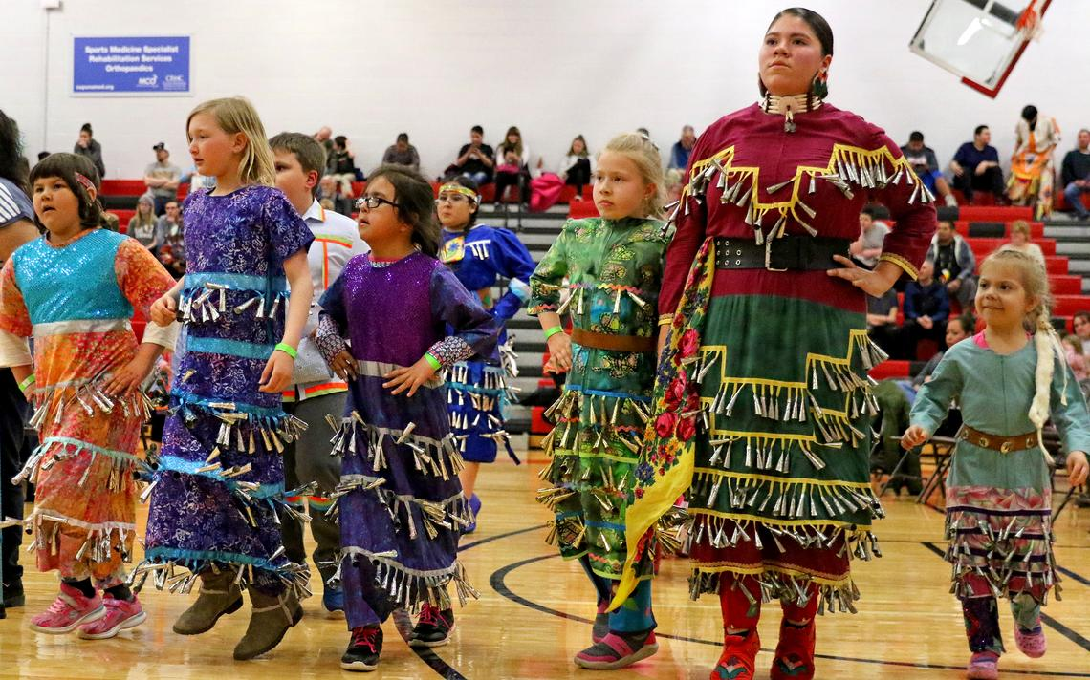

Top: https://www.powwows.com/jingle-dress-dance/
Bottom: https://www.brainerddispatch.com/news/4772169-Dressmaker-showcases-iconic-regalia-of-Ojibwe-heritage
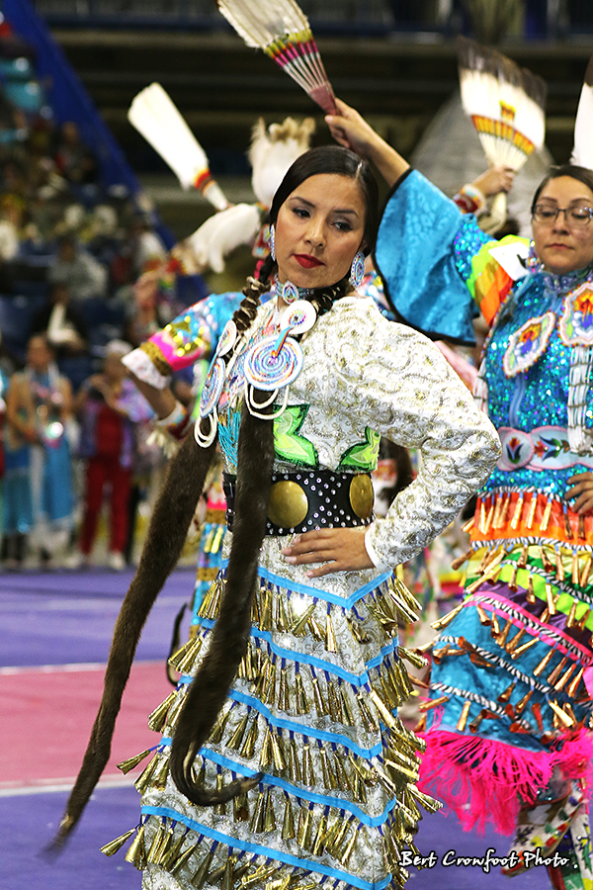https://www.ammsa.com/publications/windspeaker/healing-gift-jingle-dance
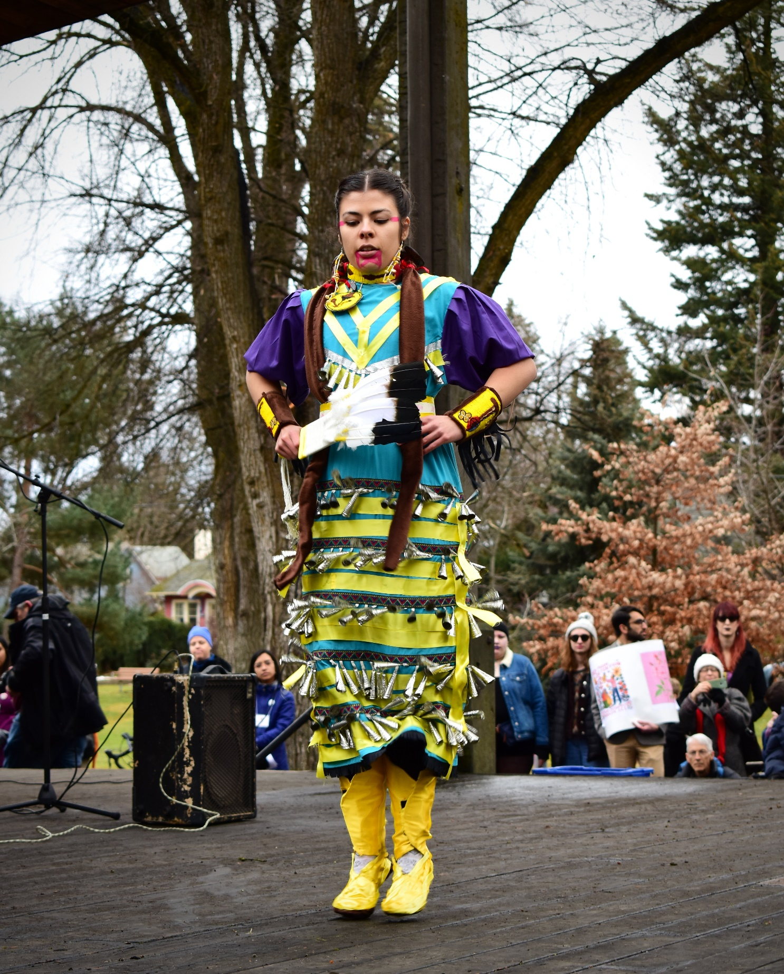
https://www.uiargonaut.com/2019/01/27/the-women-dancing-the-jingle-dress-dance/

