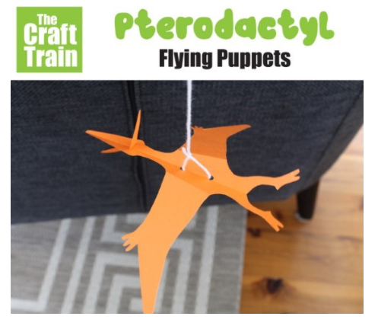
You will need
- String
- A long craft stick or dowel rod (or any stick really)
- A hole punch and scissors
- Tape
- The free printable template below printed out on heavy paper or light card stock – mine is 160gsm which is about the maximum weight that will go through my ink jet printer. Alternatively print it out on plain paper and trace the shape onto a heavier piece of card stock.

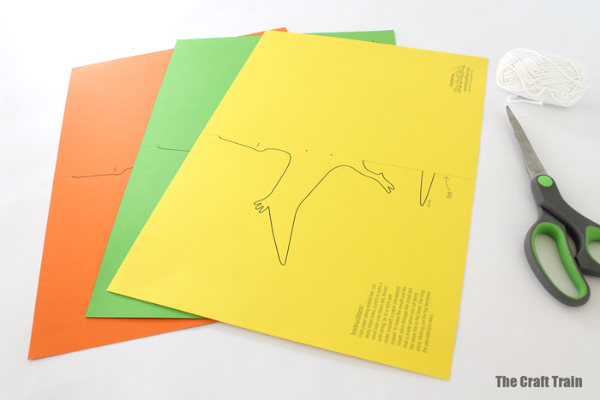

How to
To begin with score the fold line with a blunt knife (like a butter knife) and ruler. This might sound a bit weird and unnecessary but it gives you a really perfect, clean fold. You will find it’s really easy to fold after scoring the line and it helps for this project because the Pterodactyl balances on a single string so any unevenness might cause it to tilt off balance and not work properly.
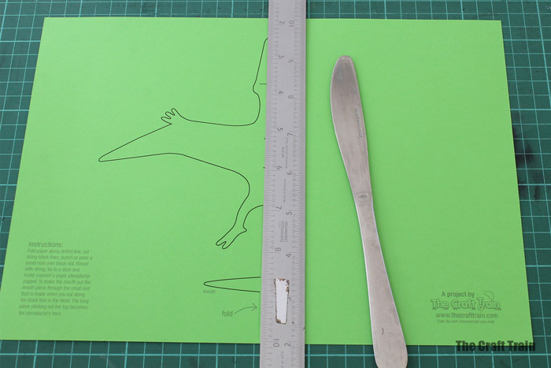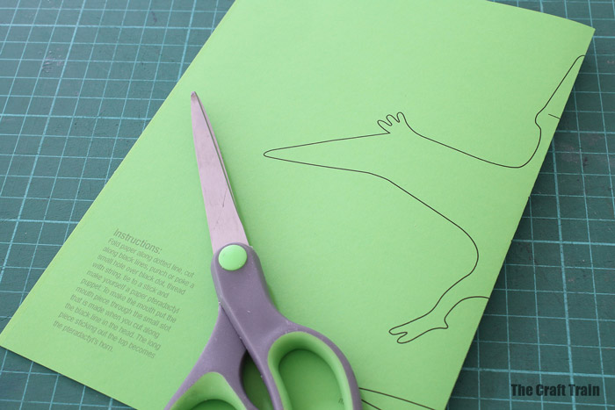
Once it’s folded, cut along the black line with a pair of scissors, including the slit on the head and the extra mouthpiece on the bottom of the page.
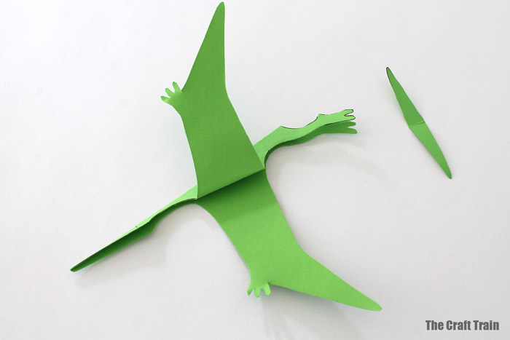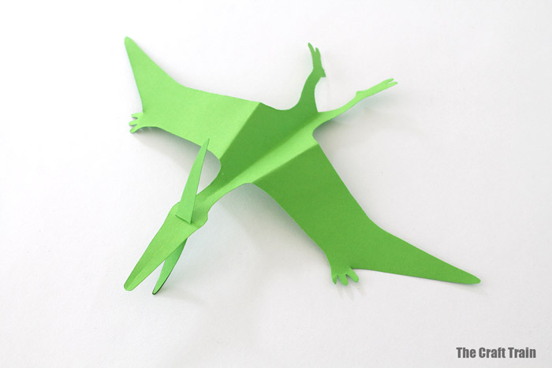
Fold the wings down evenly. The mouthpiece goes through the slit with half of it sticking out the top for the spike on the back of the Pterodactyl’s skull.
Use a hole punch to carefully make two holes over the dots marked, trying to keep them right on the fold line to keep your puppet balanced.
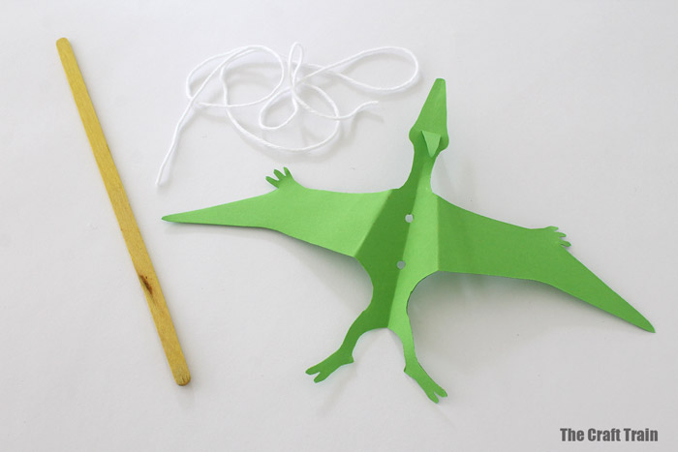
Then tie the string through the two holes and onto the stick and you have your puppet!
If you find that your puppet won’t balance properly you might need to add a small piece of tape underneath on its belly to keep the string in place. I made about six of these and only one actually needed the tape.
