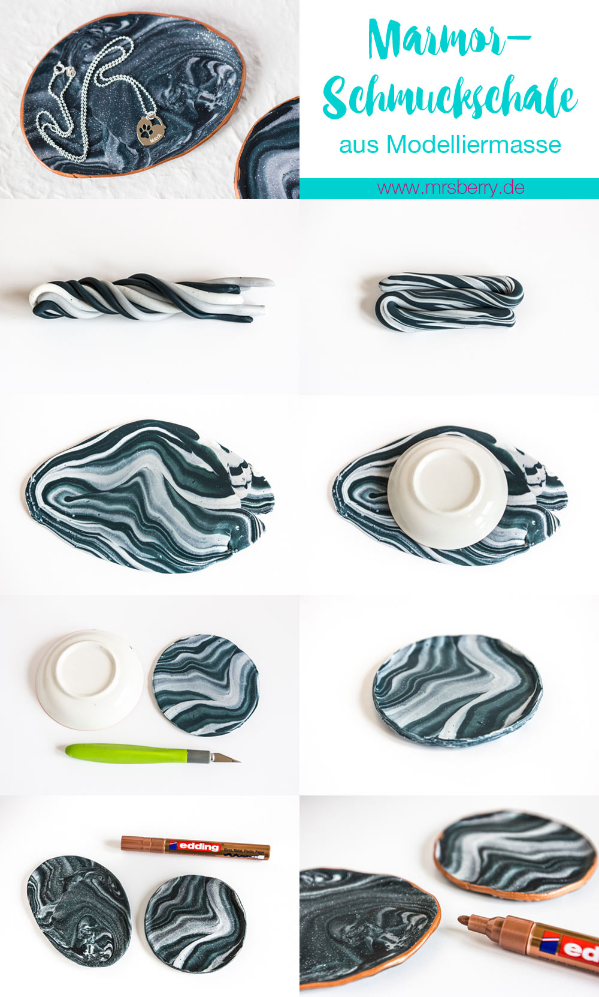

- Knead the polymer clay really soft. Here you have to persevere, even if it is exhausting. The softer the modeling clay, the easier it is to process it.
- Roll individual rolls of each color on the table top.
- Twist all the rolls together like a spiral and knead into a mass. Halve the newly created roll and twist it like a spiral. Repeat this process until you have the desired marble effect.
- Then roll out the modeling clay evenly about 4 mm thick and cut out circles or cut out with a cutter scalpel. A glass or a small bowl can be used to help create a round circle.
- If necessary, neaten the edges and gently press upwards with your fingers to create a small edge.
- For the second jewelry plate, I did without the round cut-out and left the jewelry plate as oval as the rest of the modeling compound rolled out. To be honest, I like it much better that way.
- Place the jewelry plates on a baking sheet lined with baking paper, heat the oven and let the mixture harden in the oven according to the instructions on the packet.
- Be careful, the jewelry plates are still very hot. Let them cool before you decorate the edge with the touch-up pencil.

