Rings & Hair Pins
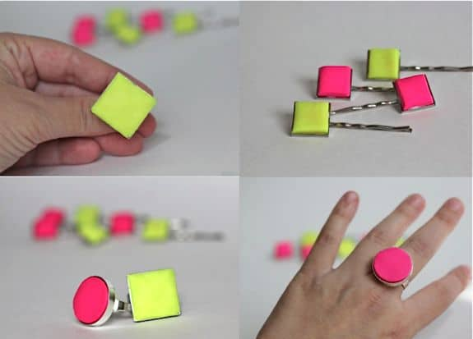
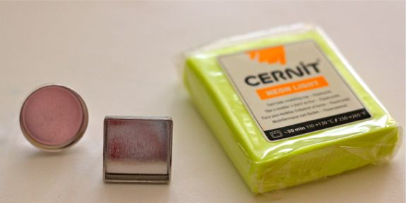

Supplies needed:
- Clay
- Square or circle rings with recessed base.
- Glue
Instructions:
- Knead the clay until it softens Then turn over your ring and press into the clay.
- Cut out the shape with a smooth knife and trim until it fits into the ring.
- Bake according to clay package directions.
- When it comes out of the oven, make sure it easily fits into the ring. While it’s still hot you can trim to fit if needed.
- Once it cools, glue into place.

