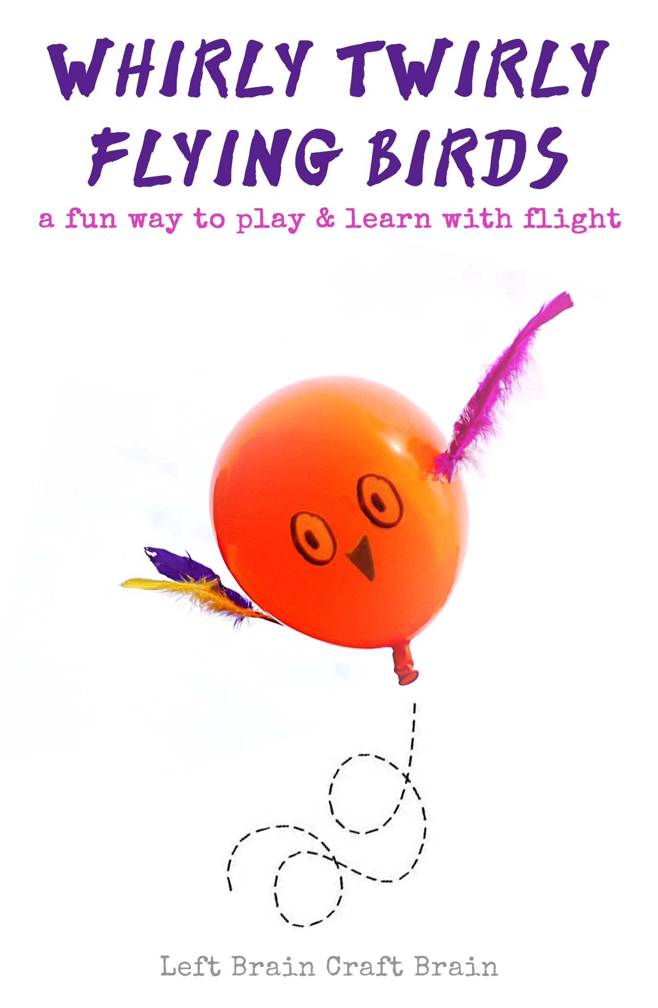
There’s something magical about flight. It’s the power of science and engineering mixed with the magic of nature. These Whirly Twirly Flying Birds can help kids learn the principles behind how birds (and airplanes!) fly. How do Birds Fly? Birds use two things to make themselves fly. The first is lift. When air quickly moves across a bird’s wings, it creates a difference in pressure between the top of the wing and the bottom of the wing. The slow- moving air under the wing wins out in the high- pressure war, causing the wing (and the bird!) to rise or lift.

The second thing that makes birds fly is thrust. In order to get that fast-moving air on the top of their wings, birds flap them. As they push their wings down creating thrust, the air speeds up and lift takes place.

We’re going to artificially supply our birds with some thrust and lift. It’s coming from a balloon and some feathers.

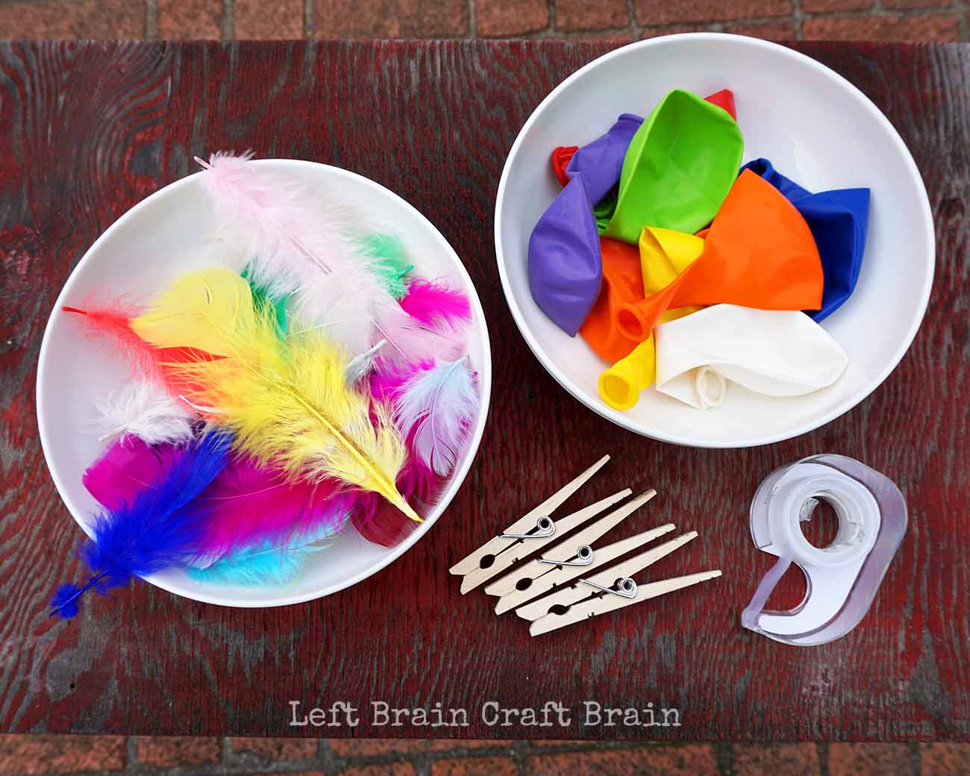
Supplies Needed
- 12” Balloons
- Clear tape
- Clothespin
- Feathers
- Sharpie marker

Make the Birds
First, blow up the balloon, twist the neck of the balloon closed and clip with a clothespin. Then draw your face on the bird. Next, pick two feathers for each wing and tape ends onto balloon. Don’t add too many feathers or the birds won’t fly as well because they’re too heavy. Safety Note: Be sure to account for all the deflated balloons as they can pose a choking hazard if swallowed.

Let the Birds Fly
Now comes for the fun part! Take the bird outside (if you’re not already there), unclip the balloon, and toss it upwards in the air.
Why it Flies
The thrust from the balloon happens because the rubber of the balloon wants to return to its natural, un-stretched state and pushes the air out. The escaping air puts a downward force on the outside air, pushing the balloon upwards. As the balloon rises from the downward thrust of the air, some fast air moves across the feather wings of the balloon giving it even more lift.

Think Like an Engineer
This is a good time to think like an engineer and start learning from trial and error. Some questions to ask:
- Does the placement of the feathers make a difference in how it flies? Which works best?
- How many feathers does it take to make the bird too heavy to fly?
- What type of release gives the bird the most lift?
- Why did the balloon pop when it hit the bush? :)
Here’s a quick video of “the birds” flying at a park. For reference, that big tree in the background is at least a hundred feet tall. It’s amazing how far the birds flew before they lost all their thrust power.
https://youtu.be/RiHPrO2s1Js

Why Do Balloons Spin When They Deflate
The biggest question kids usually have while doing this activity is why the birds spin instead of going straight up and down. For the bird to fly in a straight line, the air rushing out of the balloon would have to create a force exactly in the center of the balloon. But because the neck of the balloon is flexible, it wobbles with the force of the releasing air. Thus, the force is never quite in the middle, causing it to rotate. In theory, if you put something with a bit of weight on the nose of the balloon, directly opposite the neck, it should fly in a straight line.

FEBRUARY 22, 2015 BY LEFTBRAINCRAFTBRAIN

