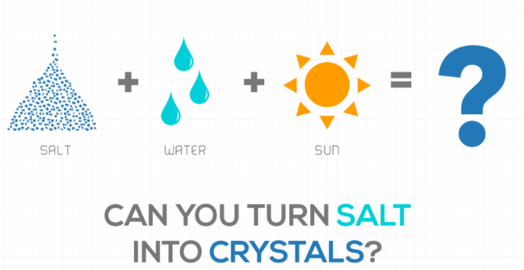
Winter is the perfect time to do fantastic frozen science! The days can often be rainy, snowy and dreary, but this CRYSTAL SUNCATCHER captures the winter sun so beautifully you'll want to hang one in every window and on every tree. Supplies:
¼ c Epsom Salt (provided)
¼ c Hot Water (either from the tap or microwaved for 20-30 seconds; you want it uncomfortable to the touch, but NOT boiling)
Liquid watercolor or food coloring (optional)
Clear recycled plastic lids (the clearest you can find; the kit contains two, but more are better! Yogurt or Pringles lids work great.)
Glass measuring cup (preferred for pouring) or bowl
Mixing utensil
Tray
String (provided)
Exacto knife/pin/hole punch
Magnifying glass (provided)
What to Do:
When Epsom salt is added to hot water (colored or clear), poured into a clear lid and stored in the fridge for a day or so, hundreds of delicate crystals will form.
You will be using a ratio of 1:1 water (H2O) to Epsom Salt (magnesium sulfate) for this project.
Watch the video demo https://www.youtube.com/watch?v=BoQdd0tbaBE (1:06 by Epsom Salt Council) and read through WHAT TO DO and TIPS before you begin.
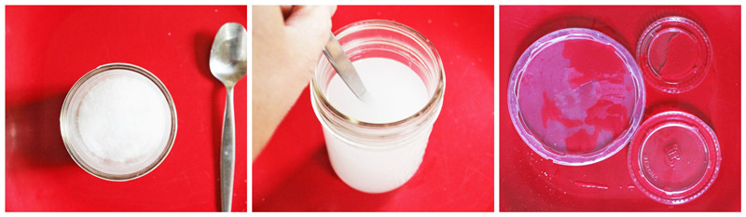
1. Pour ¼ c of water into a microwave-safe glass measuring cup or bowl and heat it in the microwave for 20-30 seconds until the water is very hot. Alternatively, use very hot tap water and skip the microwave. Very hot water will dissolve more salt than cooler water.
2. Add ¼ cup of Epsom salt (the amount in one of the condiment cups) to the very hot water in the glass measuring cup or bowl. Do this quickly so that the water is still very hot. Stir the salt and water for 1-2 minutes until the salt is dissolved. It will seem like a long time, but it’s important to keep stirring until all the salt (solute) has dissolved into the water (solvent) to form a super saturated solution.
3. Add a few drops of liquid watercolor or food coloring (if desired) to the solution and stir well.
4. Place several clear plastic lids on a flat-bottomed tray, so you can transport them without spilling.
5. Carefully pour the super saturated solution into the clear plastic lids. Use just enough to cover the bottom of the lid. DON’T OVERFILL! If you have extra, you can pour it into a glass jar to grow a crystal “garden” in the same manner as the suncatchers.
6. Place the tray with the lids in the freezer for 10 minutes, then transfer it to the back of your refrigerator. You might want to put a sign on it reading, ‘Danger! Science Experiment! Do Not Drink!” just in case someone is thirsty ;)
Depending on how much liquid has been added, it will take a few hours to a day or two to start crystallizing. They might look like lids full of water at first but be patient! The longer you leave them in the refrigerator, the more crystals will form.
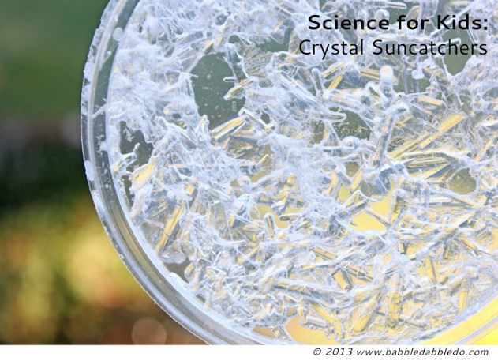
What’s happening? As the solution cools and evaporates, there is less room for the dissolved Epsom salt in it, so the (magnesium sulfate) atoms bump into each other and join together in needle-like crystal structures.
7. When the liquid has completely evaporated (or when you carefully drain off any remaining liquid), your crystal sun catcher is ready! You will be able to see lovely crystal structures from both sides of the lid. DO NOT leave liquid in the lid once you remove it from the refrigerator or your crystals will re-dissolve!
8. The crystals are small and thin and numerous, but they are also VERY delicate and can crumble easily. Get adult help to carefully poke a small hole in the edge of the lid and thread a piece of string through the hole. Tie a knot and hang up your sun catcher!

Tips:
*Instead of filling the clear lids first, try pouring the solution into a glass jar to make a crystal “garden.” Freeze for 10 minutes and refrigerate overnight as instructed above. Then, carefully drain off the cooled excess liquid and pour it into clear lids (remember not to overfill). Set the lids on a tray in a VERY sunny location where they won’t be disturbed. Leave them there (about a week) and watch as the water completely evaporates leaving crystals behind. Meanwhile, enjoy looking at the crystal garden in the bottom of your jar.
*You have a second condiment cup (¼ c) of Epsom salt as a backup, but you can grow more suncatchers or crystal gardens by (re-)using any leftover supersaturated salty solution from your first batch or any that you drain off a crystal garden. In addition, if your crystals fall apart or you’re not pleased with the result of your experiment, you can always mix them into an equal part of very hot water and try again! In other words, you can regrow crystals over and over.
* Over time, your crystals will begin to dry out and harden even more. Eventually they will whiten as the salt dries out completely. These suncatchers will have a limited lifespan, but left undisturbed, the crystals should last months or more!
*Use the magnifying glass to closely examine the crystals. Notice that while some are larger than others, they all have the same shape. How many sides does each have? Do they end in a point or a flat face? Look at sugar or salt crystals with your magnifying lens too. How do their shapes compare to those of the Epsom salt crystals?
Extend & Reflect:
1. How would the experiment change if you used a larger or smaller lid or jar?
2. How would the experiment change if you used slightly warmer or colder water?
3. Have you ever seen crystals like this outside on a cold winter day? Where did you see them, and how do you think they formed? How are they similar to or different than the crystals in the experiment?
4. If you added color, what color made the crystals stand out the best?
5. Try setting the tray in a sunny location instead of using the freezer/frig method. Did the crystals grow faster or slower in the sun versus the refrigerator? Why do you think that is? How do you think the sun is involved in crystal formation?
Credits:
https://babbledabbledo.com/science-kids-crystal-suncatcher-craft https://thehappyscientist.com/content/growing-crystals-solution https://www.youtube.com/watch?v=Vl2iY-rcLcM (Adler Planetarium)

