THE RIGHT WAY TO MAKE A PAPER SNOWFLAKE
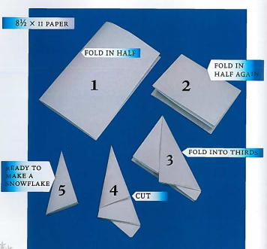
The Six-fold Way
Cutting paper snowflakes is great fun, but you really ought to make them six-sided, like real snowflakes. Real snowflakes are never eight-sided.
This picture shows how to fold a piece of paper to make a proper six-sided snowflake. Starting with an ordinary piece of 8.5x11 paper, first fold it in half, then fold it in half again.
Next is the tricky part; you have to make a 1/3 fold as shown in the third picture. After that, fold the remainder over the first third, cut off the excess, and you are ready to start creating your own paper snowflake.
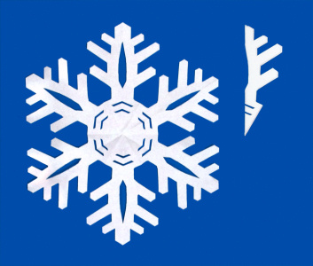
Making Anatomically Correct Snowflakes
Now here is your next challenge -- instead of making random cuts here and there, try cutting your folded paper to make something that has real snowflake features. In the example on the left, note the two concentric hexagons in the center of the flake, the central ridges on the arms, and sidebranches coming out from the branches at 60-degree angles.
This paper snowflake looks like a real snowflake!

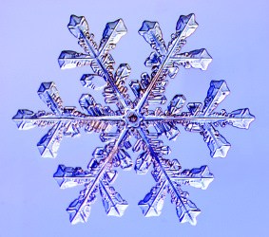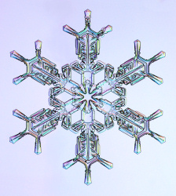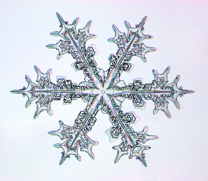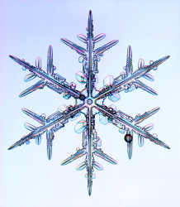
Some Practice Snowflakes
Here are some actual snowflakes for you to practice on. Your mission is to cut paper snowflakes that look like these. In addition to getting the outlines right, try putting in some cuts to display the internal features of each crystal, as I tried to do in the above example.
Good luck, but be warned ... cutting anatomically correct snowflakes is not as easy as it sounds!

