Truck Ornament Instructions
Supplies Needed:
Large popsicle sticks (I have precut them for you)
1 small Popsicle Stick
Glue
-I did not include glue in this kit. You can use a variety of types. I made my example using school glue because it is the most commonly available. However, you could also use wood glue or hot glue. Hot glue would be the fastest and holds up quite well. I did not include glue because I assumed some people would use that option instead.
Twine/String
1 green pipe cleaner
Decorative paper or a small photo

*In my instructional pictures I have used plain popsicle sticks without color. The finished product I have shown has been colored in with marker. I would however recommend you color the sticks before you start gluing. This makes it easier to get an even coloration.

- To start gather all your large popsicle sticks. You should have two full-sized, one with a flat cut on top, one with a slanted cut on top, a half stick, and a tiny piece.
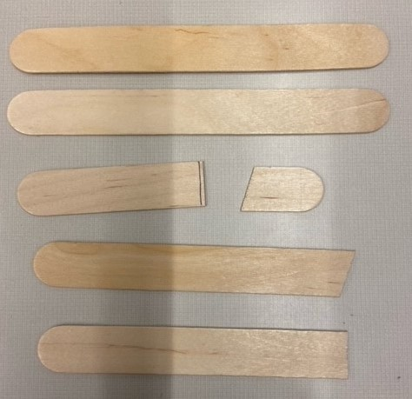
- Color your popsicle sticks whatever color you want. In my example I used a Crayola washable marker, but you could also use crayons if you have no markers available.

- Using the provided template place the stick with the slanted cut and the stick with the flat cut in their places on the template.
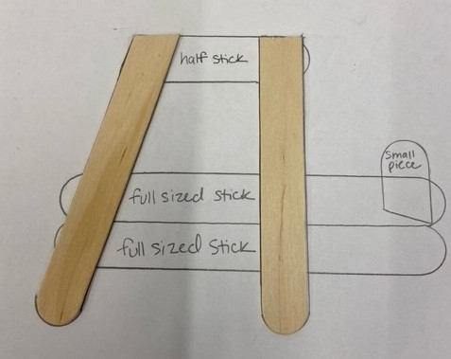
- Place glue where the full-sized sticks will go.
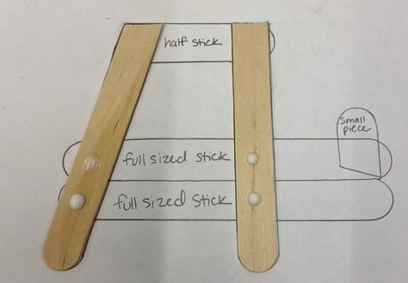

- Place the full-sized popsicle sticks on the glue.
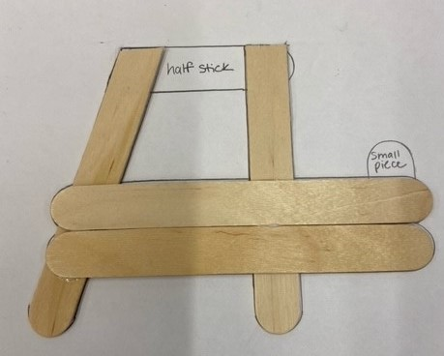
- Glue the on the buttons underneath the two full sized sticks.
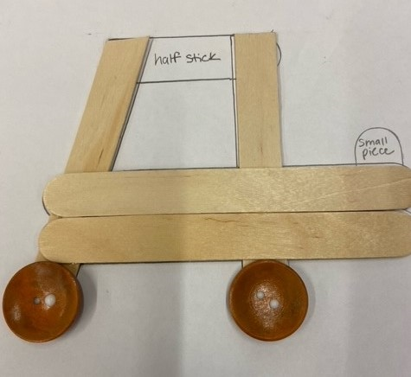

- Glue the half stick into the spot indicated on the template. The half stick serves as the roof of your truck.
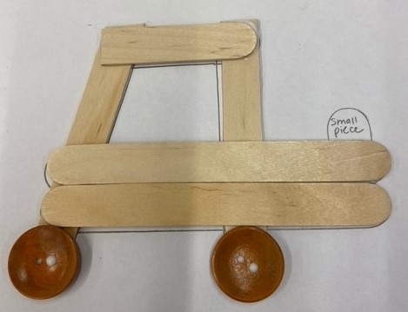
- Allow everything you have glued to dry down. If using hot glue, you may continue to the next step. If using school glue or wood glue wait for the glue to dry enough that you can pick up the truck without the sticks moving.
- Place glue on the small slanted piece. Line the piece up with its matching place on the template.
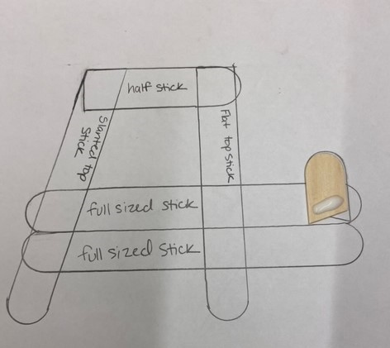

- Match your truck with the rest of the template and press down, making sure to focus on the small “gate” piece.

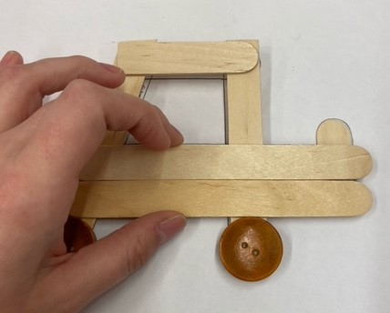

- At this point you can add an optional tree in the “bed” of the truck. If you do not want to do that skip to step 15.
- Grab your small popsicle stick. You can either color the stick dark brown to look like a tree trunk, or you can leave it the natural color for a lighter tree.

- Take your green pipe cleaner. You can do this one of two ways. You can cut the pipe cleaner into small pieces and glue those on the popsicle stick. You can also, bend the pipe cleaner into a tree shape and just slide the pipe cleaner onto the stick.
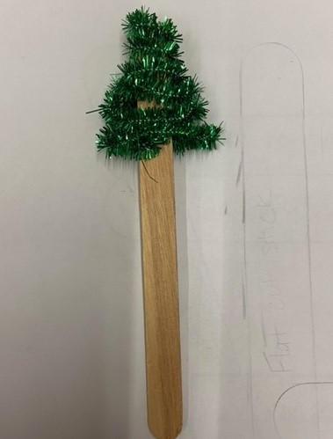

- Place the popsicle stick behind the truck. When you find the correct placement, glue the stick to the back of the truck.
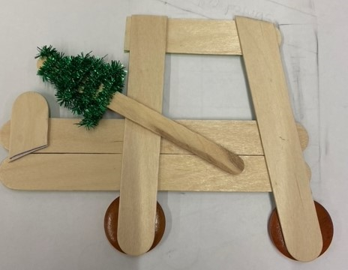

- Glue or tape string to the top of the truck. You don’t have to do this step, but it does make it easier to hang the truck.
- For your final step you can glue or tape a picture in the truck window. If you don’t have a small picture you can use the included paper, or you can leave the window empty.
