Grandma’s Favorite Dishcloth
Size: approximately 8” X 8”
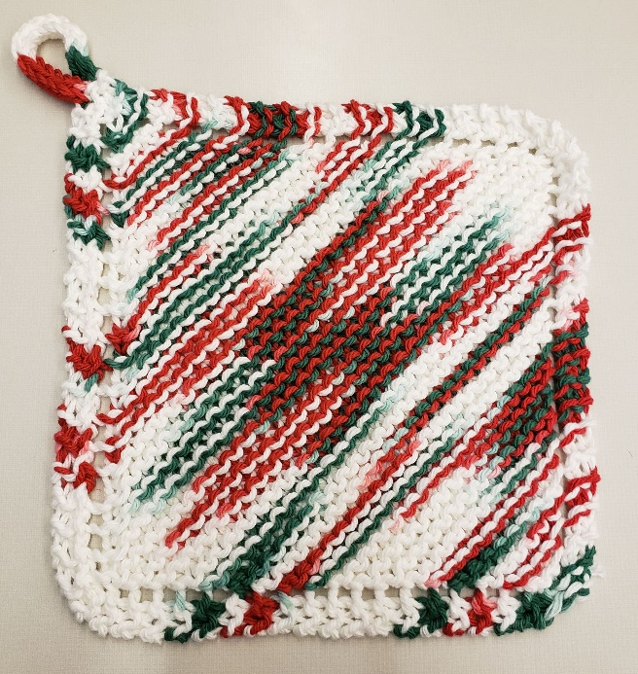
Yarn: worsted weight cotton, about 25g/42yd
Needles: size 8 US (5.00mm), straights or circulars
Washing Instructions: Machine wash and dry.

Abbreviations
BO – Bind off
CO – Cast on
K – Knit
K2tog – Knit two together
YO – Yarn over

Directions
CO 4 stitches. Knit 1 row.
Every following row: K2, YO, K to end.
Repeat this row until you have 40 stitches total on the needle.
Every following row: K1, k2tog, YO, k2tog, K to end.
Repeat this row until you have 4 stitches remaining.

Finishing
BO all four stitches, break yarn, and pull end through last loop to fasten. Weave in ends.
OR
BO 1 stitch.
Knit 16 rounds of I-cord.
BO remaining stitches, break yarn, and pull end through last loop to fasten.
Sew end of I-cord to washcloth to form a loop to hang by.
Weave in ends.

Traditional Dishcloth
Size: approximately 7.5” X 7.5”
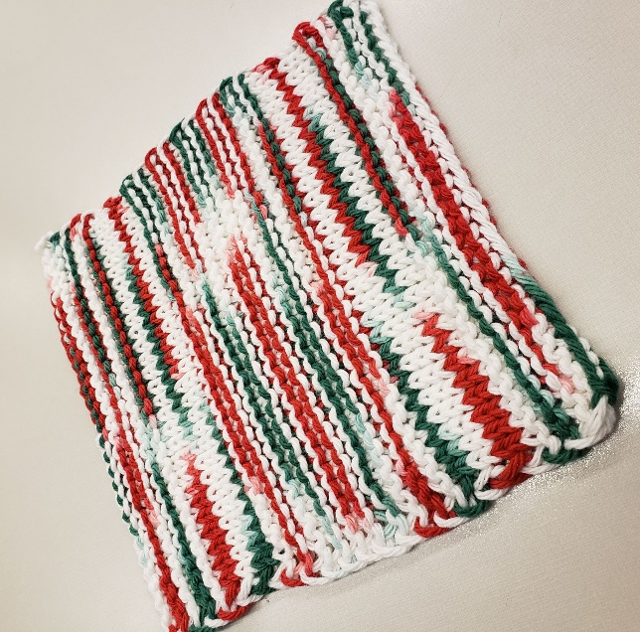
Yarn: worsted weight cotton, about 25g/42yd
Needles: size 8 US (5.0mm) straights or circulars
Washing Instructions: Machine wash and dry.

Abbreviations
CO – Cast on
BO – Bind off
Garter st – knit every row
St st – stockinette stitch, knit the right side rows and purl the wrong side rows)
RS – right side
WS – wrong side
K – knit
P – purl

Directions
CO 32 stitches.
Work 6 rows in garter st.

First stockinette band:
Work 4 rows in St st (k one row, p one row), ending with a WS purl row.

Main body:
Work in garter st until piece measures 5 inches from CO edge, ending with a WS row.

Second stockinette band:
Work 4 rows in St st, ending with a WS purl row.

Finishing:
Work 7 rows in garter st.
BO.
Weave in ends.

