Getting Started with Knitting

How to Make a Slip Knot
Almost all knitting projects start with a slip knot.
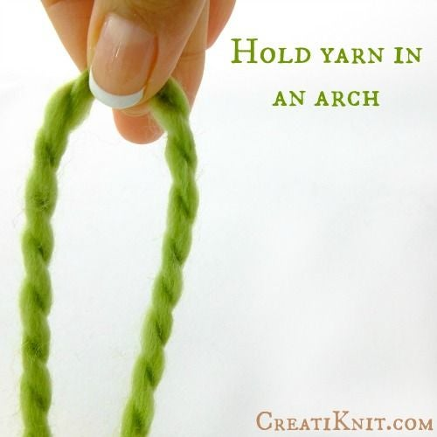
Step 1: Begin by holding your yarn in an arch. Leave a tail long enough for the project you are working on.

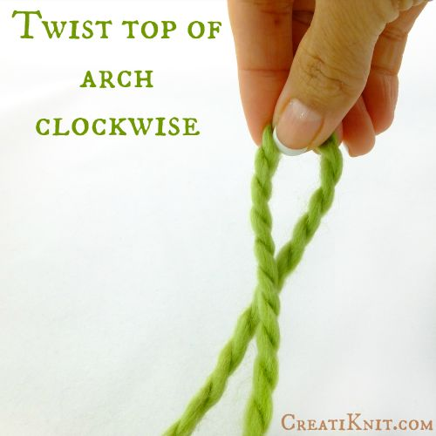
Step 2: Twist the top of the arch clockwise.

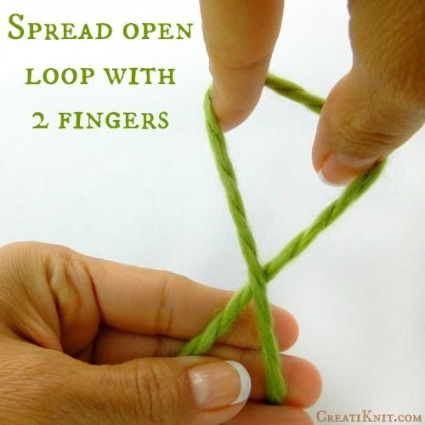

Step 3: Spread open the loop with your fingers.

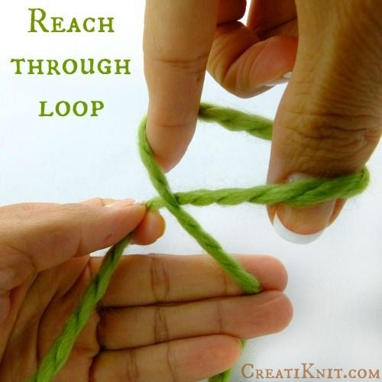
Step 4: Reach through the loop.

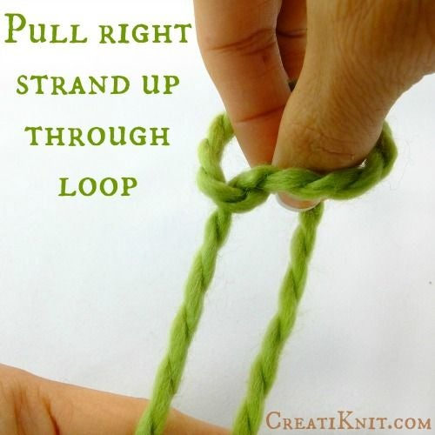

Step 5: ​Pull right strand through the loop.

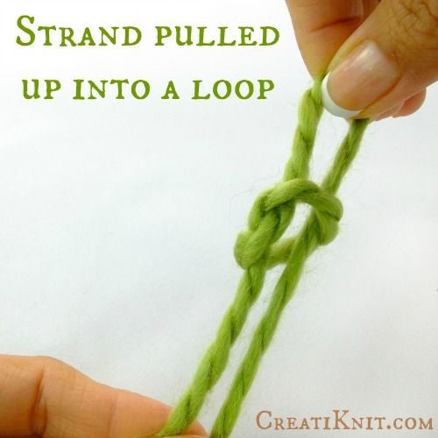

Step 6: This is what it will look like after you have pulled the strand up into the loop.

Once pulled up through loop, leave it loose and do not tighten yet.

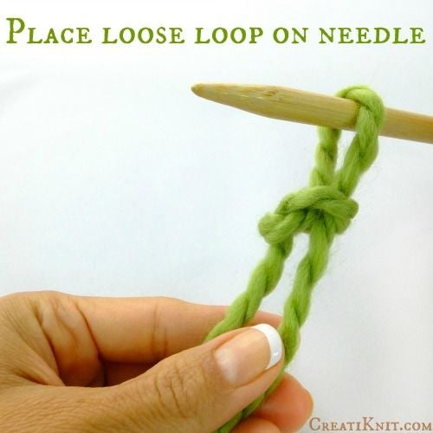
Step 7: Place your loop on your needle.

Casting On
“Casting on” just means getting some live stitches onto your needle to start knitting from.
There are many different ways to cast on. This is the “Knit Cast On,” which I think is the easiest for beginners.

Begin with a Slip Knot
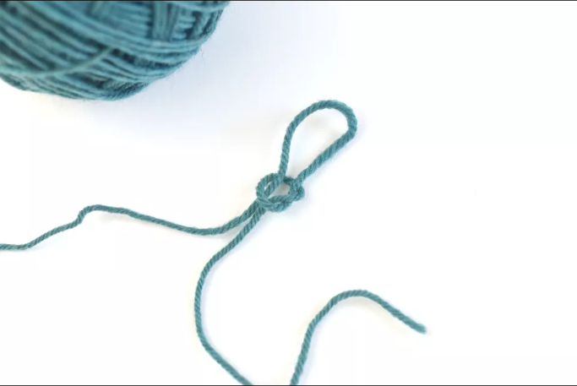
Like most cast-on techniques, the knit cast-on begins with a slip knot.

Open the Loop to Make a Stitch
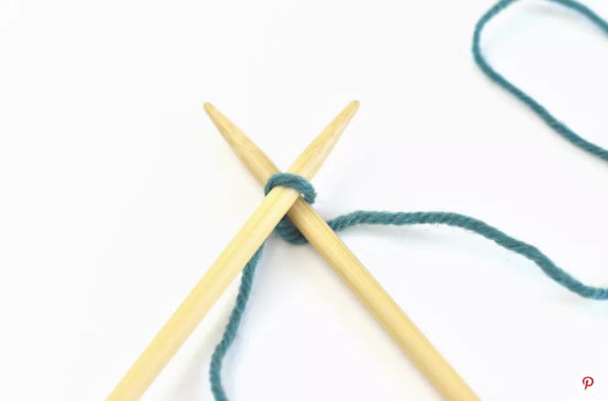
Hold the needle with the slip knot in your left hand and the empty needle in your right hand (if you are right-handed). You can flip it if you are left-handed.
To begin the cast-on, slide the right-hand needle into the loop on the left-hand needle, from front to back. This is known as "opening the loop." This is exactly how you start making a knit stitch.

Wrapping the Yarn
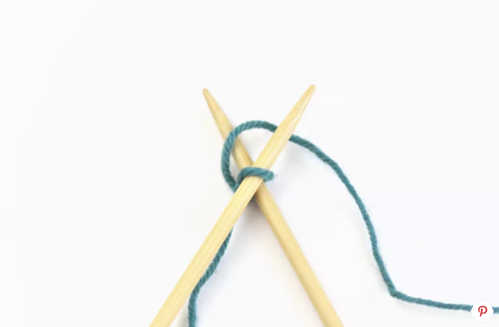
Loop the working yarn (the yarn coming from the ball) over the point of the right-hand needle, going counter-clockwise. Be careful not to loop the yarn over both needles.
Hold the yarn loosely in your right hand. This is known as English knitting, right-hand knitting or "throwing," which is different from continental knitting, in which you hold the yarn in the left hand. You can, of course, do the same thing continental style if that is the method you want to learn.

Bring the Loop Through to the Front
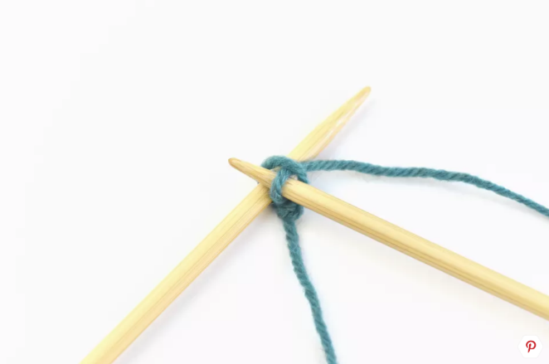
Next, you will bring the looped yarn through to the front.
Keep holding onto the yarn with your right hand so it does not get away from you.
Slowly slide the right-hand needle down so the loop gets close to the tip of the needle without sliding off.
In the same movement, bring the right-hand needle out from behind the left-hand needle.
When the right-hand needle barely comes out from behind the left-hand needle, push the needle in front of the left needle.
The goal of this step is to keep the loop you just made on the right-hand needle while bringing it to the front of the work. The slip knot stays on the left-hand needle.
Although this can seem a bit awkward at first, with practice, it becomes second nature and you will not even have to think about it.

Finish Adding the Stitch
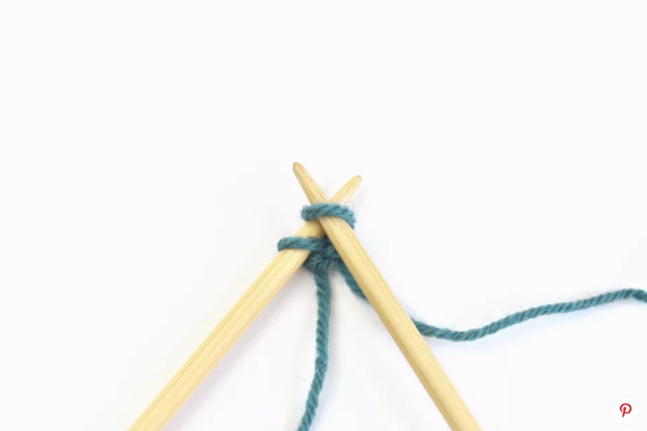
Add the new stitch you just formed to the needle. Slide the loop that is on the right-hand needle onto the left-hand needle, next to the slip knot loop.
Try to pay attention to the direction of the loop as you add it to the needle, keeping it consistent throughout the cast on. Turning the stitches produces different results.

A New Stitch on the Needle
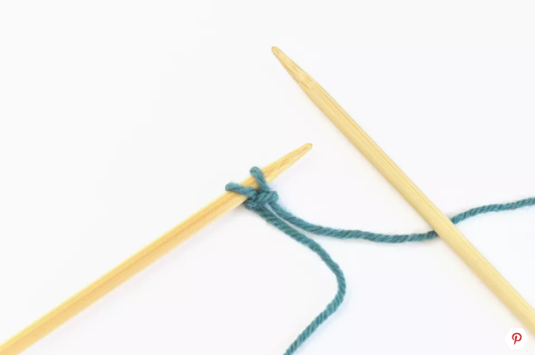
You now have two stitches on the left-hand needle, and you can continue. You will want to repeat these steps until you have the required number of stitches on your needle.
Watch your tension. As you cast on stitches, try not to pull too tightly as you wrap, or your stitches will be hard to work on the next row. Your loops should be tight enough to stay on the needle, but loose enough to slide the second needle through with ease.
This is tightness is called the tension. With more experience, you will learn what the right amount of tension feels like.

Cast-On Stitch Success
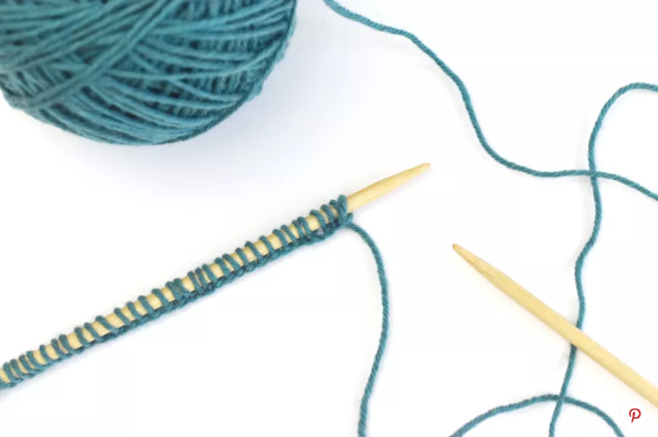
Now that you have all the knit stitches cast on, you can continue with the rest of your project.
Once you feel comfortable with this method, try other cast-on stitches like the long-tail cast-on, the cable cast-on, the wrap cast-on, and the frilled cast-on, to name a few.

The Knit Stitch
This is the basic stitch in knitting. If you knit every row and never use another type of stitch, this is called garter stitch. Make a garter stitch square, and you have a dishcloth! Keep going for 5’ or 6’, and you have a scarf!
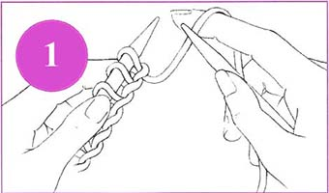
Start by casting on as many stitches as are required by your pattern. Hold the needle with the cast-on stitches on it in your left hand so that the first stitch is approximately one inch from the top of the needle. Loop the yarn that goes from the bottom of the first stitch to ball over the top of the forefinger of your right hand and hold the empty needle in your right hand.

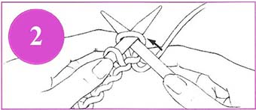
Guess what? You already know what to do next! Insert the tip of the right needle into the stitch closest to the tip of the left needle. This is the same way that you inserted the needle when casting on.

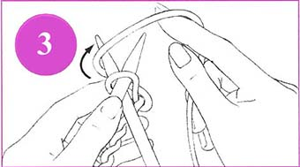
Move your left hand so that both needles are held in your left hand between your thumb and your forefinger. Using your right forefinger, wrap the yarn from the stitch on the left needle up and over the top of the right needle in a clockwise motion (this is the direction that the hands on a clock move). This is the same motion that you used in step 6 in the section on casting on.
Slide the right needle (with the loop of yarn on it) down and towards you through the center of the stitch that is on the left needle.
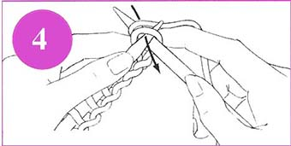
Pull the yarn that is around the tip of the right needle down and through the stitch on the left needle to create a new loop ('stitch') on the right needle. This is the same motion you used in step 7 when casting on.

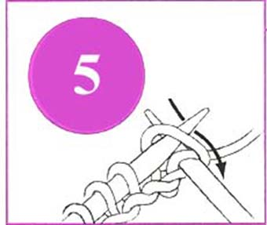
Now for something new! Slip the new stitch and the stitch from the left needle to which it is connected completely off the tip of the left needle.

You now have one stitch on your right needle.
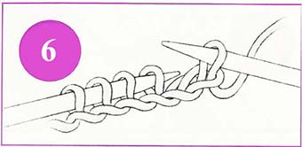
CONGRATULATIONS! You have just knit your first stitch!

Now continue repeating steps 1 through 6 until you have knit all the stitches off of your left needle and onto your right one. You have now completed a ROW. Note that the cast-on does not count as a row if you are knitting a piece where you have to count rows. What you have just finished-- cast-on included -- is row 1.
When the row is finished, it is time to turn your work. Exchange the empty needle in your left hand with the full needle in your right and begin again.
Just remember that knitting is a 4-step process:
- Insert the needle
- Wrap the yarn
- Pull through the loop
- Pull off the new stitch
After you have knit several rows, the fabric you are making will feel bumpy, and you'll be able to tell that it is composed of a series of ridges. Each ridge is created by two rows of knitting. The ridges are on both sides of the knitted fabric, and you can easily see and feel them.
This is called the GARTER STITCH.
Fabric that is made completely in garter stitch is very stable and stretchy. Pieces made in garter stitch do not curl. Because of this characteristic, garter stitch edges are often used to stabilize pieces of knitted fabric so that they will lie flat.

Increasing
There are many different ways to increase stitches in knitting. The way we will use in Grandma’s Favorite Dishcloth is the “Yarn Over.”
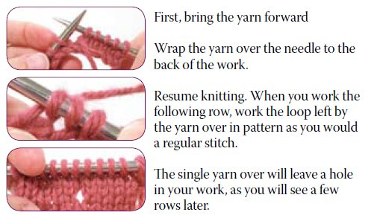
Yarn Over Increases
An easy way to make an increase in your knitting is to yarn over (yo). This does, however, create a hole in your work. For this reason, it is primarily used as an increase in lace knitting and other pieces where open space is intentional or decorative.

Decreasing
Again, there are many different ways to decrease stitches in knitting. We are going to use the “Knit Two Together” method.

Knit Two Together (K2Tog)
A basic stitch in knitting, K2Tog (or knit two together) means exactly what it sounds like: knit two stitches together. It's used often in knitting patterns and is one of the most common ways to decrease the number of stitches on your needle.
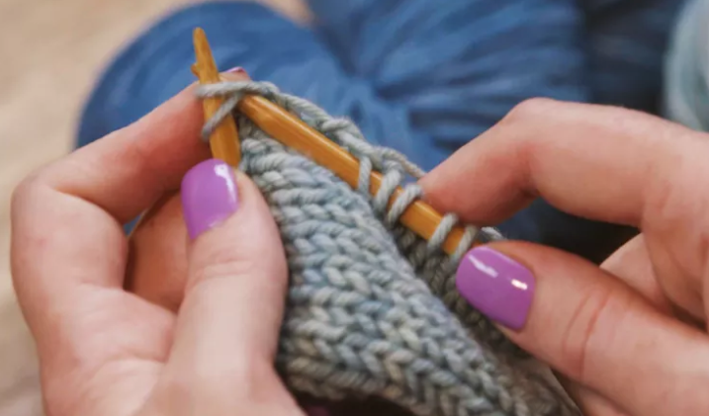
To "knit two together" is just like making a regular knit stitch, but you work through two stitches instead of just one.
Insert your right needle through the next TWO stitches on your left needle, instead of one. Wrap your yarn and knit the stitches together.
You can do the same thing with purl stitches, which is known as purl two together (P2Tog).

When you have mastered the knit stitch (k), yarn over (YO), and knit two together (K2Tog), you are ready to start Grandma’s Favorite Dishcloth!

The Purl Stitch
The second most basic stitch in knitting is the purl stitch. We will use this stitch in the Traditional Dishcloth.
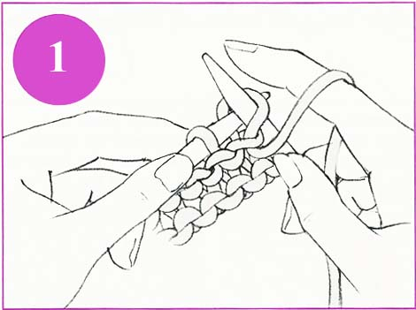
To make a purl stitch, you do all the same steps as you do to make a knit stitch except with slightly different motions. Hold the needles as if to knit -- the needle with the stitches is in your left hand and the empty needle is in your right hand. . Place the yarn from the existing piece and the ball IN FRONT of the left needle. Insert the right needle towards you through the first stitch on the left needle (right to left, from the back to the front). The right needle will be on top of the left needle and pointing towards you (downward.)

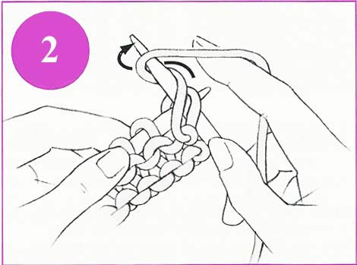
Loop the yarn from the left needle around the tip of the right needle from the front around the back in a downward counter-clockwise motion (the motion that is opposite the direction that the hands of the clock move)
To make sure you don't lose the loop, place your right thumb over the yarn on the right needle so it won't come loose when you move the needle. Slide the tip of the right needle and the yarn on it through the center of the stitch on the left needle, moving it away from you.
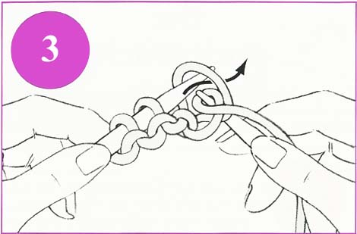
With the tip of the right needle, pull the new loop off the tip of the left needle.

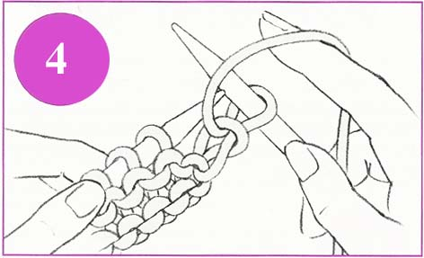
You now have a stitch on your right needle.

CONGRATULATIONS! You have just made a purl stitch!
Repeat steps 1 through 4 to complete the row. If the process feels a little awkward, you are not alone. If you have only done the knit stitch, it will seem a little strange, but soon you'll feel at home using both stitches.

When you have finished this row, turn your work (place the full needle in your left hand and the empty needle in your right hand) and KNIT the next row. After that, PURL the next row. Continue working, alternating each knit row with a purl row.
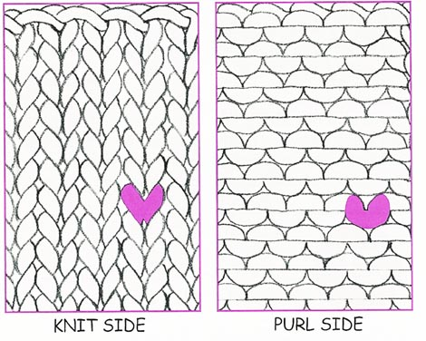
The process of alternating knit and purl rows creates stockinette stitch. Stockinette is smooth on one side with stitches that look and feel like V's. That's the knit side. The other side of a piece that is knitted in stockinette stitch looks and feels like it is covered with bumps. and ridges. When you are knitting stockinette, the side that is smooth is considered to be the right side (abbreviated 'RS'). The purl side with the bumps and ridges is considered to be the wrong side (abbreviated 'WS').

Binding Off
When you have completed your project, it’s time to bind off (BO) your stitches. This secures your last row of stitches so they don’t unravel when removed from the needles.
Again, there are many different ways to bind off. This is the simplest way. We will use it for both Grandma’s Favorite and the Traditional Dishcloth.
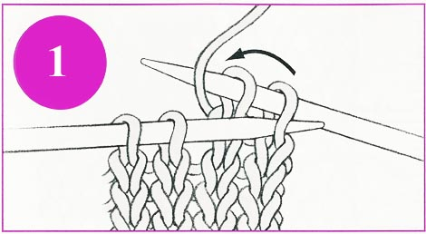
Knit two stitches. Insert the top of the left needle into the first stitch on the right needle. Lift the stitch over the last stitch you knit and over the top of the right needle.

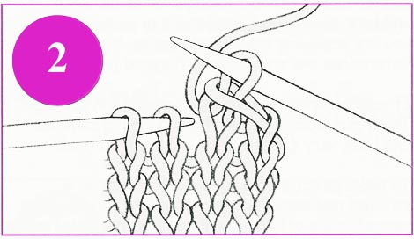
One stitch remains on the right needle. Knit another stitch. Lift that stitch over the stitch just knit.

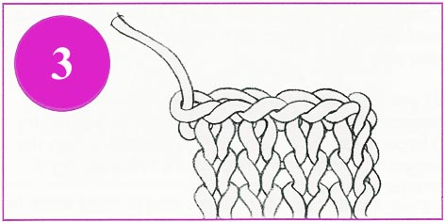
Continue in this way until one loop remains. Cut the yarn, leaving a tail of 4 or 5 inches and draw the end through the last stitch.

I-Cord
The I-cord is a tube knitted in the round with two double-pointed needles (or one circular needle). Elizabeth Zimmermann, a famous knitter who revitalized the craft in the 20th century, named it the Idiot Cord in honor of her accidental discovery of the simple technique.

Cast On and Knit
To begin, cast on 3 stitches (or leave three stitches live on the needle when you bind off). Knit these 3 stitches normally, from the left needle to the right. DO NOT TURN YOUR WORK.

The Slide
Now all 3 stitches are on the right-hand needle and the yarn is attached to the left stitch. Slide the stitches from one end of the needle to the other like this:
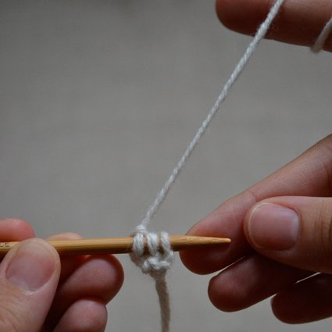
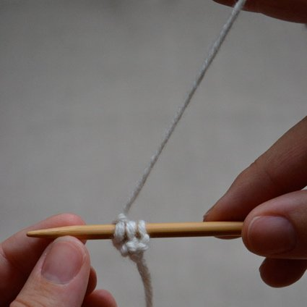

The Trick of It
Without turning the needle, place the needle in your left hand. The yarn is coming from the far left stitch. Pulling the yarn so that it is snug, knit the 3 stitches from the left to the right needle. Everything is normal EXCEPT the yarn is coming from the last stitch in the row instead of the first when you begin knitting this row.
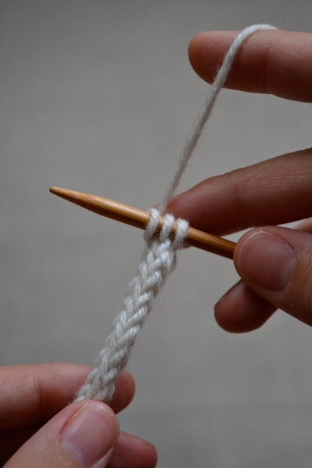
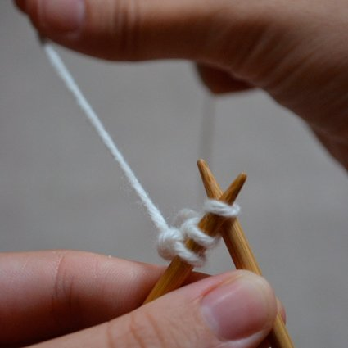
When you have knit all 3 stitches onto the right needle, slide the stitches from one end of the double-pointed needle to the other. Repeat these steps, pulling the yarn snug at the beginning of each row to insure even stitches. Bind off normally.

You can use this technique to make cords for drawstrings, shoelaces, and more. We will use this to create a hanging loop for Grandma’s Favorite Dishcloth, as a special finishing touch.

Weaving in Ends
The final step to finishing your knitting project is to weave in your yarn ends. This hides them away nicely and ensures that your work will not unravel.
Can you guess what I’m going to say next? Yep, there are many different ways to weave in ends! This is one of them.

Weaving in Ends on the Diagonal
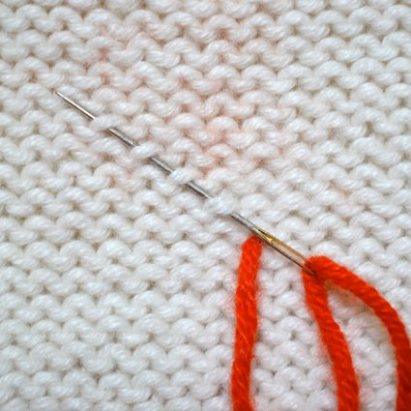
Hold your fabric with the wrong side facing you. With your needle (wide-eyed yarn or “tapestry” needle, not a knitting needle) threaded, bring it from the right side of the fabric through to the wrong side, the side you are looking at. Point your needle at roughly a 45-degree angle. Weave it at a diagonal, under the purl bumps of each of the above rows.

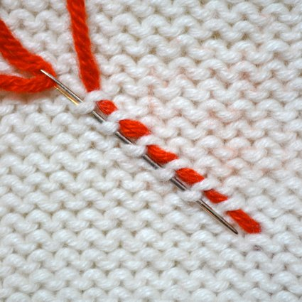
After taking 4 to 6 stitches, rotate your needle 180 degrees. Take another 4 to 6 stitches, parallel to your original stitches. For extra security, you can rotate your needle once again and take a few more stitches.
At this point, it is okay to snip off any extra yarn that may still be dangling.
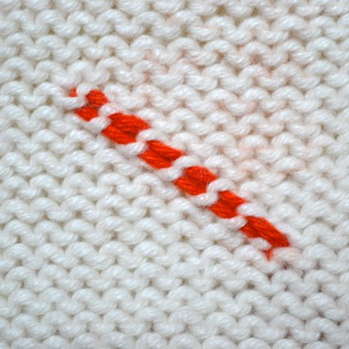
This example uses contrasting yarn, so you can see it. When done in the same yarn as your project, the ends will be almost invisible.

https://www.instructables.com/id/How-to-make-a-Slip-Knot-for-Knitting-or-Crochet/
https://www.thesprucecrafts.com/knit-cast-on-2116503
http://www.lionbrand.com/how-to-knit-knit-stitch
https://tutorials.knitpicks.com/lace-increases-and-decreases/
https://www.thesprucecrafts.com/knit-two-together-2116139
https://m.lionbrand.com/page/how-to-knit-purl-stitch
http://www.lionbrand.com/how-to-knit-binding-off
https://www.purlsoho.com/create/i-cord/
https://www.purlsoho.com/create/weaving-in-your-ends/

