Make Your Own Jump Rope from Scratch
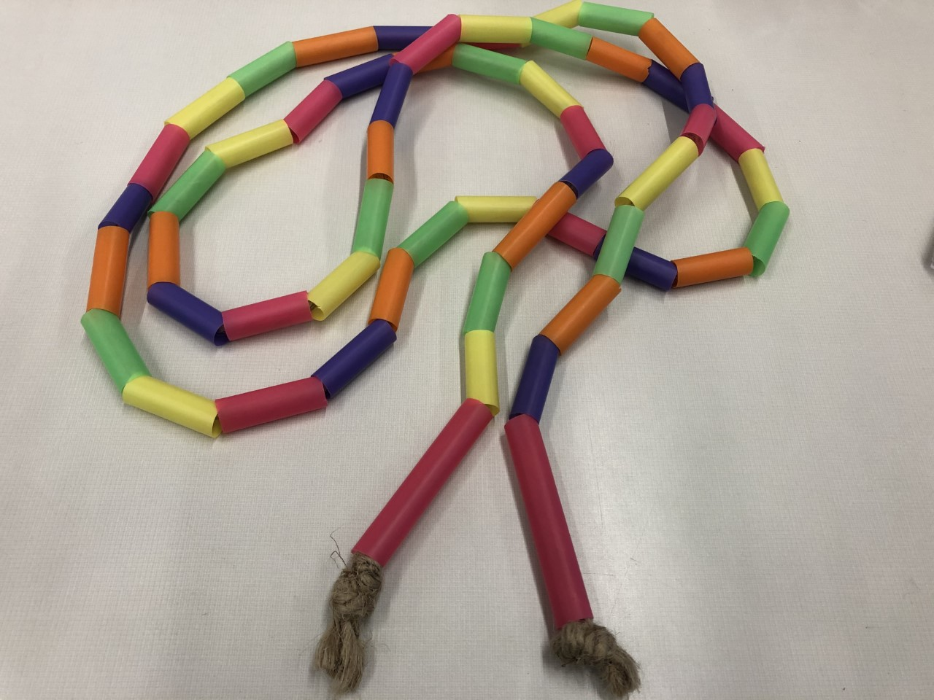

Step 1: Cut the Plastic Straws
First, you’ll need to cut two handles. Hold a straw in your hand to determine what length feels right for you. You’ll want them long enough to be able to fit your hand on the handle with an inch or two to spare. Then cut up all the remaining straws into 1 ½" sections (they don’t need to be exact, but they should be fairly uniform) to create “beads” for your rope.
Step 2: Choose the Bead Pattern
Adding beads to a jump rope increases the durability of the rope and adds weight to make turning the rope easier. Most importantly, colored beads help to add flair and style to your rope! You’ll need to decide in what order you’ll string them onto the rope. Laying them out in a line on a flat surface like a table will make it easier to assemble.
Step 3: Assemble Your Rope
First tie a big knot (or two) in one end of the rope. Slide your first handle onto the non-knotted end and pull it until the handle rests against the knot you just made. String the beads onto the rope in the pattern you chose. When you have almost reached the end of your rope, slide your other handle onto the rope and make one more big knot (or two) on this end of the rope. Cut the excess rope (if there is any). If you want to keep the end of the rope from fraying, an adult (and only an adult!) can use a lighter to melt the two ends of the rope.
There you have it, your own jump rope.

