Make Your Own Yoda Out of Shapes!

Supplies Included:
1 sheet white background paper
1 sheet black construction paper
1 green 4.5-inch circle
2 green 2in by 4in triangles
1 red 1-inch square
2 brown 2in by 6in rectangles
Additional Supplies:
Glue stick or liquid glue
- First take your black piece of paper and cut out a triangle that is two taller than it is wide. I used a ruler and made mine 6 inch wide on the bottom with each of the sides being 8 inches long. You don’t have to use a ruler if you don’t want to, I just thought it was easier.
- Glue the black triangle so that the bottom of the triangle lines up with the bottom of the white paper.

- Glue the green circle at the top of the triangle. You will want to cover the top inch or two of the triangle.
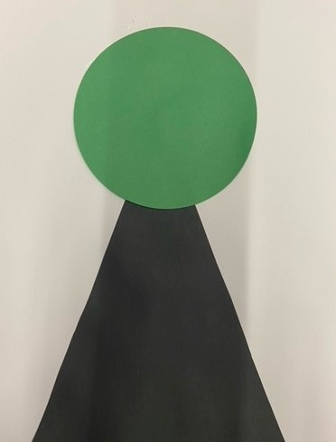
- Glue one of the small triangles on each side of the circle for the ears. I have placed mine underneath the circle, so it looks more seamless. However, it does still look cute if you place them on top.
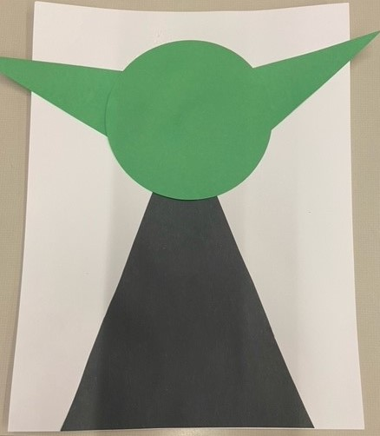
- Glue the brown rectangles along the sides of the black triangle. You will want to place them as much on the triangle as possible.
- Place your googly eyes on the green circle face.

- Included is a red square that you can use for the mouth. It gives Yoda a surprised look, but you can also just draw on the facial expression of your choice.
