The Benefits of Jump Rope for Kids (and Adults!)
https://www.care.com/c/stories/3968/11-catchy-jump-rope-rhymes/
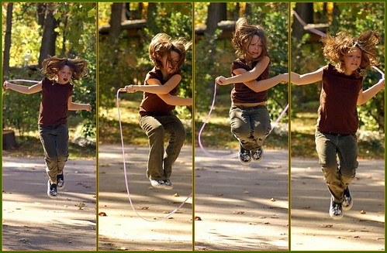
"Jumping Rope" by wishymom (Stephanie Wallace Photography)
Kids may not realize it, but jumping rope to rhymes can offer benefits that extend well beyond the playground.
“On the most basic level, jumping rope is a great conditioning tool for the cardiovascular system,” says personal trainer John Urena, owner of Coach U Training & Performance in Los Angeles.
Urena says there are even more positive takeaways of jumping rope to songs, such as:
Teaching their bodies to take on the compression of gravity. “By learning how to create force with the aid of the ground, we are training the body to absorb force, as well as use energy efficiently and safely,” Urena says. This benefit can ultimately ward off physiological imbalances, pain and injury — all of which could lead to surgery.
Learning coordination. Because it’s a cyclic activity that’s performed at a steady, regular cadence, jump rope helps kids develop coordination among their eyes, feet and hands. Singing adds even more challenge, according to Urena: “The jump rope rhymes act as a metronome to help with timing and overall coordination.”
Boosting cognitive function. Jump rope requires kids to learn new motor patterns, which improves the nervous system communication among the brain, wrists and lower leg muscles, which, in turn, improves overall cognitive function, according to the American Council on Exercise (ACE).
Building foot strength. “Our feet are the base of our bodies,” Urena says. “Jumping rope promotes foot strength, coordination between foot and ground contact and builds explosiveness.” And if kids build foot strength, they’ll be strong and mobile in a variety of other ways.

Jumping rope to rhymes and songs will encourage little ones to exercise, play, build physical and mental strength and bolster their creative thinking. So, whether they’re playing at recess or at home, there’s no doubt a case for encouraging kids to try the activity.
10-Minute Jump Rope Workout for Kids
https://www.youtube.com/watch?v=44wt7DfDZ3E

Teaching Young Children How to Jump Rope
https://www.youtube.com/watch?v=_EZnGbfMqsc&feature=emb_logo

