Tissue Paper Flowers
This is a very versatile “flower” pattern that can create four different looks by changing the shape of the tissue paper edges.

Supplies:
Tissue Paper (2 sheets per flower)
Scissors or Rotary Cutter
Stapler

Basic Flower Folding Instructions:
- Start with your first two sheets of tissue paper. Lay the two sheets on top of each other.
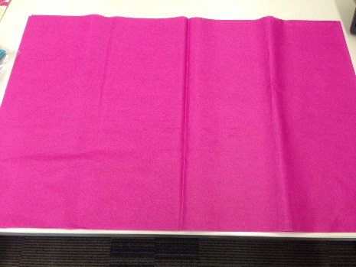

- Fold in half.

- Fold in half again.

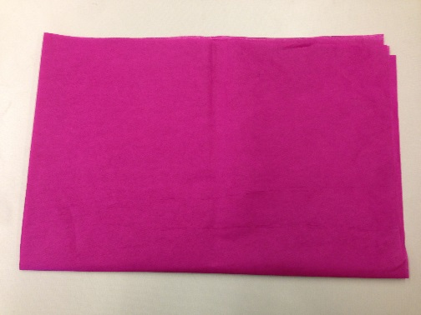

- Find the corner with all of the separate pieces of paper (not one with a fold). Take this corner and fold it to the opposite edge to make a triangle.

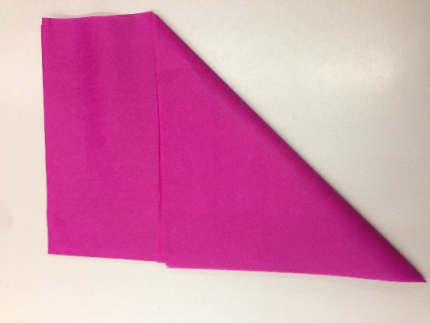
- Cut off the extra rectangle of paper.

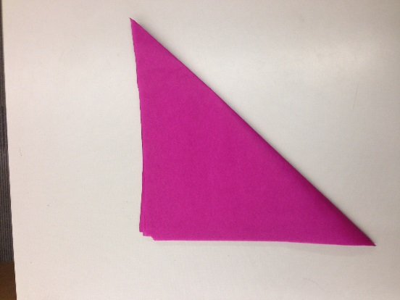

- Open the triangle. You will notice that one edge of your squares is not cut. Trim off that edge. Now you have 8 individual squares.

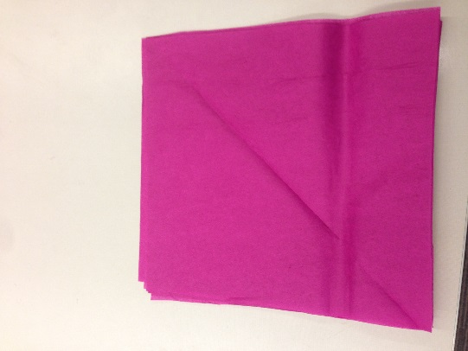

- Fold the paper accordion style. You should end up with 6-8 folds.

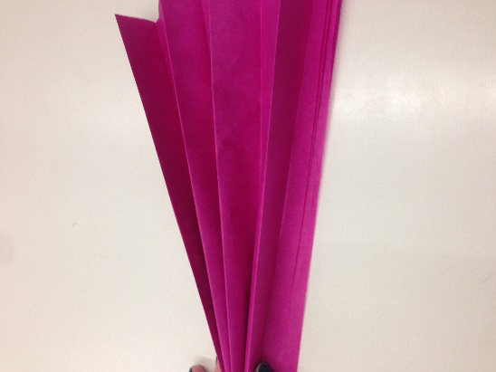

- Staple the accordion in the center.

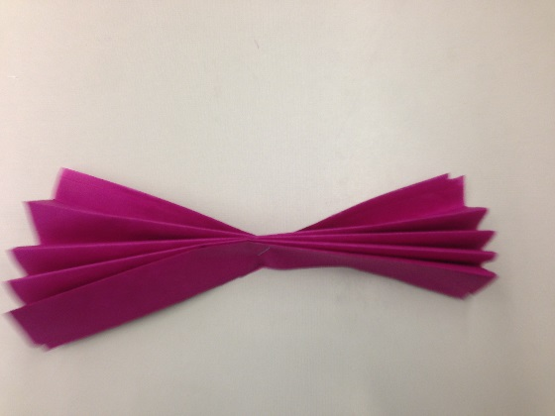

- Now we will trim the edges to create different petal and flower shapes.
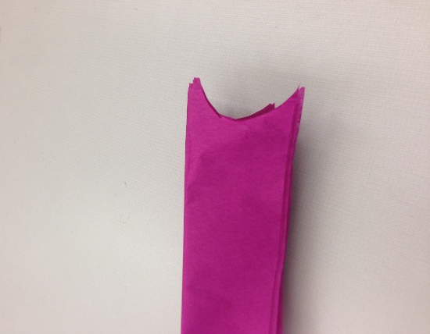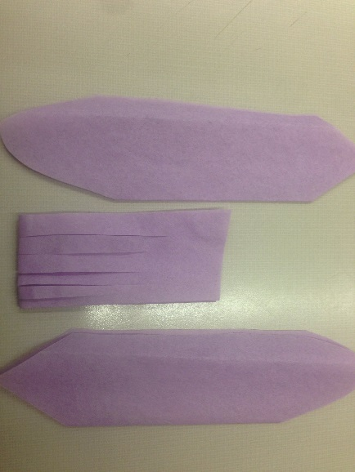

- Carefully separate the edges of your cut paper. Pull from the inside rather than the edge to reduce the chance of tearing. If this happens, don’t panic as the full flower will camouflage most tearing. Continue fluffing until you have a full flower!

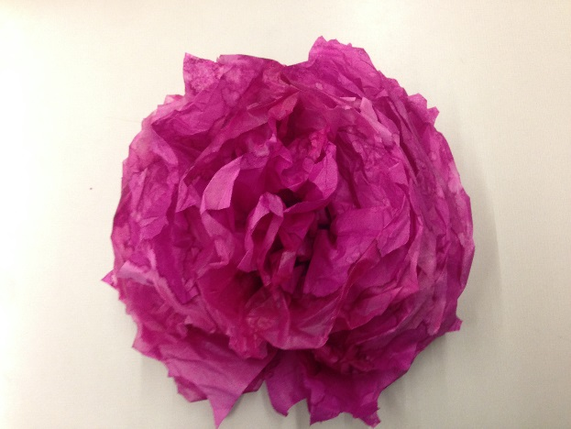

To Make a Tissue Paper Flower Wreath attach your tissue paper flowers to the metal wreath with pipe cleaners or floral wire.

Wreath Examples:
