DIY Fleece Dog Toy Tutorial
6 - 1 inch X 18 inch pieces of fleece fabric
Step 1: Lay the 6 fabric strips on top of each other and tie a knot in one end. I find it helpful to tape the braid down onto a table or put it between your knees. This helps you to be able to pull things tight as you go along. Separate the fabric out into 3 pairs.
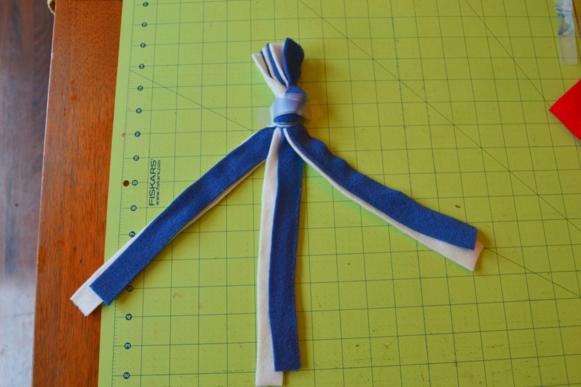
Step 2: Braid the fabric.
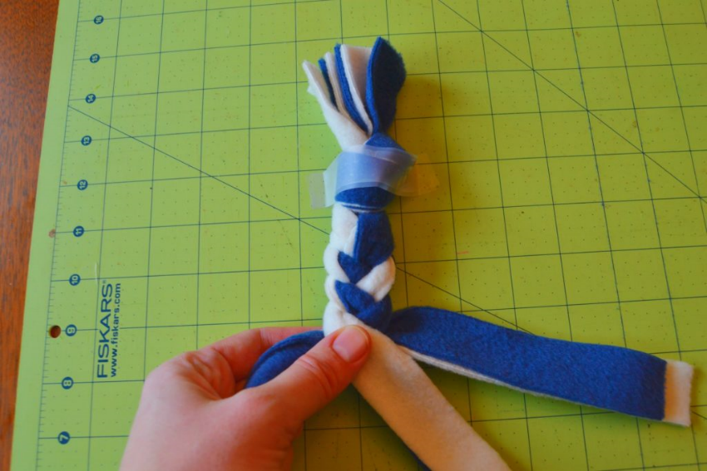
Step 3: When you have braided what you want to braid then you will tie a knot on the other end to finish it.
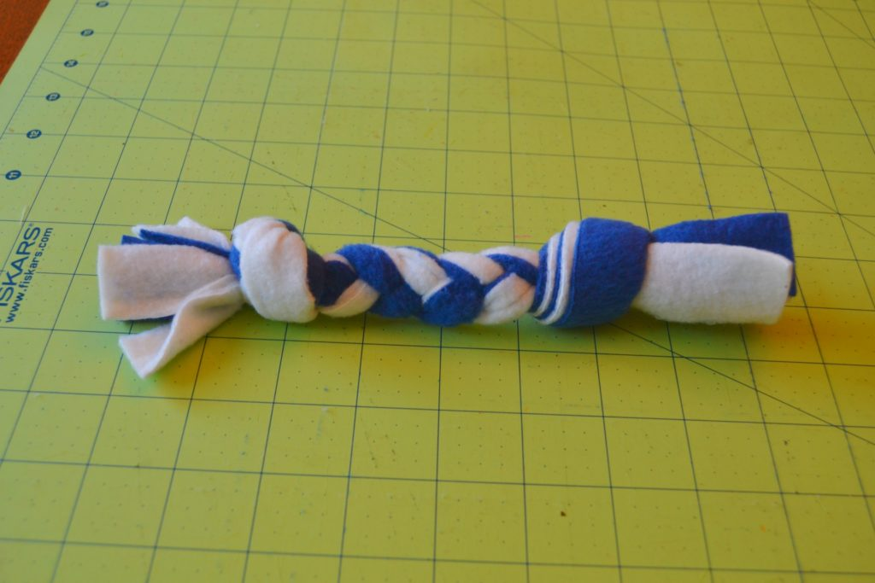
This size of fabric will make a small rope toy, about 9 inches long.
If you want to make a longer toy then use longer strips.

