Dog Bow Ties with No Sew Hacks
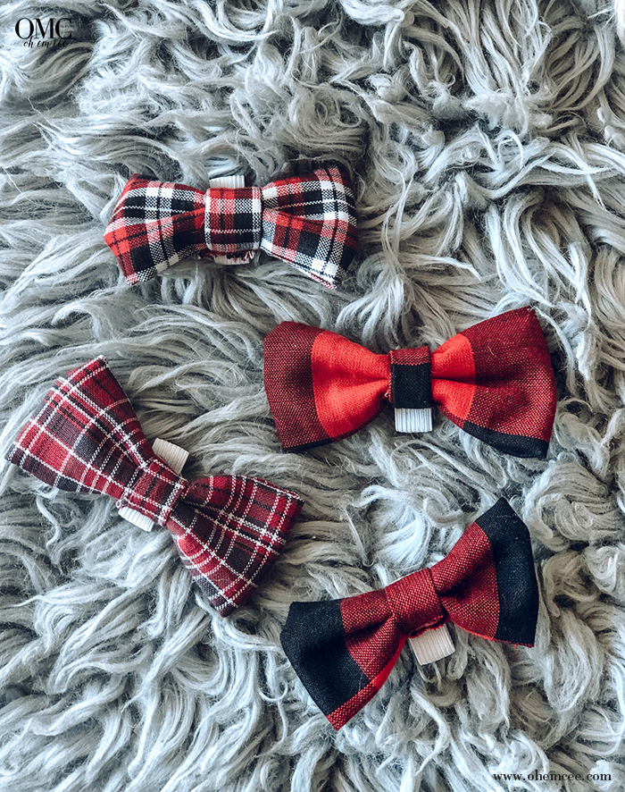
FINAL BOW TIE SIZE | | FABRIC SIZES
X-Large  5.75″w x 3.5″h | 12″w x 7.75″h  4″w x 2″h
Large  5″w x 3.25″h | 10.25″w x 7″h  4″w x 2″h
Medium  4.25″w x 3″h | 8.75″w x 6.25″h  4″w x 2″h
Small  3.5″w x 2.5″h | 7.25″w x 5.5″w  4″w x 1.5″h
X-Small  3″w x 2″h | 6.5″w x 4″h  4″w x 1.5″h
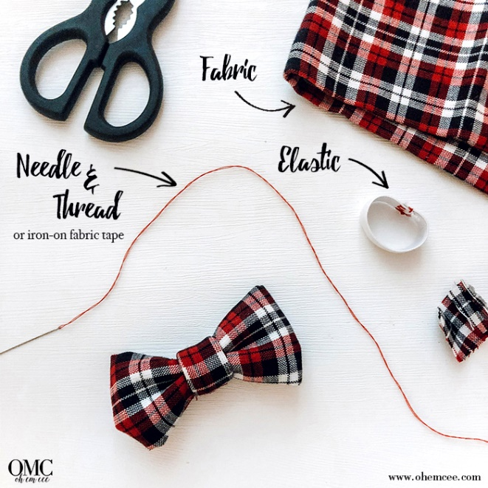

Supplies:
- Fabric – You will need TWO pieces of fabric for each bow tie – a larger one for the main bow tie and then a smaller piece used to wrap around the center.
- Elastic – These bow ties are meant to be worn with a collar. The elastic is attached to the back of the bow tie so the collar can be looped through. It’s simpler than customizing to your pet’s specific neck size.
- Needle & Thread OR Iron-On Fabric Tape
- Other No Sew Materials – If you will not be sewing the bow tie, you will also need a small rubber band and a hot glue gun.

Step 1 – Fold the Fabric Once
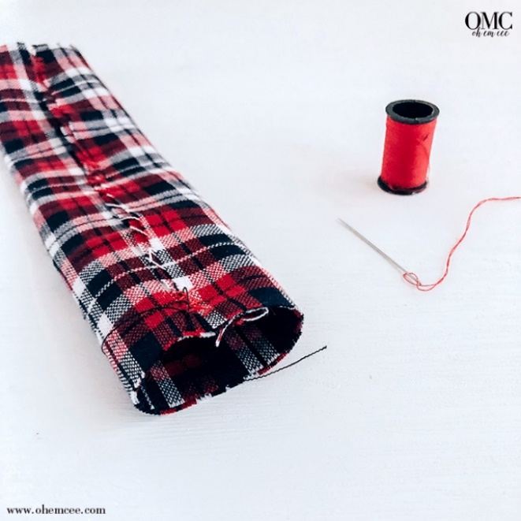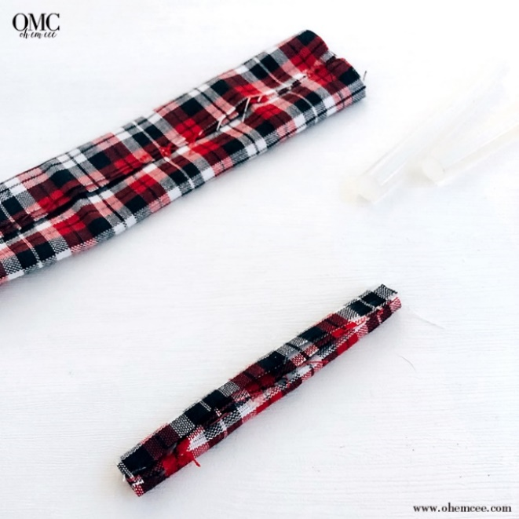
Once you have your two pieces of fabric cut, take the larger one and fold the long sides in, overlapping about a quarter inch. Sew the edges together.
OR use the iron-on fabric tape! Iron the adhesive between the two edges to melt the glue, bonding the fabric together. If you’ve got the iron going, run the iron over the entire strip to flatten it.
Do the same with the smaller piece of fabric, folding in the long edges so they overlap and adhere them together.
Step 2 – Fold the Fabric a Second Time
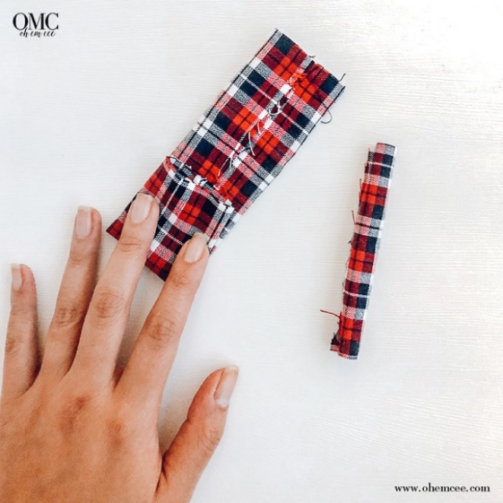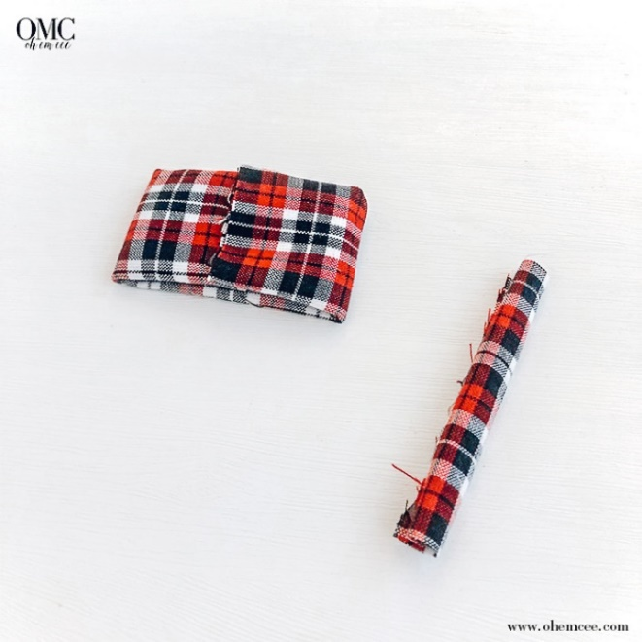
Take the larger piece and again fold the edges in, this time on the short side. Overlap them about a quarter inch and sew together.
You can use the iron-on fabric tape here again!

Step 3 – Pinch and Tie
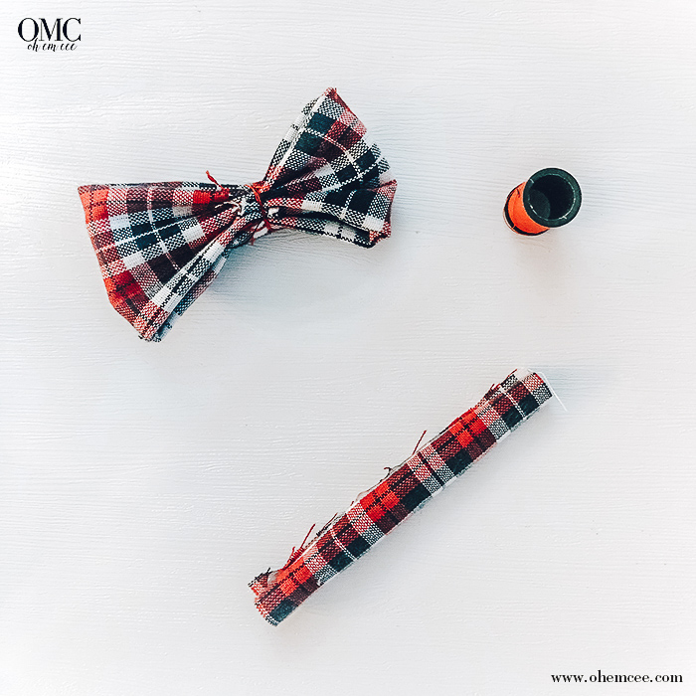

Now it is time to shape your bow tie. Easiest way to do it is to fold the fabric in half long ways, the seam on the inside. Then fold back down both edges.
Pinch the middle of this accordion fold and that’s where you tie it so it holds the bow tie shape! Here is where the rubber band comes in handy. Instead of using string/thread, use the rubber band to secure the center of the folded bow tie.
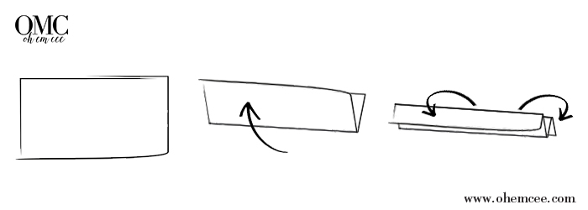
Step 4 – Wrap the Center
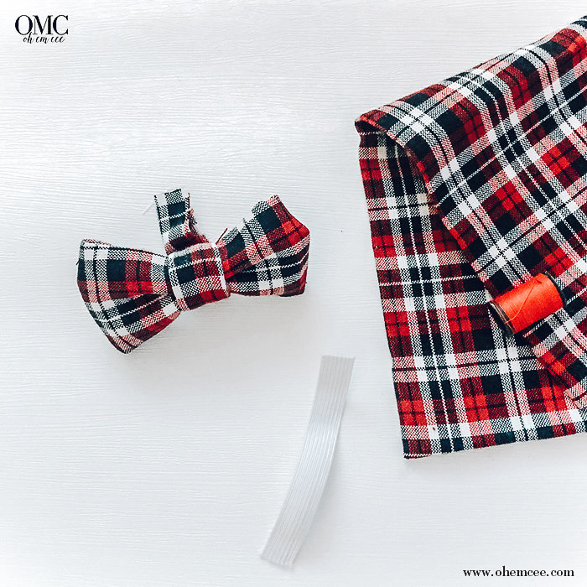
Using the smaller piece of fabric, wrap it around the pinched bow tie, twice. This will cover the string or rubber band. Cut off any extra fabric so that it ends in the back. Secure it by sewing or with some hot glue.
You have a bow tie!
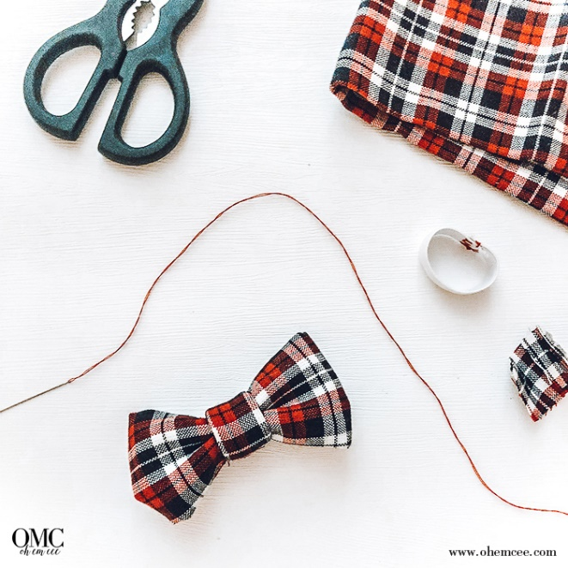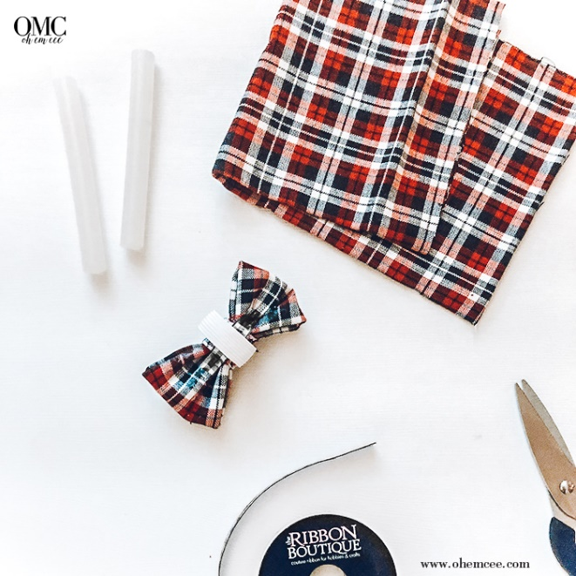
Step 5 – Attach the Elastic Band
First, cut the elastic band and make a loop. Use a dog collar as a guide for how big it should be. The elastic band should fit snug on a collar, so it stays put. Basically, the loop should be the same as the width of the collar. You can hand sew the band closed or use a hot glue gun. Watch your fingers!
To attach the elastic band to the bowtie, you can again sew or use hot glue. For extra security, place a piece of fabric through the band and adhere it to the back of the bow tie. This also covers all of the thread and hot glue so it looks neater! Cut off any stray threads and pull off any stringy glue.

