How to Address an Envelope
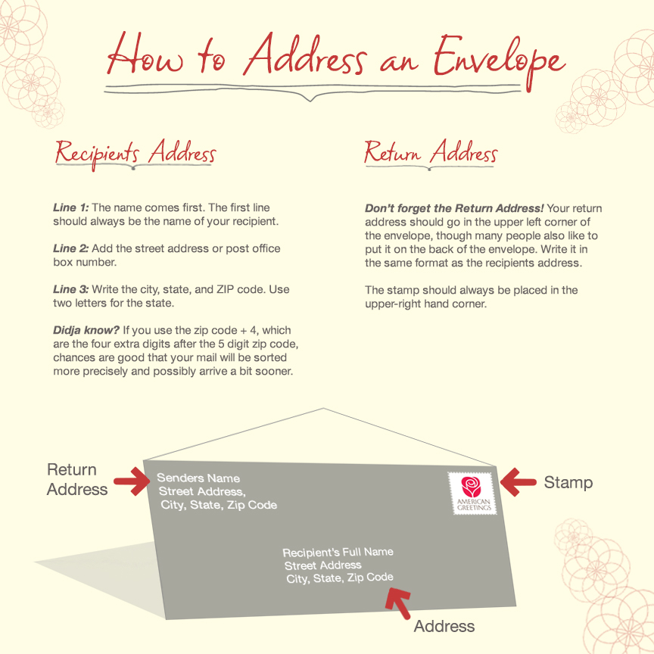
Need more details?
Step 1: Use the full, proper name of your recipient.
Step 2 (optional): If the person you’re sending to is somewhere other than their home address, you might want to add a “care of” line below the name.
For example, if you’re sending mail to a friend’s company address to brighten their day at work, write the “c/o” before the name of the company.
If they’re visiting family, you put the name of the person they are staying with on this line.
Step 3: Add the street address or post office box number. Don’t forget directional notes like “West”or “North”, or apartment numbers. If you can’t fit the street address and apartment number on one line, write the apartment number on the line below the street address. You can also use abbreviations to save space. Use Ave for Avenue, Blvd for Boulevard, etc. Check out our handy list of abbreviations below*.
Step 4: Write the city, state, and ZIP code. Use two letters for the state. According to the U.S. Postal Service, do not include commas, periods or other punctuation. This helps your mail speed through processing equipment. (And if you really want to be best buds with the post office, use all capital letters.)
Step 5: Mailing from outside the country? Add “United States of America” on the last line beneath the city, state, and zip code.
Don’t forget the return address!
Your return address should go in the upper left corner of the envelope, though many people also like to put it on the back of the envelope. Write it in the same format as the recipients address. (Or you could use fancy printed labels.)

*Here’s a helpful list of abbreviations commonly used in addressing:

BOULEVARD BLVD

CENTER CTR

CIRCLE CIR

COURT CT

DRIVE DR

LANE LN

PLACE PL

ROAD RD

SQUARE SQ

STREET ST

TERRACE TER

TRAIL TRL

