Kool-Aid Dipped Stationery
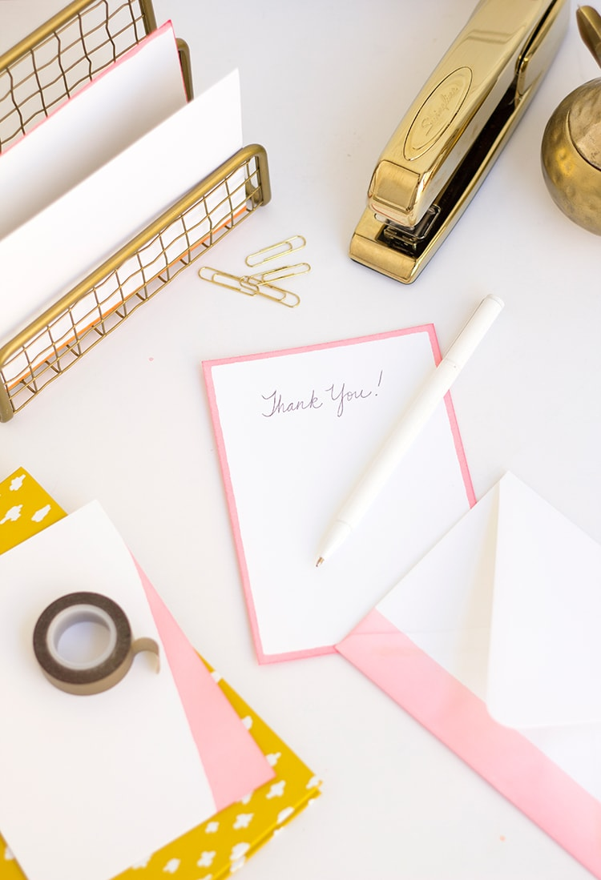

Supplies:
- White 100% cotton paper note cards and envelopes (A-6 or A-7)
- Paper towels
- Kool-Aid Liquid in a variety of flavors (I used orange, watermelon, and cherry)
- Water for diluting
- Trays or pans for dipping
- Cooling rack for drying
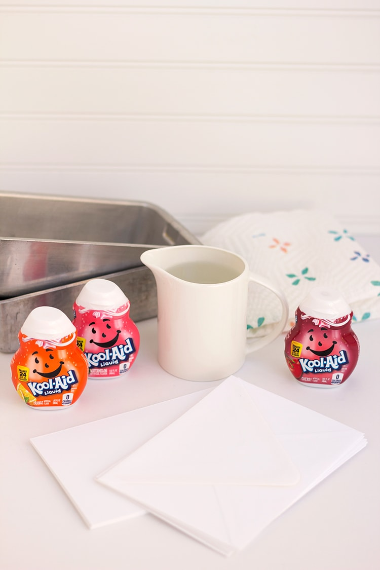

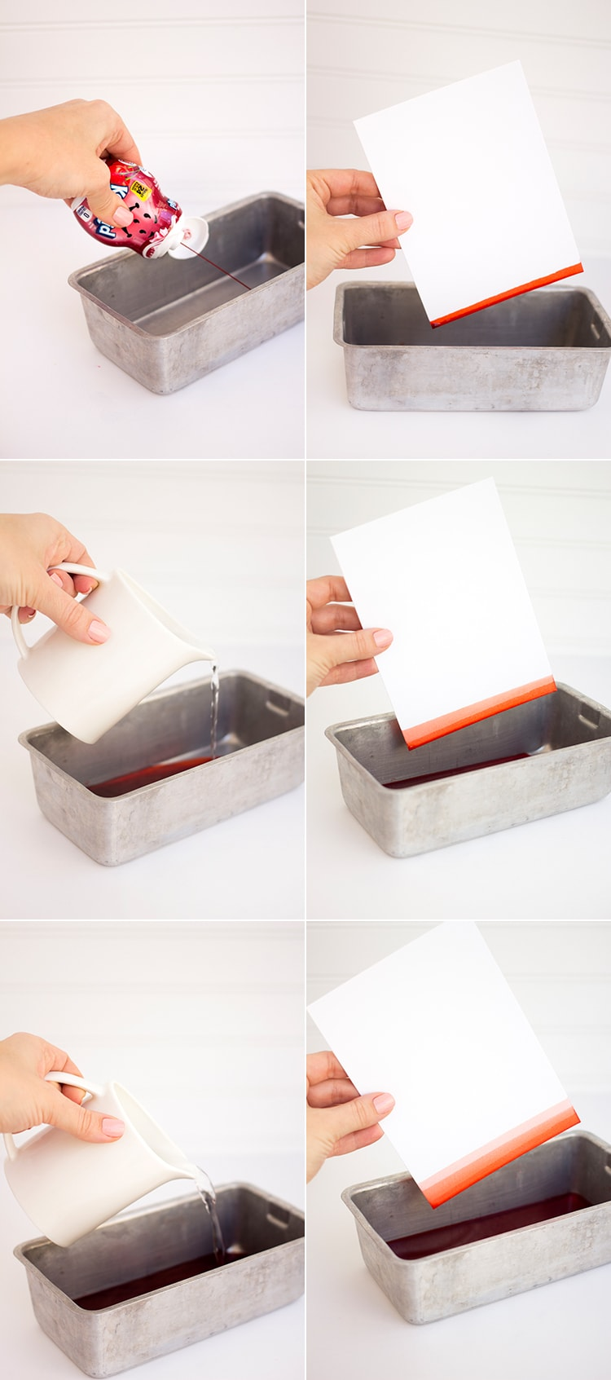
Instructions for creating ombre note cards:
1. Squeeze a generous amount of Kool-Aid Liquid into a pan. You will need enough to dip the side of your paper in for your first band of color.
2. Dip paper quickly in the liquid and remove immediately. Blot on a paper towel to avoid drips.
3. Dilute Kool-Aid Liquid by 50% by adding water.
4. Dip paper a second time quickly in the liquid to create the second band of color. Remove immediately and blot on a paper towel.
5. Dilute Kool-Aid Liquid by 50% by adding more water.
6. Dip paper a third time quickly in the liquid to create the second band of color. Remove immediately and blog on a paper towel.
7. You can continue to dilute, dip, blot and repeat as many times as you wish. Then dry on a cooling rack or paper towel.
