DIY Washi Tape Envelope
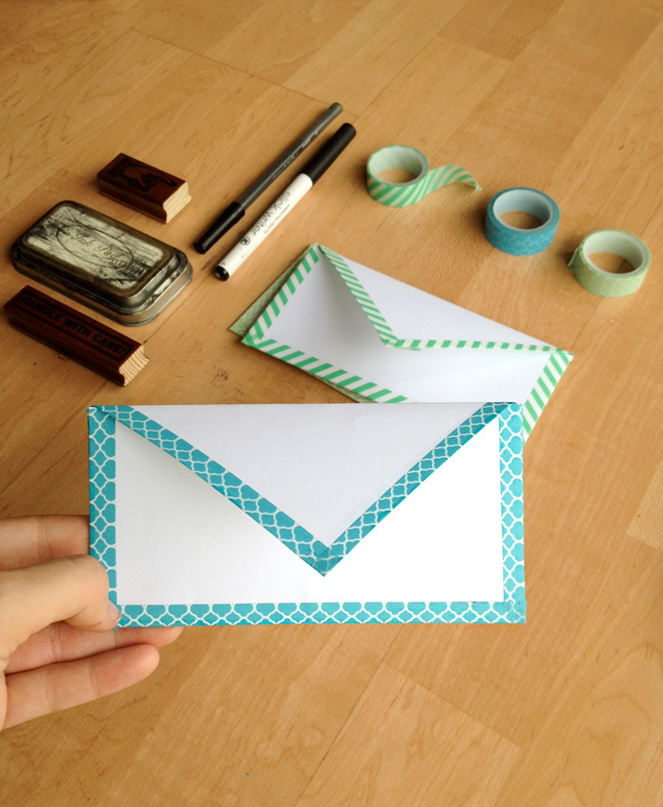

Supplies:
- 8.5” x 11” paper
- Scissors
- Washi Tape
Instructions:
- Fold your bottom right corner up until the whole bottom side of the paper is flush with the left.

- Trim off the top rectangle piece and open up your paper.
- Take the bottom left-hand corner and bring it to the top right-hand corner making a triangle. Don’t completely crease the paper! Just make a small crease at the bottom of the triangle. You will use the small crease mark as a guide instead of making a big ugly crease all the way across.
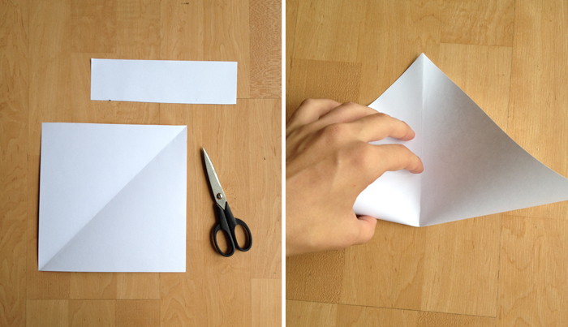
- Orient your paper so the corner that DOES NOT have a crease is at the top. Now fold the other 3 corners to the center.
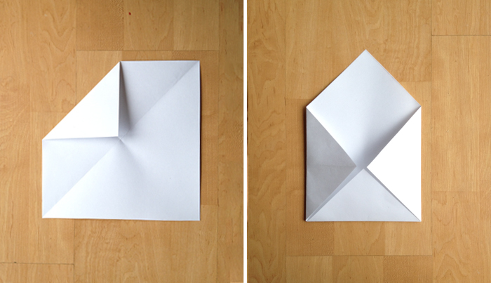
- Fold the bottom half of the envelope up in half. Fold your top flap down.
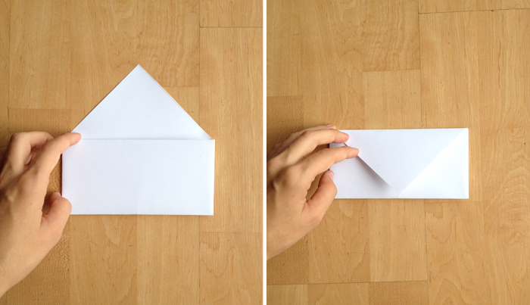
- Next cut washi tape stripes the same size as the sides of the envelope. Place the washi strips half on the envelope edges, then fold the other half around to the other side. This makes a nice edge while also holding the envelope together.

