Make a Hero Self Portrait
https://www.pbs.org/parents/crafts-and-experiments/make-a-hero-self-portrait

Materials
- Mirror
- Paper
- Paint, markers, colored pencils, crayons
- Tape

Directions
1
Look into the mirror. Notice the physical features that make you who you are. Ask yourself what you see — "What color is your hair? Your eyes? Do you have freckles?"

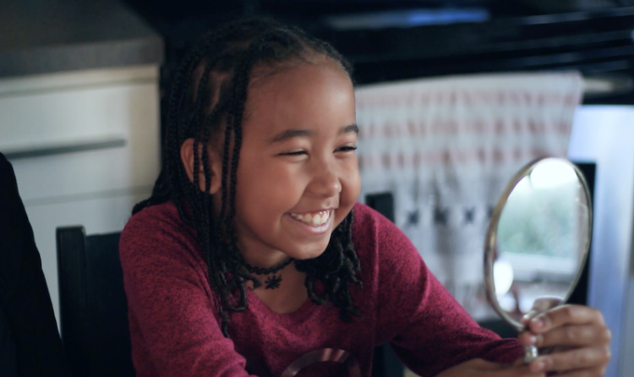
2
Using the sketch paper provided, draw a self-portrait based off the qualities you thought about. Be creative and make your portrait uniquely you!

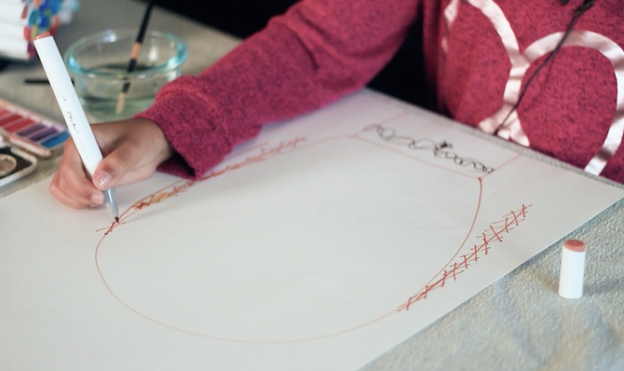
3
Brainstorm the character traits that make you unique. Ask yourself — "What makes you a good friend? How would your friends describe you? What do you like to do? How do you help others?"

4
Write down these positive qualities around the self-portrait you’ve drawn.
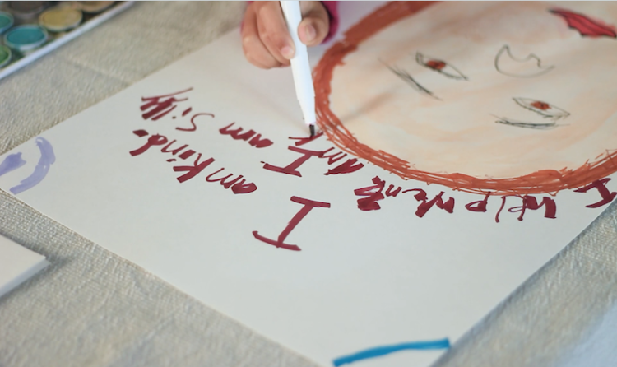
5
Once you're finished, hang the portrait so that you’re reminded every day of what makes you a hero!

