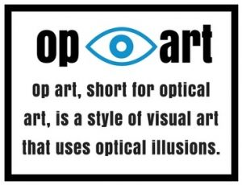
Don’t let your eyes fool you with this art project. You’re going to learn how to draw an optical illusion on paper. This art project is inspired by Victor Vasarely, a Hungarian-French artist who was widely accepted as the leader of the op art movement. What is op art? Op art, short for optical art, is a style of visual art that uses optical illusions. Op art can also be abstract art that gives the illusion of movement by the precise use of pattern and color, or in which conflicting patterns emerge and overlap.
DIRECTIONS-
Using the provided grid of 1” squares, fill each square with a different color or pattern of colors. Add ½" circle and square stickers to finish your dazzling creation! Just check out this short YouTube video to get started! (Vaserly-Inspired Op-Art Project #203) https://www.youtube.com/watch?v=Ipq6Hb-Rcyc
***TIP FOR YOUNGER CHILDREN - TRIM TO CREATE A SMALLER (SQUARE) WORK AREA ***
***MODIFICATION FOR OLDER CHILDREN- CREATE A MORE COMPLEX DESIGN BY HAND DRAWING CIRCLES AND SQUARES OF DIFFERENT SIZES WITHIN THE 1” GRIDS OR CONSIDER ADDING A “POP UP” ILLUSION IN THE MIDDLE OF THE PAGE FOLLOWING THESE DIRECTIONS! (Victor Vaserly: Op Art Lesson #1) Victor Vasarely: Op Art Lesson #1
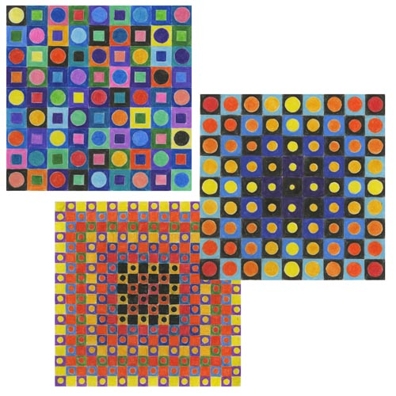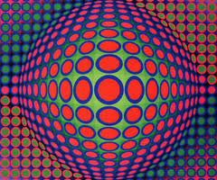

National Geographic Xtreme Illusions (2012) J152.148 X7x TWEEN

Series: National Geographic Kids

eBook Harry Houdini for kids : his life and adventures with 21 magic tricks and illusions (2009)

by Carlson, Laurie M.

Series: Paperback Audio for kids

