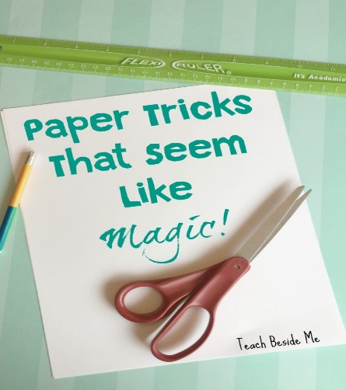
SIX PAPER TRICKS

THAT SEEM LIKE MAGIC!
By Karyn @ https://teachbesideme.com/6-paper-tricks-that-seem-like-magic/

Supplies Needed: Paper, scissors, tape

CUT A HOLE THROUGH A PAPER THAT YOU CAN STEP THROUGH!
Start by folding a piece of paper in half lengthwise. Then draw lines on the paper like the image below. Make sure you are leaving a small bit uncut at the end of each line. Once all of the lines are cut back and forth, you are going to cut through the fold, making sure to leave the last two edges of the fold un-cut. When you open it up, it will have a large opening that you can actually step through!
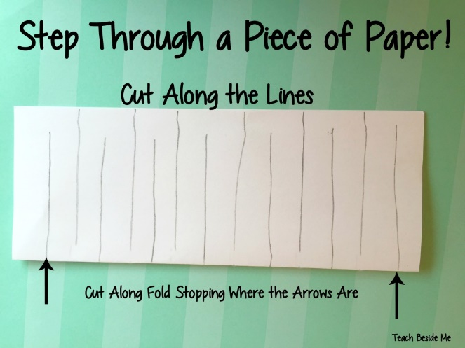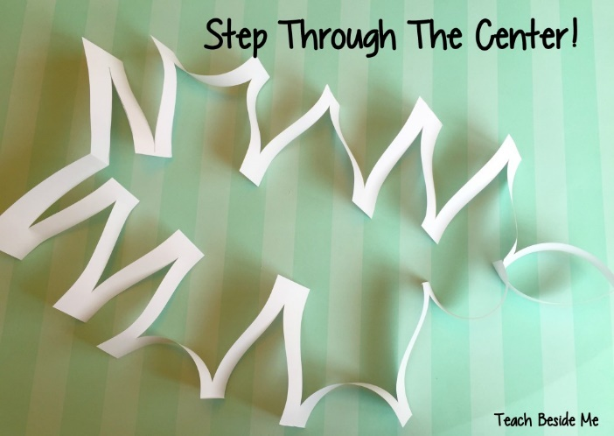

MAKE A MOBIUS STRIP
A Mobius Strip is a band of paper that has only one side. It was created by a couple of German mathematicians in the 1800s. You can easily make one by cutting a strip of paper about 1 1/2 inches wide. Then take one end of the paper and twist it once. Connect it to the other end and tape it. That is cool all on its own. But we are going to make it cooler! Take a pencil and draw a line through the center of the strip. You will end up going all the way around and back to the starting point. Now, cut through the center line and see what happens! When you finish cutting you will end up with an even larger loop!
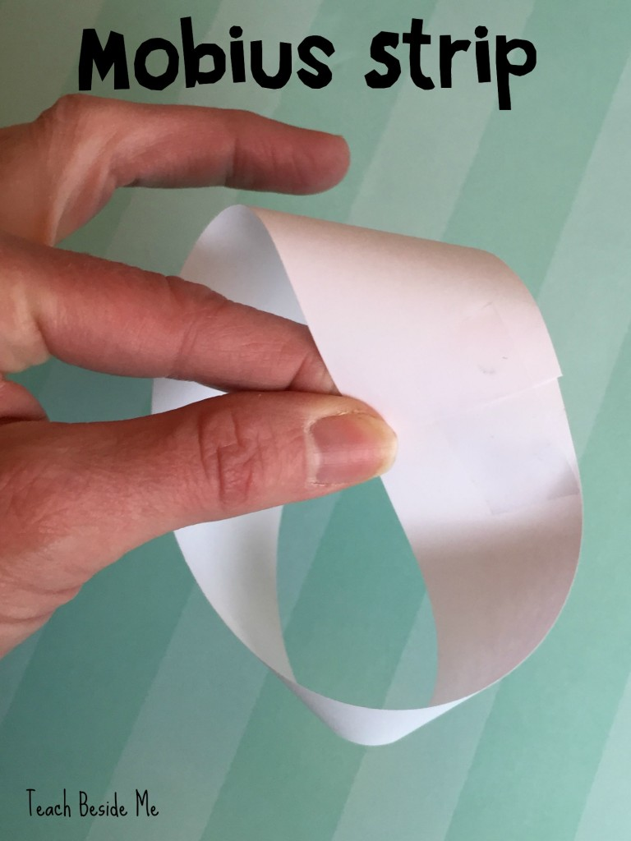

3. FROM A DOUBLE TWIST TO A DOUBLE RING
For the next trick, we will start just like the previous one. Take a strip of paper, but this time twist it twice. Tape it and cut through the center just like you did last time. Now when you cut it apart you will end up with two rings connected! Amazing, right?!
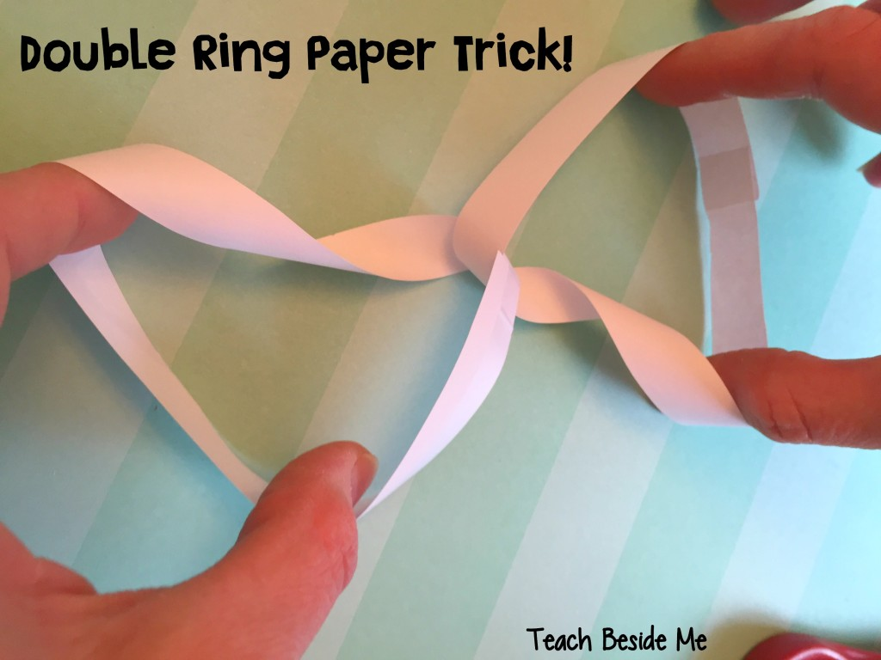

4. FROM TRIPLE TWIST TO TRIPLE LOOP
This trick also starts like the Mobius Strip. Use a strip of paper 1 1/2 inches wide. Twist it three times and tape the ends together. Draw a line through the center again and cut through the whole center of the strip. When you open it up, you will have a triple twisted loop!
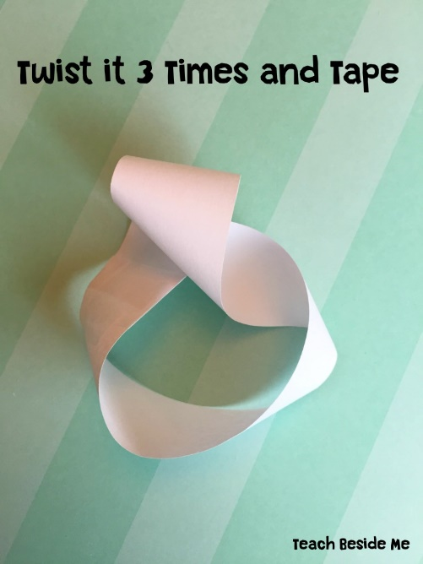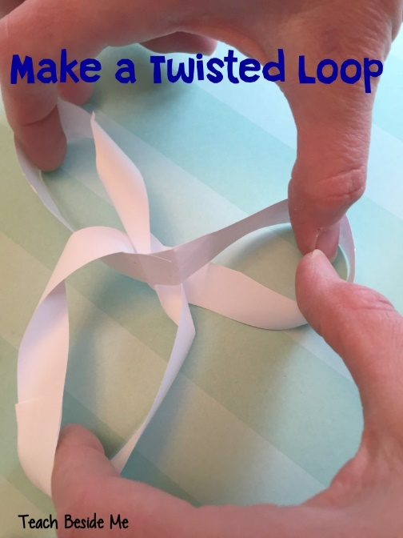

5. MAKE AN INTERLOCKED SMALL AND LARGE PAPER LOOP
Once more this starts with a Mobius Strip. Twist it only once. However, when you draw the line through the center this time, you will do it a little differently. Divide it into thirds and start on one side to draw the line all the way around. Then cut it the same way following the line all around the loop. This time when you open it up it will be a double loop, but one will be bigger than the other!
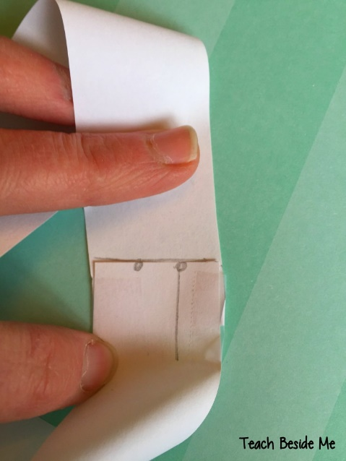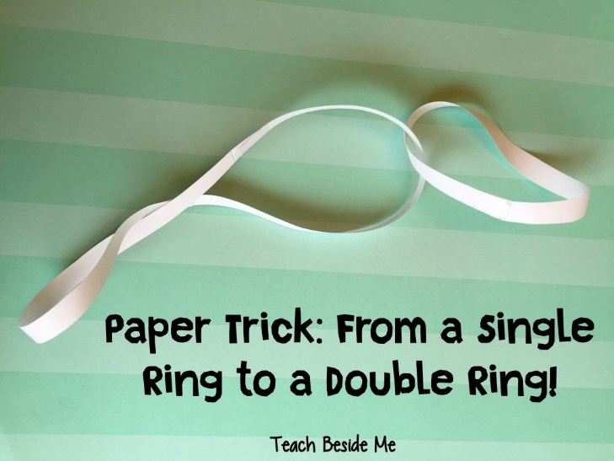

6. TURN TWO PAPER RINGS INTO A SQUARE
For the final trick, you will need two strips of paper. Tape them both into a loop, one inside of the other, without twisting them. Draw a line around both of them and tape them together as pictured below. Cut around both circles following the lines. When you finish and open it up you will have a large square!
