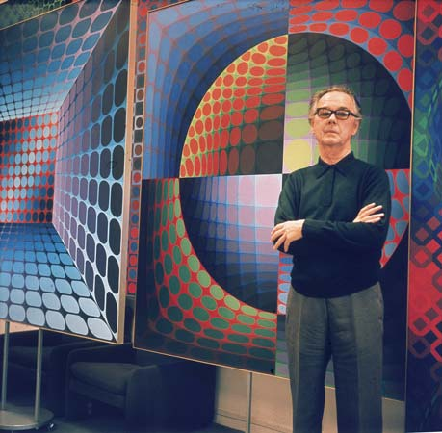
(1908–1997). Hungarian-born French painter Victor Vasarely became one of the leading figures of the Op Art movement. This movement is a branch of mid-20th-century geometric abstract art that deals with optical illusion.

Hulton Archive /Getty Images

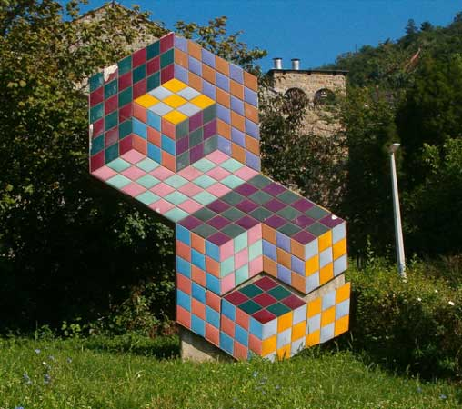
Vasarely (in Hungarian, Vásárhelyi) was born on April 9, 1908, in Pécs, Hungary. He trained as an artist in Budapest, Hungary, in the Bauhaus tradition. In 1930 he left Hungary and settled in Paris, France, where he initially supported himself as a commercial artist but continued to do his own work. During the 1930s Vasarely was influenced by Constructivism (a Russian artistic and architectural movement), but by the 1940s his characteristic style of painting animated surfaces of geometric forms and interacting colors had emerged. His style reached maturity in the mid-1950s and 1960s, when he began using brighter, more vibrant colors to further enhance the suggestion of movement through optical illusion. Representative works include Sirius II (1954), Ondho (1956–60), and Arny-C (1967–69).
Vasarely became a naturalized French citizen in 1959. Much of his work is housed in the Vasarely Museum, at the Château de Gourdes, in Vaucluse département, southern France. In 1970 he established the Vasarely Foundation, which in 1976 took up quarters near Aix-en-Provence in a building that he had designed. Vasarely died on March 15, 1997, in Paris.
Váradi Zsolt

