Easy DIY Castanets for Kids
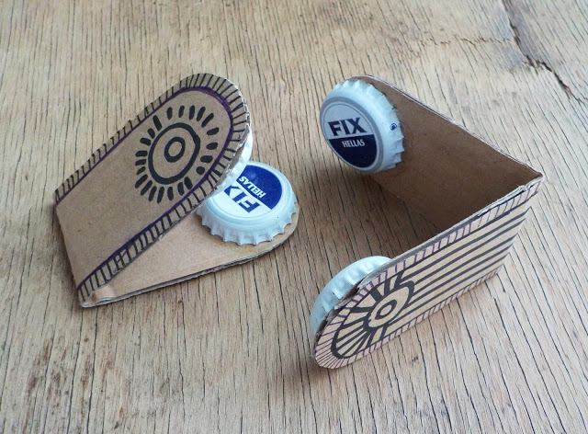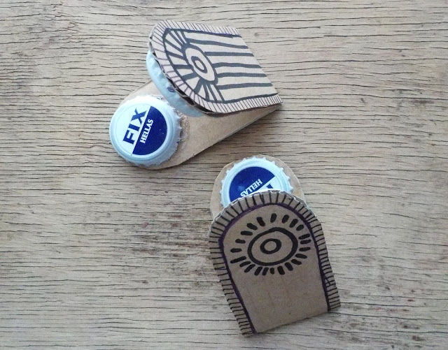
All you need for each castanet is a strip of fairly sturdy cardboard and two bottle caps.
Recycling DIY at its best!
Instructions:
1. Trace the template TWICE on the piece of cardboard and cut out TWO strips.
2. Fold the cardboard strips in half.
If desired, you can decorate the cardboard: draw on it, paint it or do whatever you want!
(Alternatively, you can leave this step for after the castanets have been completed.)
3. Now you want to hot glue(with adult help) or tape the bottle caps onto the cardboard.
Make sure you are gluing or taping them on the inside of the folded cardboard piece.
Put glue on the jagged edge of one bottle cap and place it on the edge of one end of the cardboard strip. If your cardboard is the thick kind you can press the bottle cap into the cardboard for a better grip.
Let it dry.
If using scotch tape, make a big x across the top of the bottle cap with two pieces of tape, securing well in all 4 directions.
4. Glue or tape the second bottle cap on the other end of the cardboard strip, in the same manner. Make sure that it is aligned with the first bottle cap. You want them to click together when you're done, so they have to be positioned to correspond.
Let the glue dry.
If you've left the decorating-your-castanets part for last, now is the time to go wild and have fun with it.

From ONE PERFECT DAY (BLOG) Thursday, 5 November 2015
http://oneperfectday-accessories-and-bags.blogspot.com/2015/11/easy-diy-for-kids-castanets.html

