I Will Be a Hummingbird!
By Dr. Wangari Maathai, 2004 Nobel Peace Prize winner
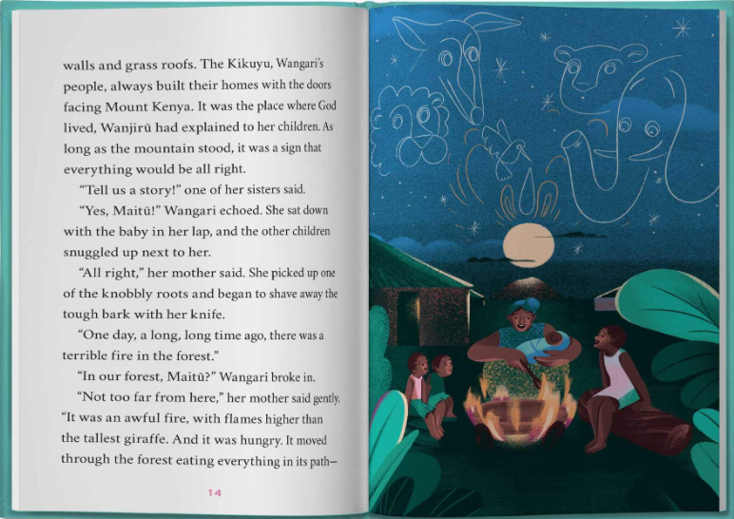
The leopard could run much faster than that little hummingbird, but he didn’t move, either.”
My leopard? Wangari thought.
“At last the antelope cried: ‘Little hummingbird, what are you doing?”
Maitũ looked straight at Wangari as she continued, “‘I am doing the best I can,’ the hummingbird told them. ‘I am doing the best I can.’’’
The other children begged for another tale, but Wangari was lost in thought. What good was it to be big like the elephant or powerful like the leopard if you weren’t going to help when it mattered? Maybe she didn’t belong only to the leopard. She shared a name with the cat – and a spirit with the hummingbird.

the trees, the flowers, everything.”
Wangari thought about flames encircling Ihithe, encircling her mugumo tree. She shuddered.
“The animals ran to the highest hill and watched that fire gobbling up their land. The elephant and the leopard, the antelope and the lion; all of them, just standing there. Until someone said, “We have to do something!” And do you know who that was?
“Who?” Wangari asked.
“It was the hummingbird. The smallest animal of all. It flew as fast as it could down to the stream. It drank up all the water it could hold in that little mouth” – here Maitũ pretended she was drinking, which made Wangari and the other children laugh – “then flew back to that fire and threw all the water onto the flames. It went back to the stream, back to the fire. Over and over again.”
“The elephant could hold so much more water in his big nose” – Maitũ gave the baby’s nose a playful nip, producing a giggle – “but he didn’t move.

