Simple Electronics: How to Make a Magic Wand
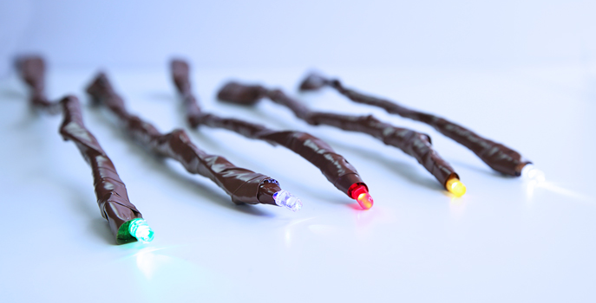
If you have wanted to try some simple electronics projects, this is a great project to begin with. Essentially, we will be making a very simple circuit connecting an LED with a battery and switch and taping the whole thing to a chopstick.
SAFETY NOTE: Coin cell batteries are extremely harmful if swallowed!!! DO NOT do this project with any child who is prone to putting things in their mouth OR if you have sibling in the home who might put battery in their mouth.

A little bit about electronics
- Electricity is the flow of electrons from a power source to something to be powered, such as lights and motors. The movement of the electricity through a wire is called current.
- In small electrical circuits, batteries are the typical power source. Batteries come in different voltages, which is the amount of power they can provide. When building a simple circuit, your power source voltage must match the power required for the object you want to move or light up. So if you are using a 3V LED, you must use a 3V battery OR (2) 1.5 volt batteries connected together.
- Electrical current flows in one direction. That is why it is so important to make sure you are connecting the wire to the correct side of your power source.
- Switches interrupt the flow of electrons. When switched off, the circuit is broken, and the electron flow is stopped. When switched on, the electrons can flow through the circuit.

Materials

For circuits:
- LED*
- 3V Coin Cell Battery*
- Copper conductive tape*
- Electrical tape*
- Switch*
- Scissors
- Chopstick*
For decorating:
- Clear crystal point*
- Air dry clay*
- Paint*
- Paintbrush*
- Hot glue gun (optional)
- Superglue (optional)

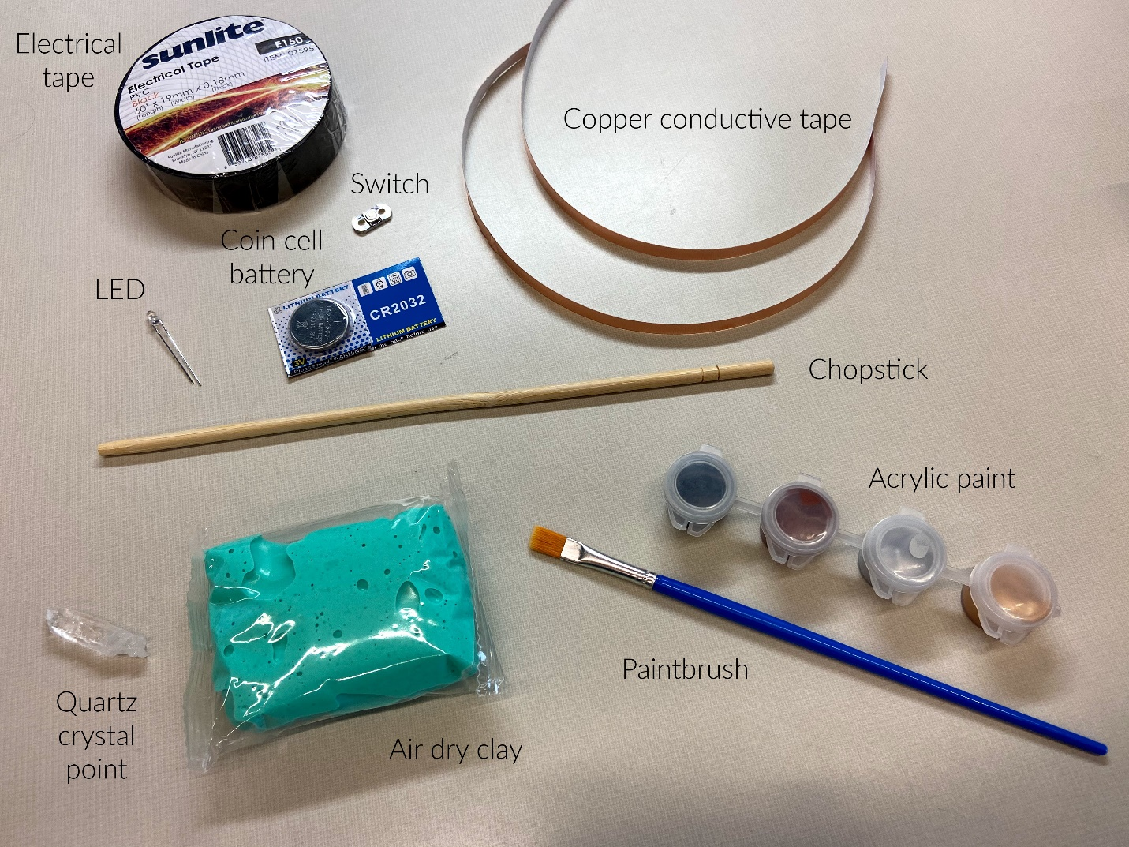
*provided

Tips before you start:
If you are new to electronics projects, I have one piece of advice: Test, test, and test your connections. I mean at every step. You can’t see electricity move, so when you build a simple circuit and flip the switch only to find it doesn’t work, you want to be able to narrow down where the connection isn’t being made. If you test each step, you can rule out trouble spots.

Instructions
- Test the LED & battery. Place the longer LED lead (that’s the positive side) on the positive side of the coin cell battery and the other leg to the negative side. The LED should turn on. (If it doesn’t, you may need a new battery.) Try putting the LED leads on different parts of the battery. What happens when you put the positive lead on the edge of the battery? What happens when you put the negative lead on the edge? Keep all of this in mind when you are constructing your circuit.
- Decide where you want your switch to be. Hold the chopstick in your hand like you would a magic wand. Where does your thumb naturally rest? What about your index finger? These might be good spots for your switch, but you can decide what feels best to you.
- Decide where you want your battery to be. Its position doesn’t really matter that much, except it will create a bump on your wand, due to the size and shape of the battery. You can smooth this bump out with your clay later, but do think about your design when you’re planning your circuit. Natural places for the battery might be the end of your wand opposite the light, or the opposite side of the chopstick from your switch. You decide what feels right to you.
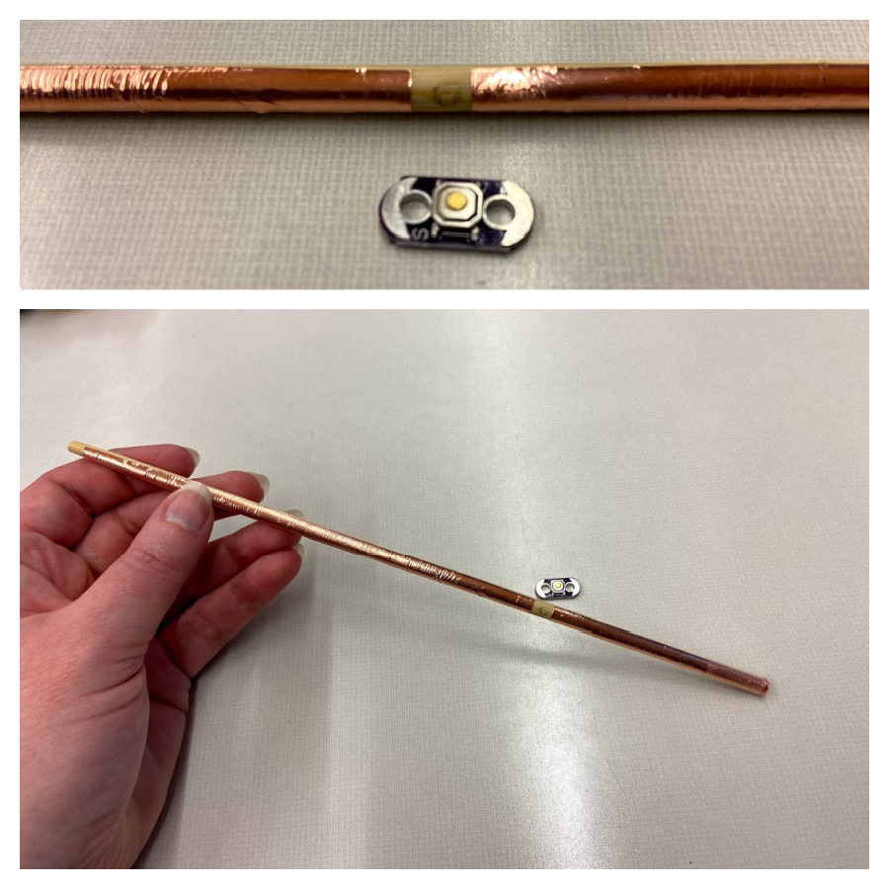
- Start placing your copper conductive tape. Start at the tip where your LED will go. Place copper tape down one side to where your switch will be. Cut the copper tape and leave a small gap, then place another piece of copper tape. Your switch needs to be able to bridge the gap and touch both pieces of copper tape, but the tape should not connect. Stick the second piece of copper tape from the other side of your switch to where your battery will go.
- Go back to the LED end of your chopstick and place another piece of copper tape on the opposite side of the chopstick from the first. Make sure the two pieces of copper tape don’t touch! Place the tape down the side of the chopstick to where the battery will go. Leave a little extra tape to stick to the battery.
- Place the battery. The copper tape from the positive side of the LED needs to touch the positive side of the battery, and the copper tape from the negative side of the LED needs to touch the negative side of the battery. I like to place the negative side of the battery down, touching the chopstick, and have the sticky side of the tape stuck to the positive side on top. This is because, as you discovered in step one, the sides of the battery are positive, and the tape may touch the sides a bit. As long as the tape touching the sides is the “positive” tape, you’re golden! But if the “negative” tape touches the positively charged sides of the battery, your circuit will not work. After your battery is placed and your copper tape stuck down, tape your battery in place (I have used Scotch tape in the example to make it easier to see, but you will use the electrical tape).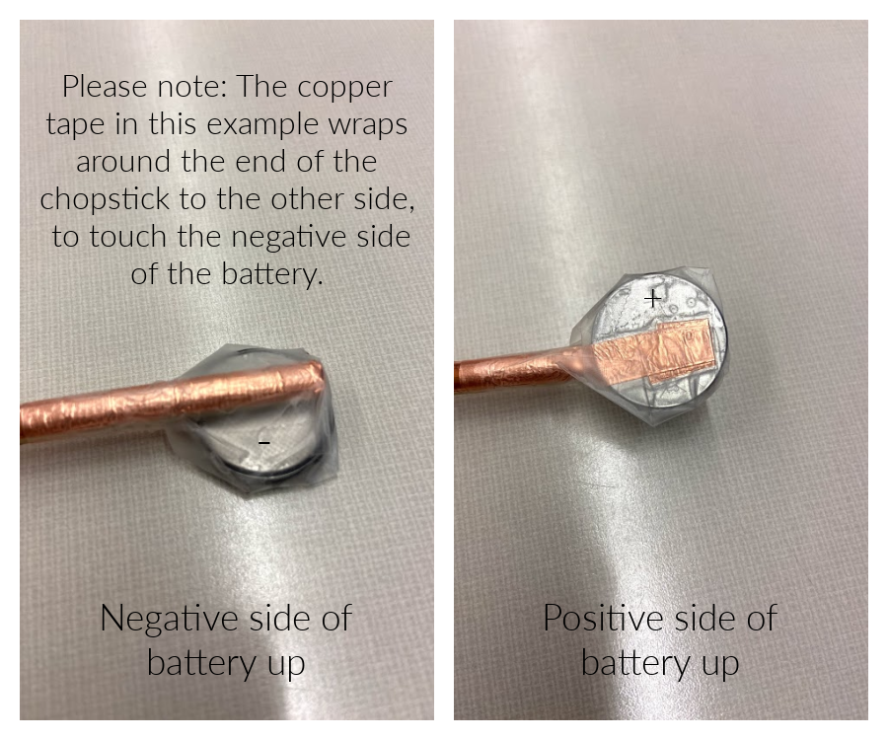
- Place the switch so that it bridges the gap you left for it in your copper tape. Use your electrical tape to tape it in place. BE SURE NOT TO TAPE OVER THE BUTTON ON YOUR SWITCH! This will make it hard to use.
- Place your LED on the end of the chopstick so that the positive (longer) lead is touching the copper tape that leads to the positive side of the battery, and the negative lead is touching the copper tape that leads to the negative side of the battery. Tape the LED to the chopstick using electrical tape.
- Test the circuit. Push the button on your switch. Does the light come on? If it does, YAY! You can move on to the next step. If not, double check all of your connections. Is the positive LED lead connected to the positive side of the battery? Push on all the places where the different components connect, one by one, while holding down the switch. Did the light come on? If so, you might just have a loose connection. Wrap it more tightly in electrical tape, so the connection is solid. If none of those fixes work, you might have to take it apart and start again. Hang in there! Circuits can be tricky, but you’ll get it if you keep trying.
- Cover the rest of the chopstick with electrical tape. Completely cover the switch with tape except for the on/off button. Completely cover the battery in electrical tape. Don’t cover the light part of your LED (obviously), but cover as much of the wire leads as you can. Your goal is to make your wand waterproof. Water is the enemy of electrical circuits. Try to make sure your wand is so covered in tape that no water can get in. Remember to leave your switch free!
And now the moment of truth, say the magic word “Lumos” and turn it on! Try it at night and watch it light up!
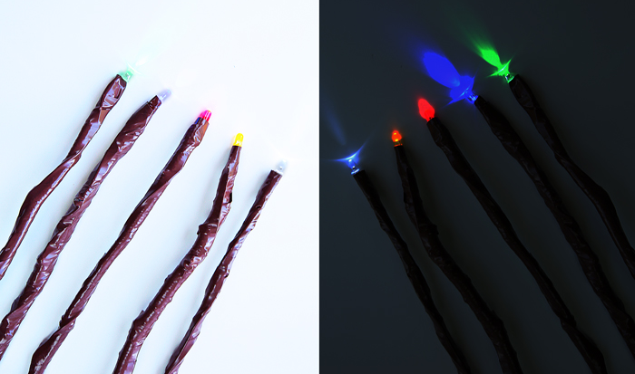

You can stop here and have a perfectly serviceable light-up magic wand. OR you can make it extra…

Time to decorate!
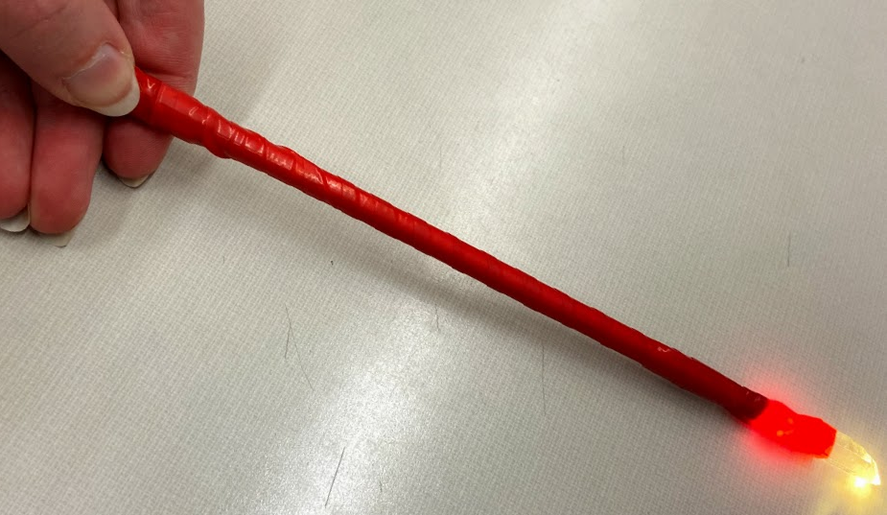
- Decide where you want to put your crystal. On mine, I put it over the LED and then covered the LED with electrical tape, leaving only the crystal sticking out, so it looks like the light is coming from the crystal. But you might want to put your crystal on the back end of your wand, or sticking out the side, or somewhere else entirely! This is where your hot glue gun or super glue might come in handy, if you have it. If not, just use your electrical tape to affix your crystal.
- Start covering your wand in clay. You can do this any way you want. This is where your creative vision really shines! You might want to roll out your clay and then wrap it around your wand. Or just stick gobs of it on and then smooth it around with your fingers. Or make long, thin ropes of clay and wrap it around your wand in a spiral pattern. You could cover your wand in vines and tiny leaves. Or have a snake slithering around it. Or just experiment with different textures. You can ball up aluminum foil and use that to press a crinkle pattern into the clay. Or use a toothpick or pencil point to make tiny indentations. Just remember to leave your switch button uncovered! 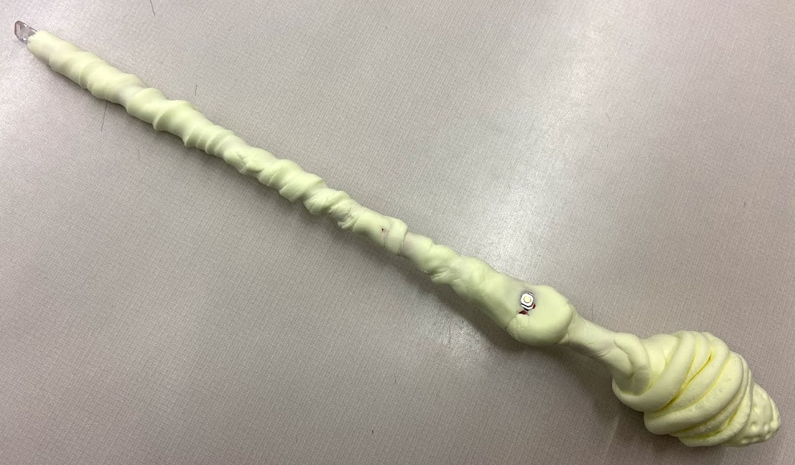
- Let the clay dry. Depending on how thick a layer of clay you applied, you may need to wait several days. If your light won’t turn on during this time, don’t panic! A little bit of moisture from the clay may have made its way into your circuit. When it completely dries out, it should turn on again.
- When your clay is COMPLETELY dry, you can paint it! If you want it to look like natural wood, you will want to paint the entire thing black first, then drybrush brown over the top. Drybrush is a painting technique in which a paint brush that is relatively dry, but still holds paint, is used. To do this, dip your brush in the paint and then wipe most of it off on a paper towel before applying the paint brush to your project. You can also add metallic accents to particular areas of your wand, or use this same drybrushing technique with the metallic paint.

- (Optional) Make it EXTRA extra. What craft supplies do you have around the house? Glitter, paint, feathers, small gems or stones? The sky’s the limit! Make your wand uniquely YOU.

