The Southern Oaks Library presents:
A Visit to Greenwood
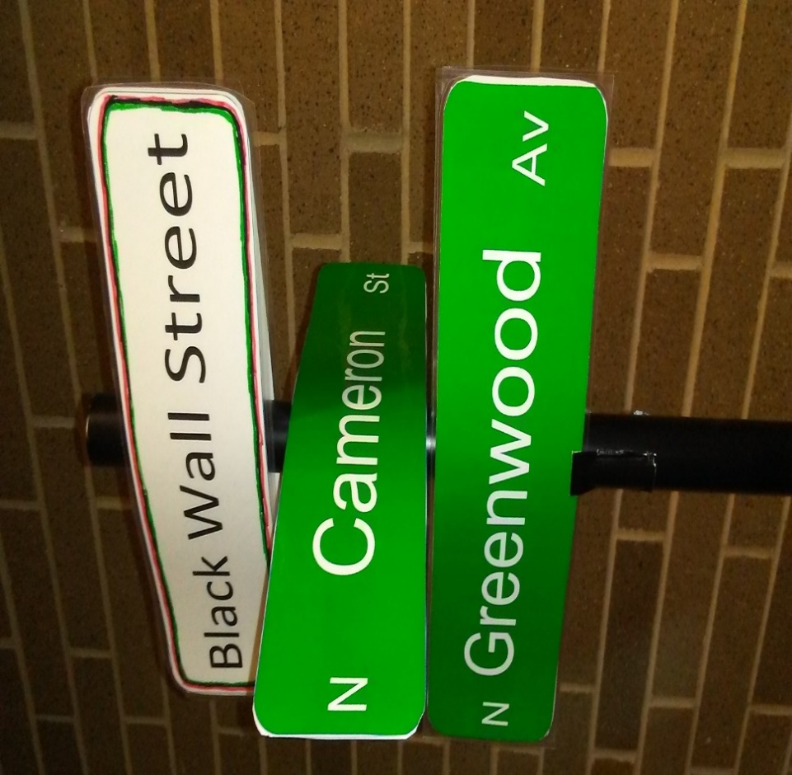

A fictionalized story and kit about a young musician’s journey to the Greenwood district in Tulsa, Oklahoma in February 1920, and his desire to relocate there.
Readers of the story will receive a kit with maps, addresses etc., and enough play money to complete a 6-day visit ($5.00).
Kits are available at the Southern Oaks library. Adults, young adults, and families are invited to sign up for a kit during the month of May while supplies last.
To obtain a Kit contact the Southern Oaks Library
405-631-4468
6900 S. Walker
Oklahoma City, Oklahoma 73139
The Southern Oaks Library presents:
A Visit to Greenwood

A fictionalized story and kit about a young musician’s journey to the Greenwood district in Tulsa, Oklahoma in February 1920, and his desire to relocate there.
Readers of the story will receive a kit with maps, addresses etc., and enough play money to complete a 6-day visit ($5.00).
Kits are available at the Southern Oaks library. Adults, young adults, and families are invited to sign up for a kit during the month of May while supplies last.
To obtain a Kit contact the Southern Oaks Library
405-631-4468
6900 S. Walker
Oklahoma City, Oklahoma 73139

