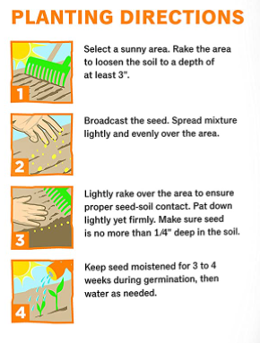
Hummingbird, Butterfly and Pollinator Wildflower Mix

Hummingbird, Butterfly and Pollinator Wildflower Mix

