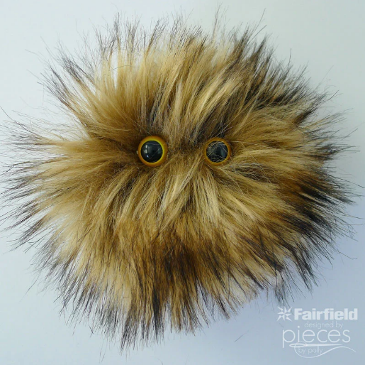
WORRY PETS - SENSORY BUDDIES FOR ANXIETY
Lots of people struggle with worries or anxiety. These Worry Pets are small enough to fit in a pocket. The cuddle fabric is snuggly soft. The poly-pellets inside provide comforting sensory input and something to rub between worried fingers, and the eyes make them oh-so-cute. These are not just for worriers, though! The whole family will want one.

WHAT YOU NEED TO MAKE THIS PROJECT
MATERIALS
Cuddle Fabric (approx. 5 x 10 inches)
Poly-Fil® Poly Pellets® Weighted Stuffing Beads
1 Set Plastic Safety Eyes
Thread
SUPPLIES
Sharp Scissors
pins
needle
marker

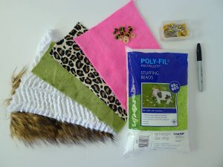

INSTRUCTIONS

STEP ONE
Fold your cuddle fabric in half (or you could start with approximately 2 – 5″ squares).

On the back of your fabric, mark your circle using a large drinking glass or something similar (I used the base of a 1 cup measuring scoop). Mark your eyes.
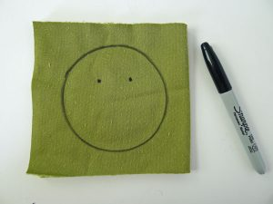

STEP TWO
Snip a tiny hole at each of your eyes.
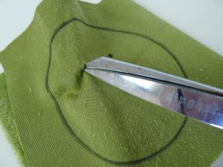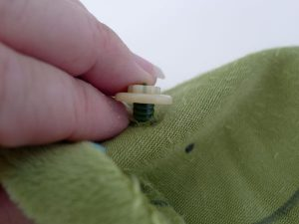
Insert your safety eye and attach the backing.

STEP THREE
Fold back in half.
Stitch around your circle leaving and opening big enough to turn right-side out. I left about a 1” opening, and it was almost too small. I would recommend at least 1 ½" to 2”.
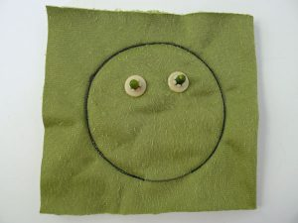
Trim, leaving a bit extra where the opening is. Snip the curves. Make sure you don’t snip your thread!
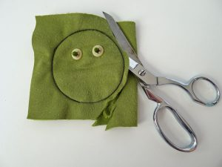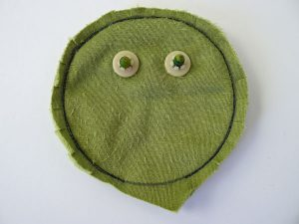

STEP FOUR
Turn right side out. You might find it helpful to use the eraser end of a pencil to push the fabric through the opening to turn it right-side out. You might want to use your fingers, a comb, or the pointy end of a pencil to tease the fur out of the seams.
Add poly-pellets. You can fashion a funnel out of a spare piece of heavy paper or cardstock. Again, you might find the eraser end of a pencil helpful to push the poly-pellets through the opening. You may not need to use all of the pellets included, depending on the size of your worry pet.
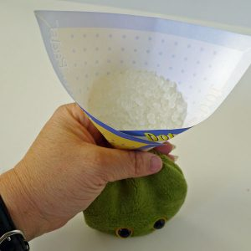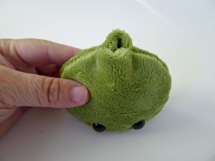

STEP FIVE
Use a needle and thread to hand-stitch closed.
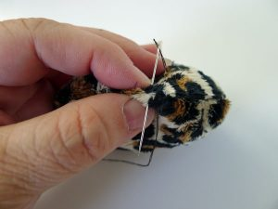
And your Worry Pet is all ready to calm some anxious hands.

