Constellation String Art
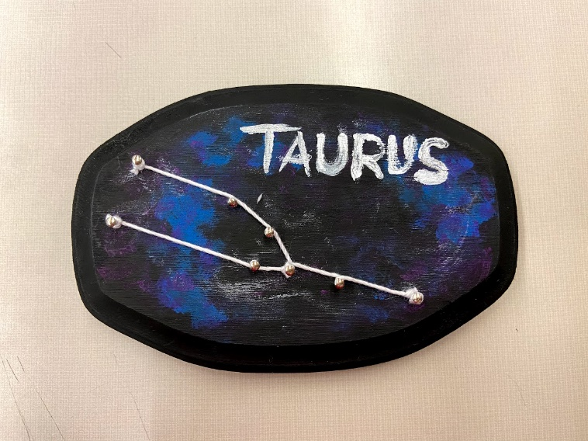

Materials
- Wood plaque
- Nails
- String
- Paint
- Paintbrush
- Hammer (not provided)

Instructions
- Protect your work surface. You might want to cover it with newspaper or plastic for the painting part. If your wood plaque is one of the thin ones, and your nails are long, you might also want to protect your surface from damage from nails, too. Use a thick wood or plastic (not glass!) cutting board, scrap wood, or several layers of corrugated cardboard between your table/countertop and your wood plaque. Or, if the weather is nice, you could just work outside!
- Paint your wood plaque. You could choose to paint it a solid color. Or you could add nebulae and/or stars. 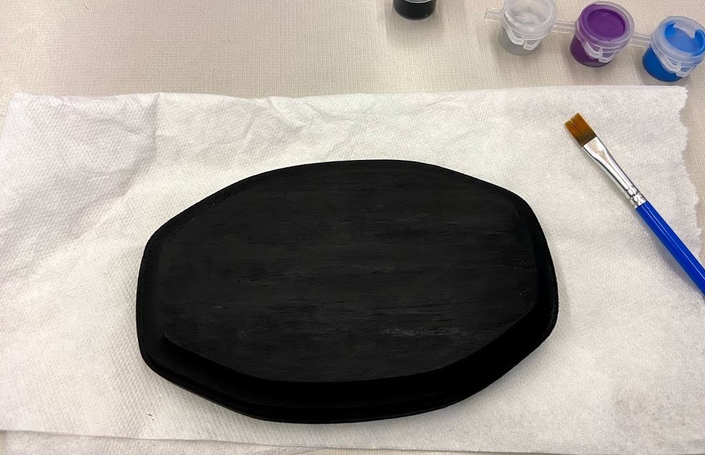
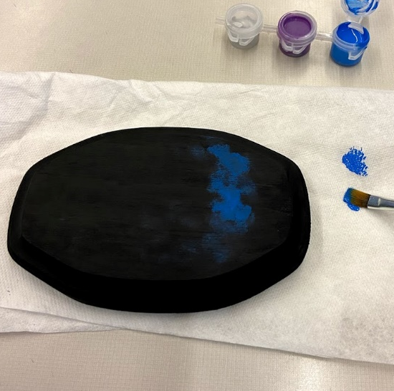
  - To paint nebulae, start with your plaque painted black. Dip your paintbrush in just a tiny amount of blue or purple paint, then wipe most of the paint off on a paper towel. Use a dabbing and twisting motion to add color to your nebula in curving pattern. Layer other colors on top, until you like the look of it.
  - To paint stars, turn your paintbrush around and dip the pointy end in the silver paint. Dab little dots of silver paint onto your wood plaque for stars.
- While your paint dries, decide on your constellation. The twelve constellations of the zodiac have been provided. You could use your own zodiac sign or make someone else’s to give them as a gift. You could also look up other constellations, like the Big Dipper or Orion, or even make up your own!
- Position your constellation template on your plaque. You might want to use a few pieces of tape to hold it in place, or you could just hold it with your hand. Once you have a few nails in place, it won’t move around. (If not using a template, you could use paint or a pencil to mark the positions of your nails.)
- Position a nail over one of the major stars of your constellation. Use your hammer to tap the nail into the wood. Don’t hammer it in all the way! You want a bit of nail sticking out to wrap your string around. *If you got one of the thin plaques, you will have two sizes of nails. The smaller ones are ideal for these plaques, as they will not poke through to the back. But they are very hard to hold while you hammer. You have been provided a small rectangle of cardboard with a slit in the corner to use as a nail holder. You might have to cut new slits, as the original one gets worn out. Or, if you have them, you could use needle-nose pliers to hold your nails. If this is too difficult, you can just use the longer nails. Just be sure not to hammer them in too far. You don’t want the sharp ends poking through the back of your plaque.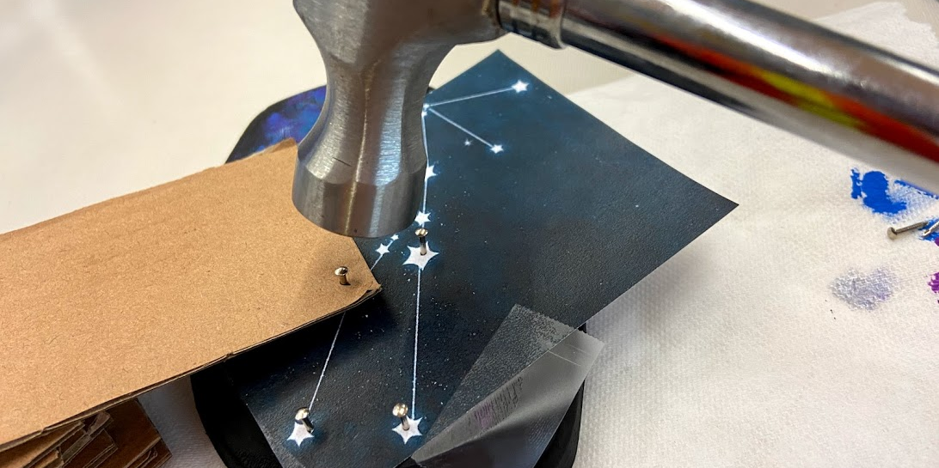
- Continue placing nails until you have a nail for each major star in your constellation, then carefully pull off the template.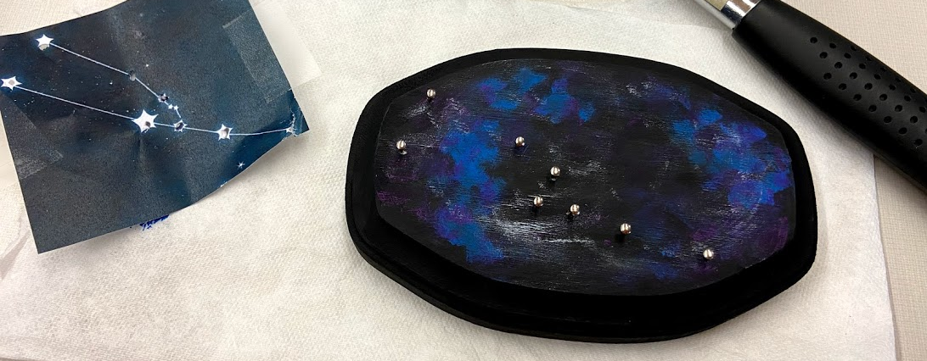
- Tie your string around a nail where you want to start (probably at one end or corner of your constellation. Wrap the string around each nail and then the next to make the “lines” between stars. You can experiment with how you wrap your string. There is no right or wrong way to do it, as long as it stays in place, and you like the look of it.
- When you’ve connected all your stars, tie the strong off tightly and trim the trailing ends. You might want to use a little dab of school glue to secure the knots, but you don’t have to.
- Optional: If you want, you can paint (or write with a marker) the name of your constellation on your plaque.

