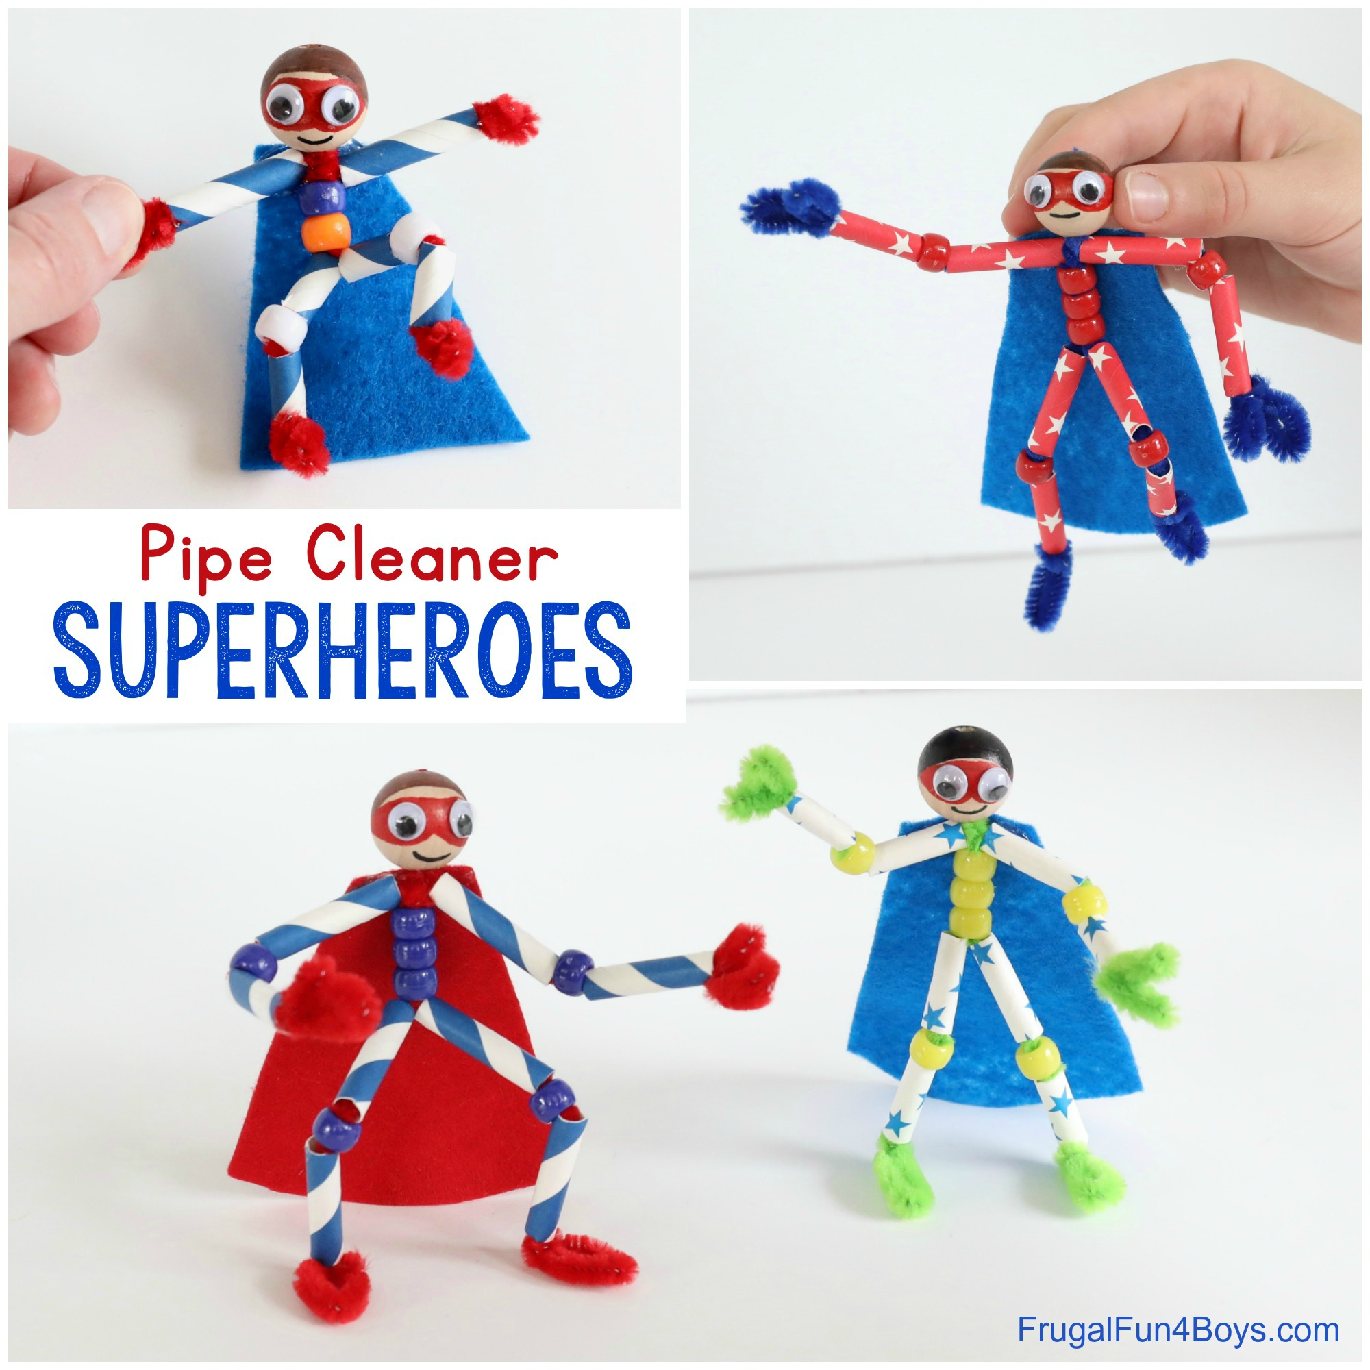
Step 1: Start by drawing hair and superhero masks on the wooden beads.
Step 2: Stick on googly eyes, then draw a little mouth.
Step 3: Grab three pipe cleaners. Twist them together in the middle. This should hold them securely. Then adjust them so that they are in the arrangement shown.
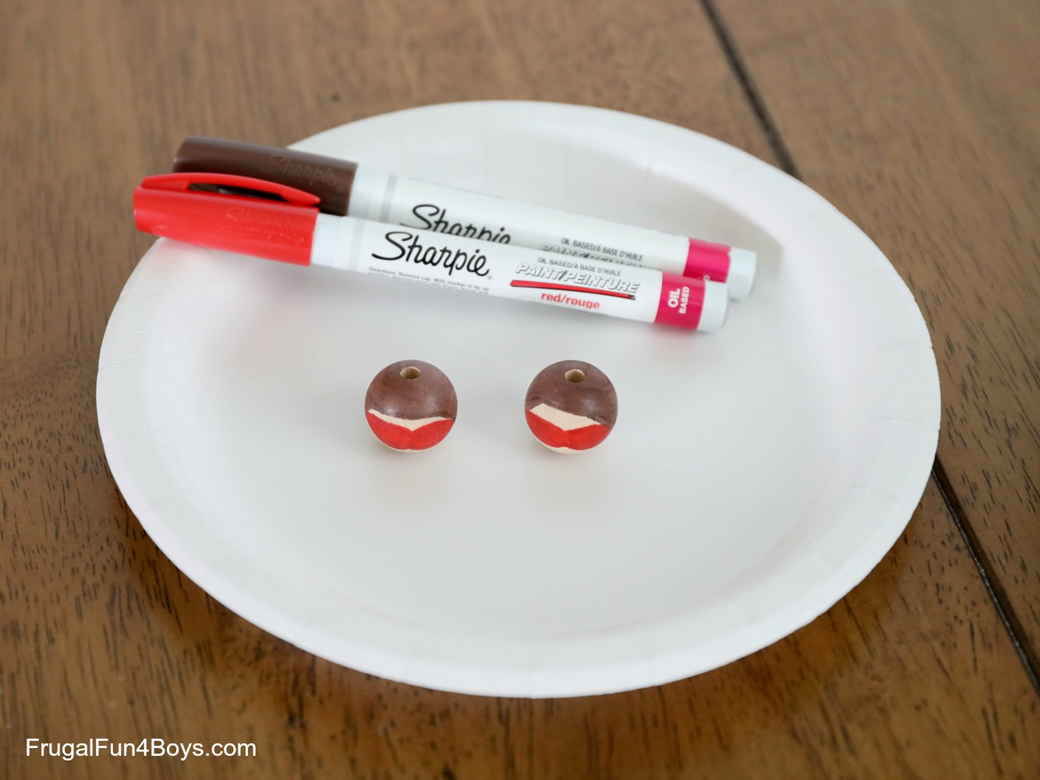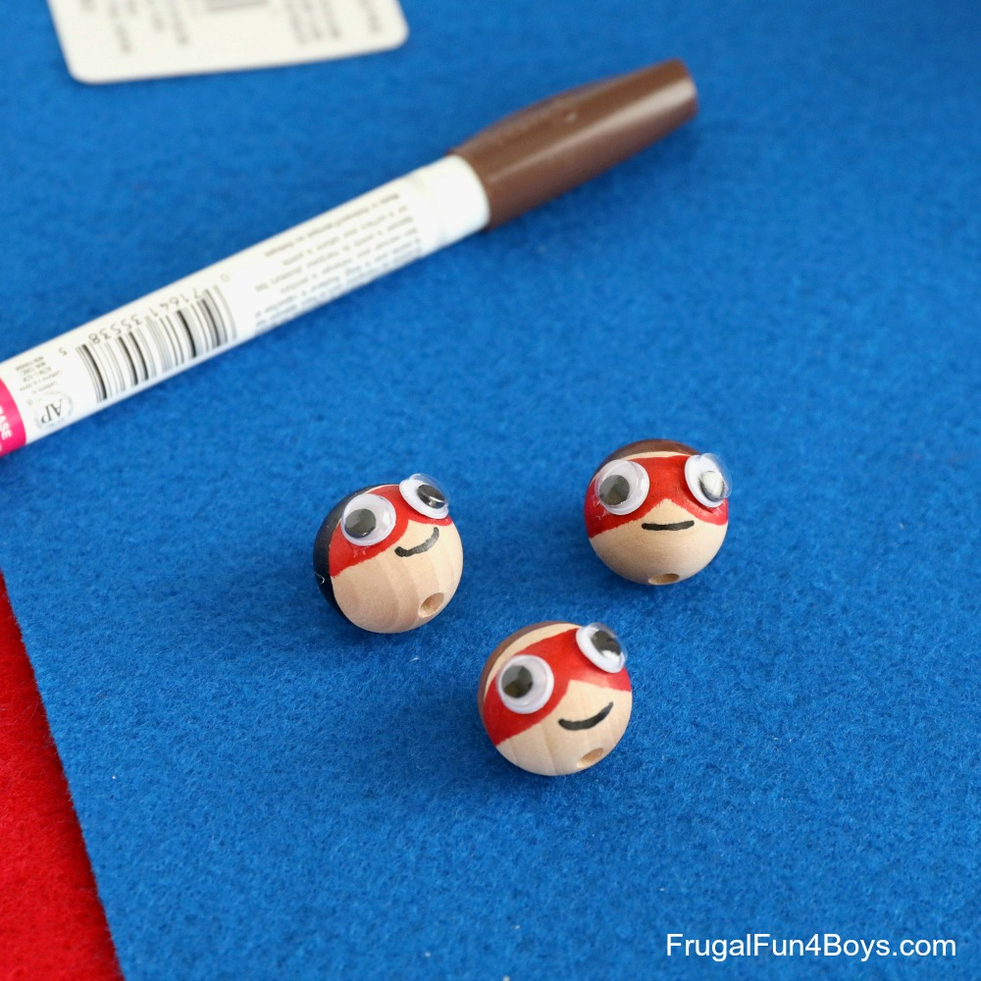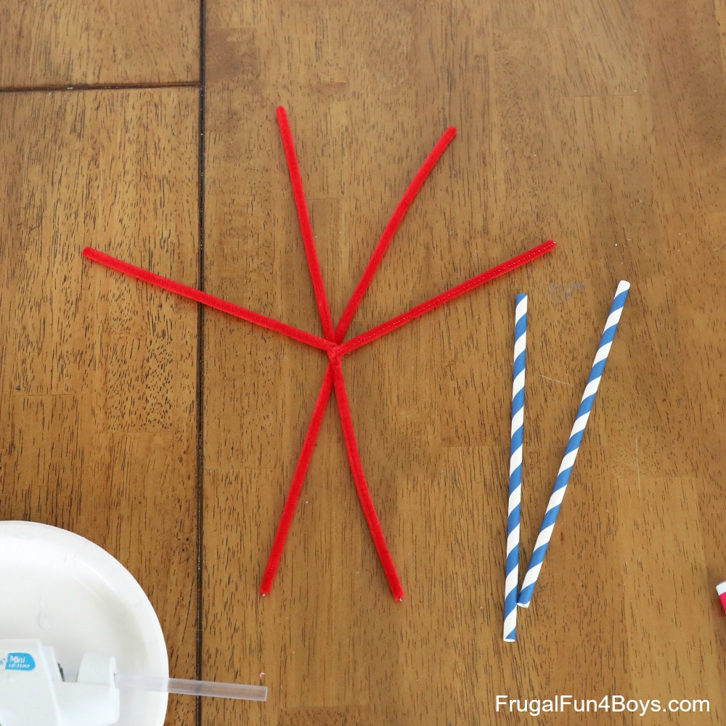
Step 4: Slide three pony beads onto BOTH of the bottom two pipe cleaners. This will form the body.
Step 5: Cut a straw into 8 one-inch segments. (Or feel free to adjust the size!) We found that we could get 7 segments out of each straw, so you’ll need two straws per superhero, with quite a bit left over.
Step 6: Build each limb by sliding on a straw segment, then a pony bead, then another straw segment.
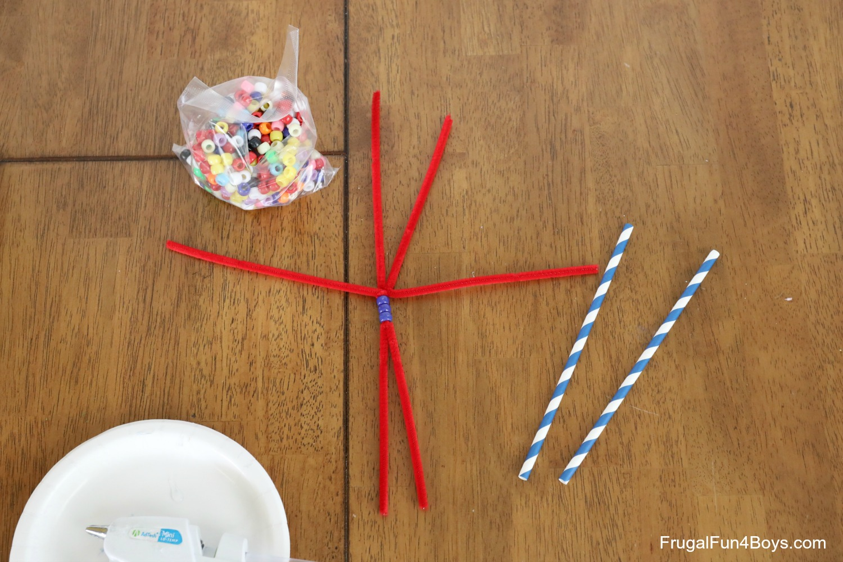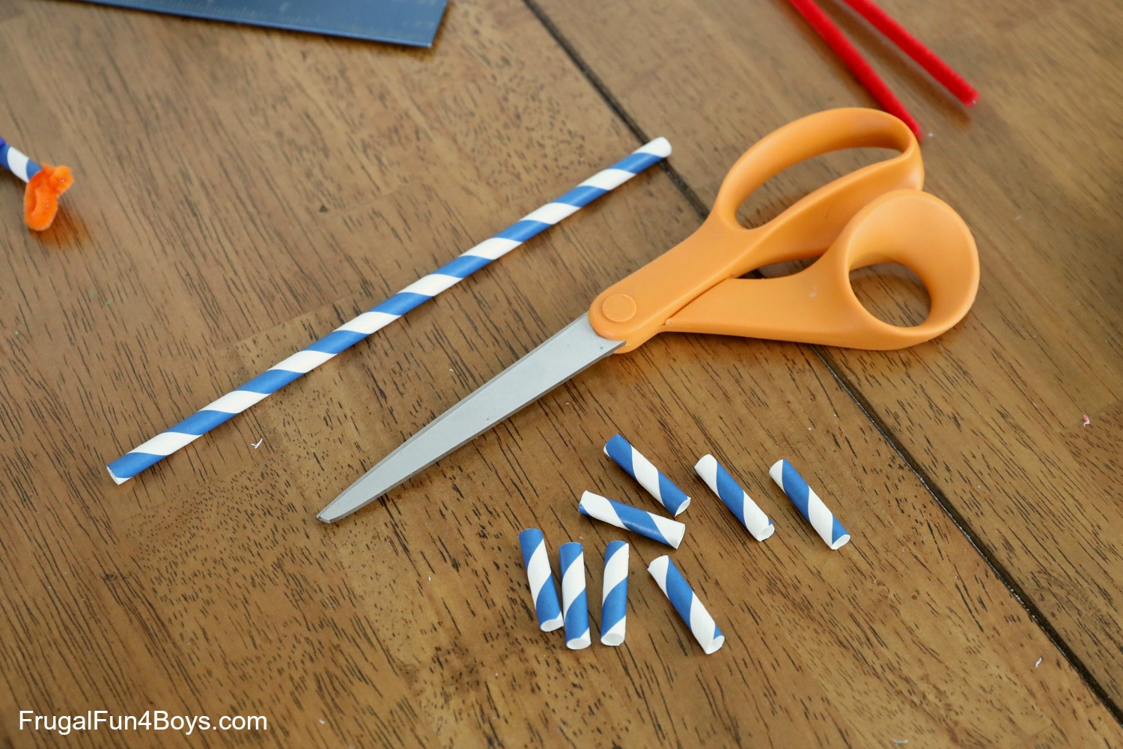
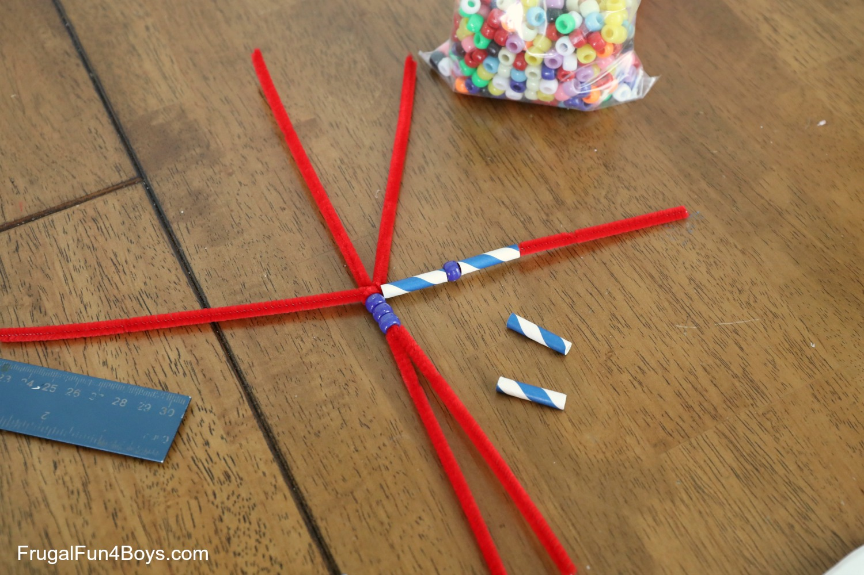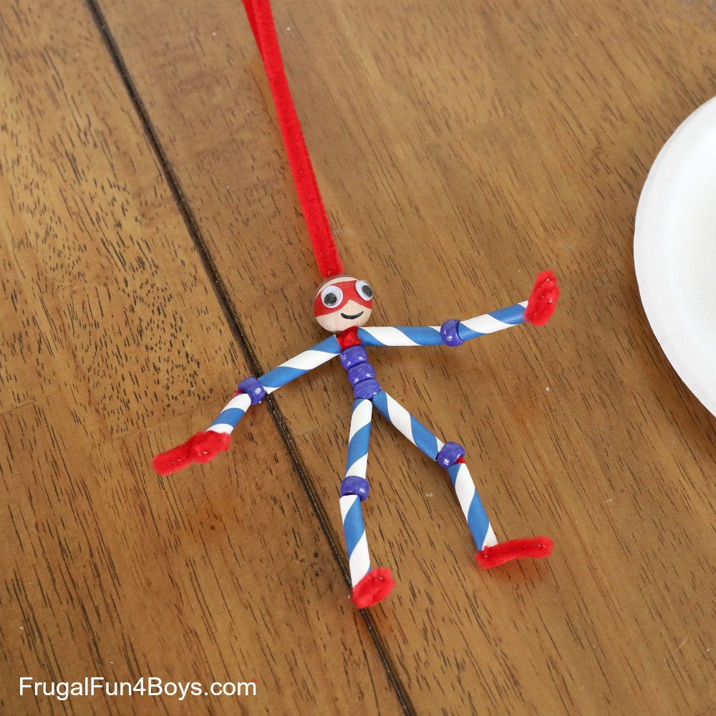
Step 8: Slide the head onto the final two pipe cleaners. Then trim off the excess.
Step 9: To make the head more secure, attach it with school glue. Squirt some glue onto the pipe cleaners. Then slide the head on. If a little bit of glue oozes out at the bottom of the head, just wipe off the excess with a paper towel.
Step 10: Cut out a cape from felt and use hot glue (or clear tape) to attach it to the backs of the arm segments.

To Make a Smaller Superhero Sidekick--
Use only two beads for the body and one each as knees. Cut straws into shorter segments and use only one for each arm instead of two.
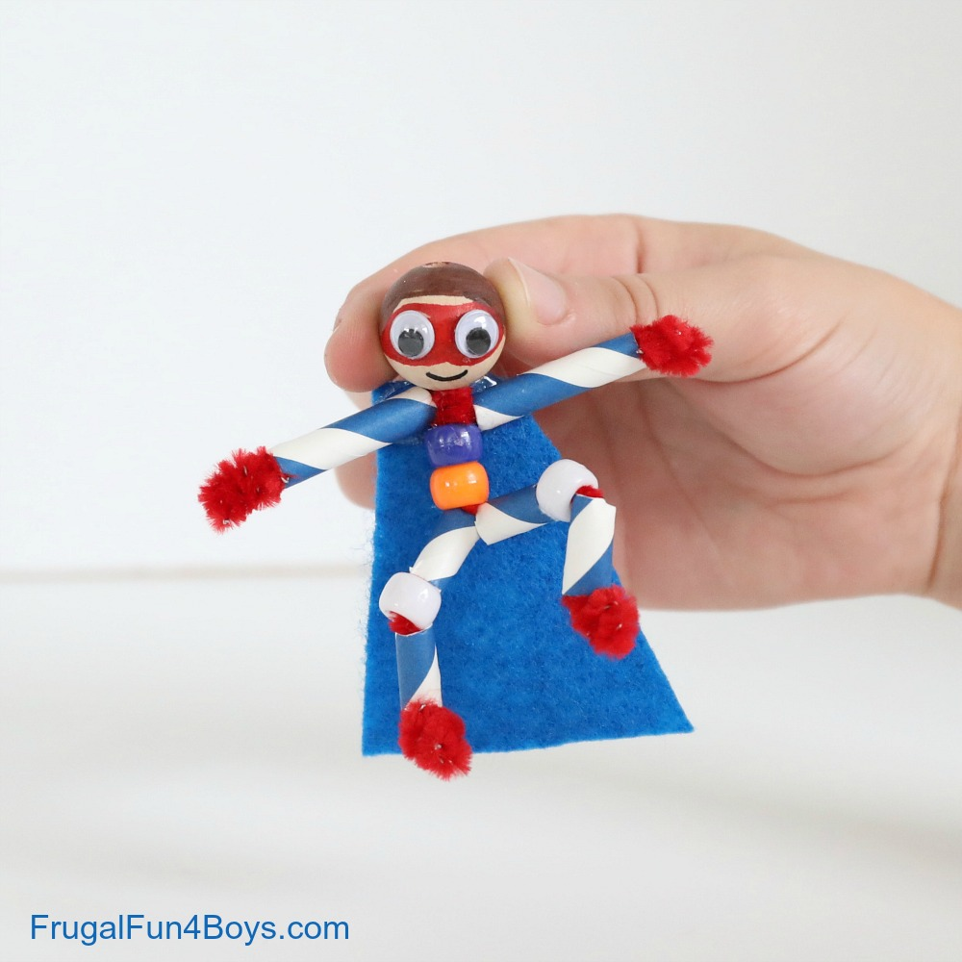

To Make a Smaller Superhero Sidekick--
Use only two beads for the body and one each as knees. Cut straws into shorter segments and use only one for each arm instead of two.

