YOUR AMAZING EYES!

Learn all about the human eye…
You carry around a pair of cameras in your head so incredible they can work in bright sunshine or at night. Only 2.5cm in diameter, they can bring you the image of a tiny ant or a twinkling star trillions of kilometres away. They can change focus almost instantly and stay focused even when you’re shaking your head around. These cameras are your eyes…
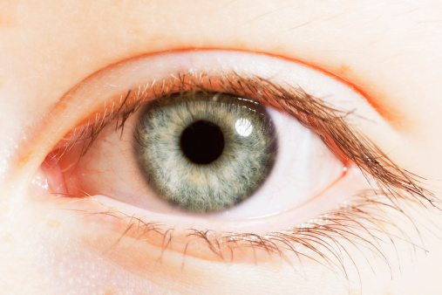 Extreme close up of blue eye

Eye-Popping Fact ONE: A crucial part of your eyes is as flimsy as a wet tissue!
A fly darts towards your head! Light bounces off the insect and enters your eye’s cornea, a clear covering over your eye. The light passes through your pupil, the black circle in the centre of the iris, to the lens. The lens focuses the light onto your retina – a thin but vital lining on the back of your eye that is as flimsy as a wet tissue. Your retina acts like camera film, capturing the picture of the fly. This image is sent to the brain, which instantly tells you to – duck!

Eye-Popping Fact TWO: You blink more than 10,000 times a day!
Your sight is incredibly important , so your body has ways to protect your eyes. Each eye sits on a cushion of fat, surrounded by protective bone. Your eyebrows prevent sweat dripping into your eyes, while eyelashes keep dust and other particles out. The eyelids act as windscreen wipers, spreading tear fluid with every blink to keep your eyes moist and wash away bacteria. You blink more than 10,000 times a day! And if anything gets too close, your eyelids slam shut with amazing speed. How fast does this happen? In the blink of an eye – about 2/5 of a second!
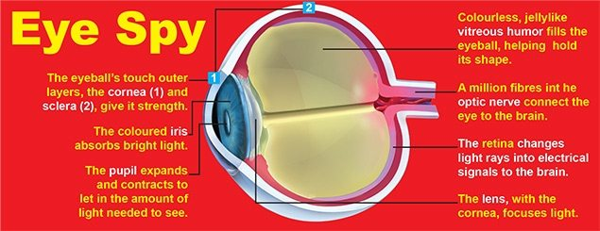

Eye-popping Fact THREE: Your eyes adjust in milliseconds to ANY movement of your head!
You bounce your eyes around all the time. Even when you’re not running or jumping, your head doesn’t stay still. Why isn”t everything a blur when you”re moving? The eyes automatically adjust to the movement of your head with great speed and precision. They’re good at following a moving object, and even better at adjusting to the motion of your head. Test it: Keeping your head still, hold up your hand about 30cm away, and quickly move it back and forth. As fast as your eyes are, your fingers become blurry. Now keep your hand still and move your head back and forth. Amazingly, your fingers stay in focus!
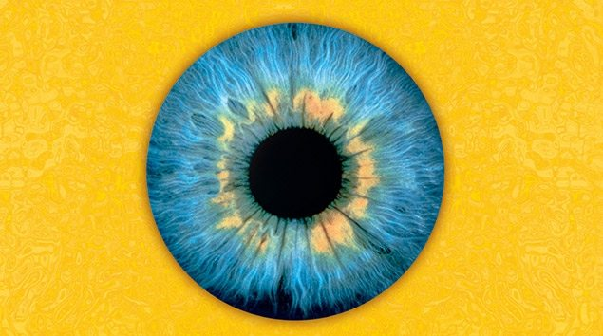

Eye-Popping Fact FOUR: Your eyes see everything upside down and backward!
Your eyes are amazing, but the images they send to your brain are a little quirky – they’re upside down, backward and two-dimensional! Lucky for you, the cameras in your head come with an impressive software package – your brain – that can fix these problems. The brain automatically flips the images from your retinas right side up and combines the images from each eye into a three-dimensional picture.
There is a small area of each retina, called a blind spot, that can’t record what you’re seeing. Your brain makes adjustments for this, too. But sometimes it can be fooled! Check it out – hold the tips of your two index fingers together, about 15cm in front of your eyes. Now separate them slightly and look past them at something in the distance. A floating finger that looks like a sausage appears between your fingers. You just fooled your brain into seeing something that isn’t there!
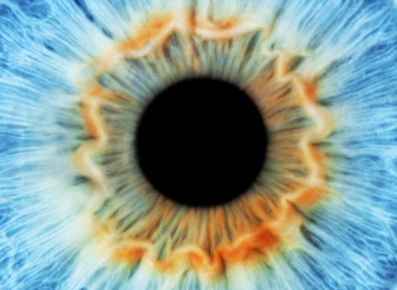 Blue eye

Eye-Popping Fact FIVE! Your pupils change size whenever the light changes!
Your black pupils may be small but they have an important job – they grow or shrink to allow just the right amount of light to enter your eyes to let you see. Try this: Go into a windowless room, turn off the light and close the door so there is just enough light to see the pupils in your eyes in the mirror. Your pupils will be far larger than usual, having grown to their maximum size to capture as much light as possible. Now, turn on the light while still watching your pupils. You’ll see them shrink to a small dot almost immediately – right before your very, um…eyes!

From National Geographic Kids-
https://uk-origin.natgeokids.com/uk/discover/science/general-science/human-eye/

