DIY HARRY POTTER WANDS

There are hundreds of Harry Potter crafts out there and making them is only part of the fun! One of the coolest things about the magical world of Harry Potter are the wands that are special to each character.
MATERIALS
- Hot glue gun with glue sticks (clear, black and glitter glue sticks are included)
- Paint (Burnt Sienna, Ochre, Sap Green, Magenta)
- 15” Wooden Chopstick
- Paint brushes (2, kinda cheap...sorry)
INSTRUCTIONS
- First, you should come up with a plan for your wand! It’s always fun to make up your own idea, or you can even try to make wands from the actual Harry Potter movies.
- After you have figured out what you want your wand to look like, it’s time to bring out the hot glue gun. This is probably the most tedious part of the craft, especially if you are trying to make little knots in the wand like the Elder Wand in the movie. The handle should be about the length of your finger. Cover the handle area with hot glue and let it harden. Add two (2) to three (3) more layers if needed.
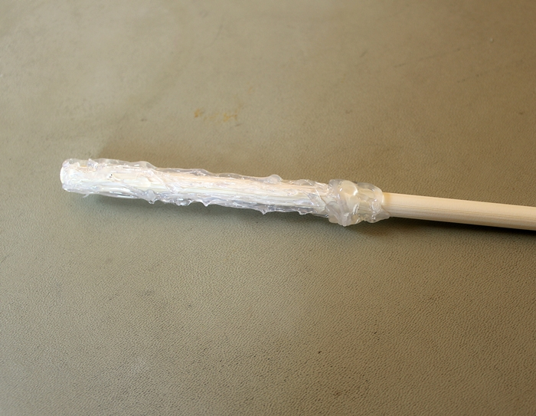
- To create a wand like Harry's, draw vertical lines to make the handle. Make them thicker at the base of the wand and thinner towards the other end of the handle.
- Some wands are plain but others, such as Hermione Granger's, have designs on the rest of the wand. You can use the hot glue to draw vines, squiggles, or spirals. You can create a neat design just by twirling your wand in your fingers while drawing a line.

- Let the glue completely dry. Remember it’s glue, it wants to stick to something, so when you are placing it to dry, don’t let the hot glue touch anything that might stick to it (like newspaper or any paper for that matter).
- After your glue has dried, and your wand is the desired shape, now you can paint it however you like! I’ve given you four (4) colors of acrylic paint (Burnt Sienna, Ochre, Magenta & Sap Green). You can add water to it to make it thinner, so the grain of the chopstick will show more. Once painting is finished, let the paint on your wand dry completely. I found that if you prop it on the top of two plastic cups (or something similar) you don’t have to rotate it to dry on all sides. (Optional: spray Wand with sealant or brush with Mod Podge [sealant not included])
- Once the paint on your wand is dry, it’s ready to summon your Patronus or an order of fries, just remember to use your wand responsibly and don’t go around turning people into cats or anything like that! Have fun and send me a pic of your wand if you are so inclined: kedwards@metrolibrary.org

